THE REPUBLIC OF UGANDA

Ministry of Works and Transport

NON MOTORISED TRANSPORT POLICY

February 2013

Table of contents

Acronyms and Abbreviations............................................................................................4
Glossary and Definitions...................................................................................................5
Foreword............................................................................................................................6
1. Introduction...................................................................................................................8
2 Analysis of Current situation..........................................................................................9
2.1. ‘Universal design’ principles..................................................................................9
2.2. Road maintenance....................................................................................................9
2.3. Road traffic: hierarchy of presumed ‘rights’.........................................................9
2.4. National roads..........................................................................................................9
2.5. District and community roads..................................................................................12
2.6. Urban roads..............................................................................................................12
2.7. Rural footpaths and trails.........................................................................................13
2.8. Urban footways........................................................................................................15
2.9. Pedestrian crossings.................................................................................................16
2.10. Cycleways...............................................................................................................18
2.11. Footbridges.............................................................................................................20
2.12. Bicycle parking.......................................................................................................21
2.13. Pedestrianisation, one-way traffic and NMT schemes...........................................22
2.14. Bus rapid transit (BRT)..........................................................................................23
2.15 Crosscutting issues..................................................................................................24
3. Non motorised transport types.........................................................................................26
3.1. Bicycle Models.........................................................................................................26
3.2. Bicycle Design Issues...............................................................................................27
3.3. Bicycle Safety, Maintenance and Cost Issues..........................................................28
3.4. Tricycles and bicycle trailers....................................................................................29
3.3. Other forms of non-motorised transport...................................................................30
4. Institutional and administrative issues.............................................................................31
4.1. Regulation and enforcement......................................................................................31
4.2. Funding and financial issues.....................................................................................31
4.3. Legislation.................................................................................................................31
4.4. Monitoring and evaluation........................................................................................32
5.5. Education and training..............................................................................................33
5. Policy Statements.............................................................................................................34
5.1. ‘Universal design’ principles....................................................................................34
5.2. Safety .......................................................................................................................34
5.3. Roads and Road Maintenance...................................................................................35

5.4. Promoting Equality Among Road Users.................................................................36
5.5. Gender......................................................................................................................36
5.6. Environment.............................................................................................................36
5.7. NMT Technologies...................................................................................................36
5.8. Other forms of NMT................................................................................................36
5.9. National Roads and Urban Environments................................................................37
5.10. District and Community Access Roads and Rural Environments ..........................41
5.11. Institutional and Administrative Issues..................................................................42
5.12. Funding and financial issues..................................................................................42
5.13. Legislation..............................................................................................................42
5.14. Monitoring and evaluation.....................................................................................43
5.15. Education and training...........................................................................................43
5.16. Way forward..........................................................................................................43
6. References...................................................................................................................45

Acronyms and abbreviations

BRT Bus rapid transit
eg for example
FABIO First Africa Bicycle Information Organisation, Jinja, Uganda
GTZ Deutsche Gesellschaft für Technische Zusammenarbeit GmbH, Germany. The German agency
for international cooperation is now known as Deutsche Gesellschaft für Internationale
Zusammenarbeit (GIZ)
I-ce Interface for Cycling, the Netherlands
ie that is to say
IFRTD International Forum for Rural Transport and Development
IMT Intermediate means of transport
ITDP Institute for Transportation and Development Policy, New York, USA
KCCA Kampala Capital City Authority
km kilometre
KURA Kenya Urban Roads Authority
MoWT Ministry of Works and Transport
MTRA Multi Sectoral Transport Regulatory Authority
NGO Non-governmental organisation
NMT Non-motorised transport
NRSA National Road Safety Authority
NZ New Zealand
RAI Rural Accessibility Index
SSATP Sub-Saharan Africa Transport Policy Program
SUSTRAN Sustainable Transport Network hosted by UN Habitat, Nairobi, Kenya
TAFMOD The African Forum for Mobility and Development, Uganda
TDM Transportation Demand Management
TOR Terms of Reference
UK United Kingdom (of Great Britain and Northern Ireland)
UN United Nations
UNEP United Nations Environment Programme
UNRA Uganda National Roads Authority
USD United States Dollar
VAT Value added tax
VTPI Victoria Transport Policy Institute

 | Glossary and definitions
Boda-boda | Originally bicycle taxis that operated at the border with Kenya. Subsequently a generic term for bicycle taxis in Uganda and then for motorcycle taxis. In present use, boda-boda increasing refers to motorcycle taxis.
Foot path | Pedestrian way not associated with a road
Footway | Pedestrian way at the side of a road
Kerb | Line of concrete, bricks or stones forming a raised edge (often around 150 mm) between a footway and a carriageway.
Pavement | Road carriageway (footway in some English documents)
Platform | A raised level surface on a road, operating like a speed bump but providing a flat surface that can be used to identify a pedestrian crossing or shared road space. Also known as speed hump.
Ramp | A slope or inclined plane for joining two different levels, as between a road carriageway and a raised footway (replacing the kerb at strategic locations such as pedestrian crossings).
Rumble strips | A series of raised strips across a carriage way (or parallel to the carriageway in the case of lane markers) that alert drivers to potential danger by causing a tactile vibration and audible rumbling, transmitted through the wheels into the vehicle body.
Shoulder | Side of road used for structural support and drainage, but also may be reserved for use by non-motorised transport and/or vehicle emergencies and breakdown
Side walk | Footway for pedestrians at the side of a road (pavement in some English documents)
Speed bump | Speed bump (also known road hump or ‘sleeping policeman’) is a speed-reducing feature of road design to slow traffic. They are often 70-100mm high and 300 mm across.
Street furniture | Objects such as lights, information signs, bollards, benches, bicycle stands and plant displays placed in the street for the public good.
Taxi | Internationally, a taxi (or taxicab) is a vehicle for hire with a driver used by one or more passengers for a specific journey determined by the passenger. Such taxis exist in Uganda, but are not as common as in many other countries. In Uganda, taxis are generally public transport minibuses that travel along specific routes, with multiple stops and multiple independent passengers.
Universal Design | Universal Design refers to pedestrian and transport infrastructure, facilities and services designed for the widest range of potential users, including people with mobility and visual impairments (disabilities), the elderly, those in wheelchairs and people walking with small children or with pushchairs. While aiming to address the needs of people with disabilities, it is a comprehensive concept with provisions that can benefit all users.

Foreword

In October 2011, the Ministry of Works and Transport agreed there was a need to develop a policy for Non-Motorised Transport (NMT) in Uganda. The intention of the policy would be to raise the profile of NMT within planning and programming for transport in general, to provide guidelines for the inclusion of NMT needs within transport projects, and to provide an over-arching advocacy document for the Government both to consider and approve.

A Steering Committee chaired by the Ministry of Works and Transport was formed to oversee the study. This included representatives of many stakeholders including the Kampala Capital City Authority (KCCA), Uganda National Roads Authority, Uganda Traffic Police, road safety specialists, FABIO and UNEP.

Non-motorised transport (NMT) in Uganda involves mainly walking, carrying and bicycling. Non motorised transport also includes animal-drawn carts, pack animals, hand carts, wheel barrows, wheelchairs, human-powered tricycles, canoes and non-motorised boats. These forms of NMT are all very important to certain people, but are not as widespread as walking and bicycling.

Despite increasing motorisation in Uganda, the non-motorised transport modes taken together are still the main means of transport in the country. Walking is the single most important form of transport in both rural and urban areas. Bicycling has long been widespread in rural Uganda and continues to provide a safe, efficient, healthy and sustainable means of transport for large numbers of people. The majority of people of Uganda do not use motorised transport on a daily basis, but depend on walking, carrying and perhaps the use of bicycles for their basic livelihoods and access requirements. Walking and bicycles are extremely important for rural people to access water, fuel wood, fields and livestock, education, health and work.
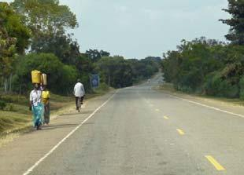
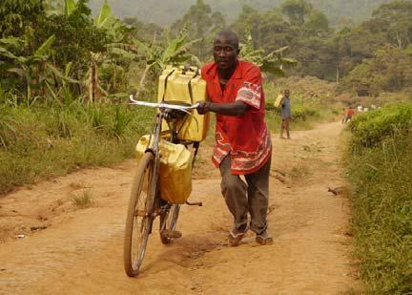

Increasing motorisation, combined with some inadequately maintained infrastructure, has made non-motorised transport unsafe, in both urban and rural areas. The needs of NMT are routinely omitted from the designs of road improvements. Road accidents adversely affect NMT users, especially pedestrians and cyclists. More and more cities are now realising the benefits of NMT and are designing policies, programmes and projects to accommodate NMT needs. Not only does this lead to more sustainable transport, it provides a strong impetus towards improved urban environments. Uganda can stand to learn from urban initiatives elsewhere, and at the same time the Government wishes to protect and enhance rural NTM mobility and safety.

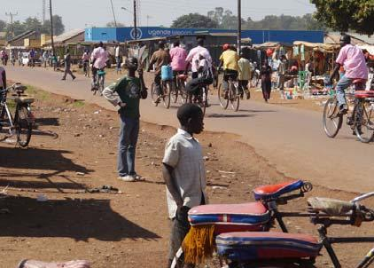
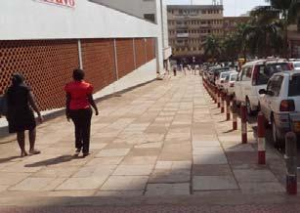
The primary objectives of the NMT policy are to:

- Increase the recognition of walking and cycling in transport, planning, design, and infrastructure provision;
- provide safe infrastructure for pedestrians and cyclists;
- mainstream resources for walking and cycling in agencies’ financial planning;
- develop and adopt universal design standards that provide for access to all sectors of the community; and
- improve regulation and enforcement to enhance safety for pedestrians and cyclists.

The policy sets out the various responsibilities of all stakeholders involved in the provision and fostering of NMT as a viable mode of transport in order to ensure that NMT provision is rendered in an appropriate manner.

Abraham J. Byandala
Minister for Works and Transport
September 2012

1. Introduction

The total extent of the infrastructure used by pedestrians and non-motorised transport in Uganda has never been quantified. According to the Uganda National Roads Authority (UNRA), the road transport infrastructure in Uganda comprises about 64,500 km of road, including about 20,000 km in the National Roads network, 12,300 km of District Roads, 2800 km of Urban Roads and 30,000 km of Community Access Roads. All of these are used by pedestrians and bicyclists. An unrecorded proportion of Urban Roads have raised footways, on one or both sides of the road. Some recently constructed or upgraded national roads have designated shoulders for use by pedestrians and bicycles (and vehicle emergencies). Some Urban and National Roads have pedestrian crossings and a small number of footbridges. However, the great majority of Uganda’s roads have no infrastructure specifically designed for use by pedestrians or bicyclist: they must ‘share the road’ with motorised traffic.

In addition to the road network, there are the countless rural footpaths that connect rural people to the road network, and also to their water sources, fields, forests and local facilities. Many of these have simple, but invaluable, footbridges. If one includes non-motorised water transport, there are also numerous rivers, lakes, waterways and associated simple quays that are vital for fishing and for important transport needs in the local communities.

The Government is undertaking major investment programmes aimed at improving the physical infrastructure of Uganda’s roads, cities and urban centres. The Government and statutory bodies are also responsible for regulating and enforcing the safe use of existing infrastructure and the design of new infrastructure. It is important that the needs of pedestrians, bicyclists and other non-motorised transport are fully considered in regulating and enforcing the use of all existing transport infrastructure in Uganda. It is essential that the requirements of pedestrians and NMT are also understood at all levels of governance and incorporated at all stages of infrastructure investment planning and implementation.
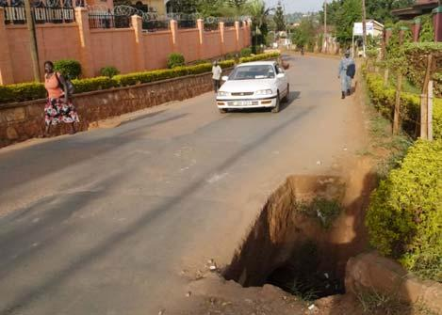
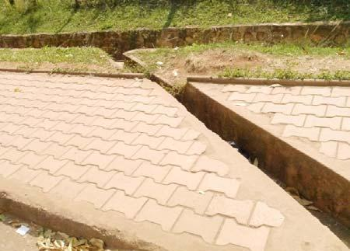
Examples of practices the policy intends to improve
Left: Uncovered cross drain on footway. Right: Unprotected culvert. Both are dangerous to all pedestrians.

Recent surveys at markets revealed how important walking and cycling are to both market traders and customers. In general, just over 50% of all market traders and customers use non-motorised transport, with 28% walking, and 22% cycling. In Kampala, 50% of all trips are made by walking. Even among the high income group, 45% of all trips are by walking.
2. Analysis of Current Situation

2.1. ‘Universal design’ principles
Universal Design makes provision for ensuring that there is appropriate pedestrian access for the elderly, men and women in wheelchairs and people walking with small children or with pushchairs. Universal Design infrastructure includes ramp alternatives where there are steps or kerbs and hand-railings alongside steps and where paths have dangerous side drops. Footways, footpaths and cycleways should be free from raised obstructions, dangerous holes, uncovered cross drains and unnecessary poles and signs. Street furniture should not produce narrow pinch points. Street lighting and clear signage are other features of ‘Universal Design’ concepts, as these benefit pedestrians of all abilities, as well as bicyclists and all road users. When incorporated at the design stage, Universal Design principles have negligible effect on overall costs, but benefit a wide range of pedestrians, including disabled people (VTPI, 2012; Venter et al, 2004; NZ Transport Agency 2009).

2.2. Road maintenance
Poor maintenance leads to the erratic and dangerous behaviour of drivers as they search for the smoothest ride and avoid potholes, gullies and runoff deposits. When the carriageway is particularly uncomfortable, vehicles move onto the shoulders (normally NMT space) on either side of the road. This is a severe challenge to pedestrians and bicyclists.

2.3. Road traffic: hierarchy of presumed ‘rights’
The great majority of drivers in Uganda appear to accept and implement an unwritten hierarchy of road rights. The hierarchy includes trucks and buses, minibuses, motorcars, motorcycles, bicycles and pedestrians. The larger vehicles expect the ‘inferior’ vehicles to give way even if the ‘inferior’ vehicle is behaving reasonably and the ‘superior’ vehicle is behaving unreasonably (in terms of speed and position on the road). The ‘inferior’ vehicles generally comply by moving off the carriageway onto the shoulder and they may decide to brake and stop to avoid an accident. Bicyclists and pedestrians are at the bottom. For their own safety, they have to get out of the way of all other vehicles even if the bigger vehicles are on the wrong side of the road and using the space normally occupied by NMT.

The hierarchy of presumed rights has no legal or moral basis and cannot be justified. However, the widespread understanding and application of this by all road users is likely to reduce the number of accidents due to uncertainties as to who is going to give way. In some countries, including Cuba and UK, the more clearly enforced equality of road users leads to situations where large vehicles will slow behind bicyclists and only overtake them when it is safe to do so. This is taken further in some Scandinavian countries, whereby motorists are quite fearful of touching a bicyclist, as enforcement is strict with the presumption of fault always acting against the motorist.

2.4. National roads
At present there are no motorways, expressways or freeways in Uganda. Such roads in other countries are designed from the outset to permit non-stop driving at high speeds. Pedestrians and non-motorised transport are prohibited (together with learner drivers and some agricultural vehicles). Implicit in the design of motorways is the proviso that alternative routes must be available for traffic that cannot use the motorways and that adequate crossing opportunities (including bridges and subways) should be provided for pedestrians, farm livestock and wild animals. When such roads are constructed in Uganda, adequate attention will need to be given to allowing pedestrians and NMTs to cross by bridges or by tunnels through the embankments.

Pedestrian and cyclists have the right to make use of all the existing national roads and to cross them, provided they do so in a safe way. Most national roads have no special provision for pedestrians or bicycles. Where there is motorised traffic, pedestrians and cyclists are generally expected to use the shoulders.

Over 75% of national roads are not paved. Most are in a poor state of maintenance. On old paved roads, the shoulders are often extremely rough and badly eroded. Silt runoff from side roads frequently obstructs the carriageway for months. It is difficult to walk on such surfaces and cycling is almost impossible, so cyclists and pedestrians used the road. Where the road is busy, pedestrians often develop informal tracks at the sides of the roads to avoid the traffic. Due to uneven surfaces and drainage channels, these are seldom suitable for bicyclists.

The older un-paved roads often have relatively small flat areas and long, steep cambers. When there is traffic (on the narrow, top portion) there is no place for bicycles as these have great difficulty to ride on the steep sides. Difficulties are greatest when it is wet or when it is very dusty (loose, slippery particles). On these roads, the movement of cyclists and pedestrians at the bottom of the road camber tends to wear the road into relatively smooth paths. When the road is potholed, these paths are often taken over by motorcyclists and even motor vehicles, which count on the ‘hierarchy of presumed rights’ to ensure that pedestrians and bicyclists must get out of their way.

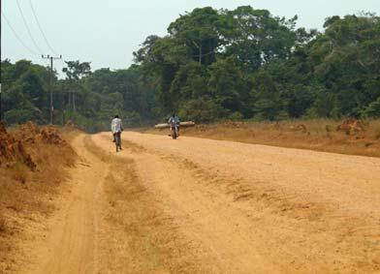
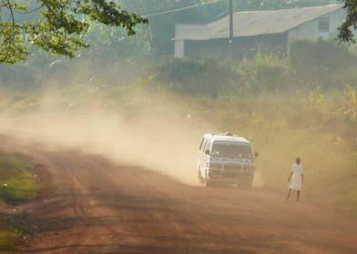
Examples of danger to bicycles and pedestrians as motor vehicles drive on road shoulders
Left: Clear motor track to side of uneven carriageway. Right. Taxi driving on shoulder close to pedestrian.

The modern national highways have hard shoulders, with a white line to clearly designate the shoulder reserve that can be used by pedestrians and cyclists. Where there is little traffic, bicyclists prefer to use the carriageway, as the surface is smother and easier. Unless the road is busy, motorcyclists generally use the carriageway, as the surface is smoother and more consistent. There is insufficient carriageway width to comfortably allow a motor vehicle to overtake a motorcycle when there is on-coming traffic. Therefore, motorcyclists generally move over onto the shoulder when being overtaken. If there are pedestrians or cyclists on that part of the shoulder, motorcyclists often use the principle of the ‘hierarchy of rights’ to horn them out of the way.
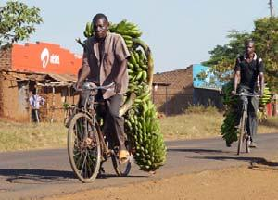
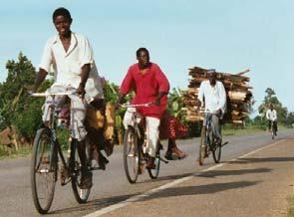
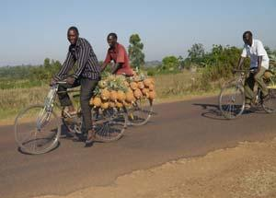
Bicyclists prefer the smooth carriageway to the rougher shoulder, unless traffic is heavy

New hard shoulders start relatively smooth, but they become rougher due to erosion, loose stones from the carriageway and deformations (heavy vehicles, local subsidence). There may also be encroachment by vegetation and various physical obstructions. As the road shoulder ages, unless it is well maintained, it becomes increasingly unfriendly for pedestrians and bicyclists, making the carriageway preferable, unless there is heavy traffic.

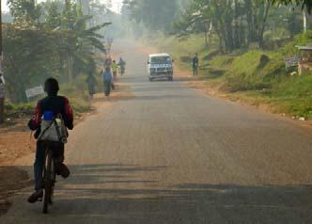
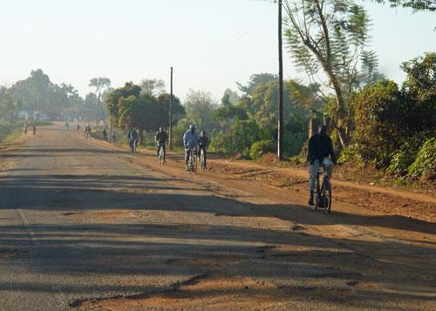
Damaged or inaccessible road pavements affecting motor traffic, bicycles and pedestrians
Left: Sandy runoff encroaching a road. Right: Off-road pedestrian footway formed to avoid dangerous vehicles

The bridge standards on the modern highways have a section designated for pedestrians that allows continuity with the hard shoulder provision. A kerb protects the lane and there is a safety fence adjacent to the valley.

The standard design of highway provides for consistent width of hard shoulder along its length, irrespective of the envisaged pedestrian and bicycle traffic. Only within trading centres, does the shoulder width increase. Here a wide and generally undefined area of additional carriageway or hard shoulder is provided to allow vehicles to stop and to load. Frequently vendors mill around vehicles and may encroach on the extended shoulder. There are also some clearly defined bus stops situated on the extended shoulder.
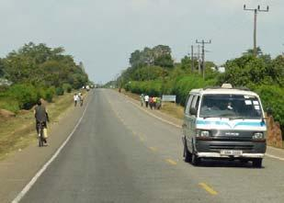
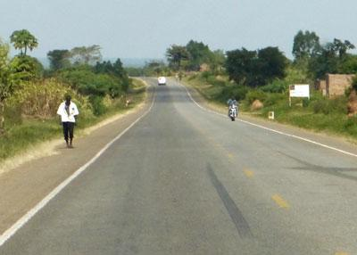

National road shoulders are currently of a consistent width irrespective of the anticipated NMT demand
The standard width of hard shoulder means that while it is adequate for the remoter sections of the road, it tends to become filled with pedestrians and cyclists close (1-2 km) to trading centres. This creates a hazard for the motorists and the pedestrians and cyclists, particularly if motorcycles also try to use the shoulders at these places.

2.5. District and Community Access roads
District and community roads have no provision for pedestrians and bicyclists. This is generally reasonable for low traffic volumes (eg, fewer than 30 vehicles an hour), when
motorists, pedestrians and bicyclist can share the road effectively. NMT move to the side of the carriageway when a vehicle approaches. It becomes more difficult if the motorists drive at excessive speeds and/or road traffic increases, particularly if the road is dusty.

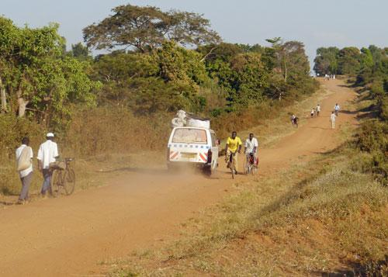
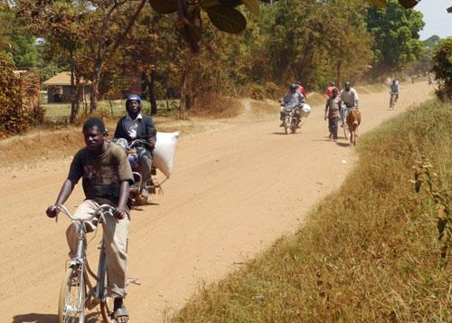
Road sharing is practicable at low levels of traffic, provided all road users are considerate

As with national roads, the main problems are steep cambers and inadequate maintenance. On puddled, muddy and eroded roads, motorists seek out optimum routes, which may take them closer to cyclists and pedestrians.

2.6. Urban roads
There is a wide range of urban roads in Uganda. Some have pedestrian footways on both sides while others have no pedestrian facilities at all. Unlike rural highways, with designated shoulders for use by bicycles and pedestrians, most urban roads have no infrastructure or designated lanes for bicycles. Recent standards for urban roads require side drains to be covered, but many roads have open side drains creating safety hazards in crowded urban streets, particular on unlit roads after dark.

The Kenya Urban Roads Authority has recently adopted a policy that all new road investments should include dedicated bicycle lanes and footways. This is being implemented. The policy will eventually result in safe bicycling routes in Nairobi and other towns in Kenya.

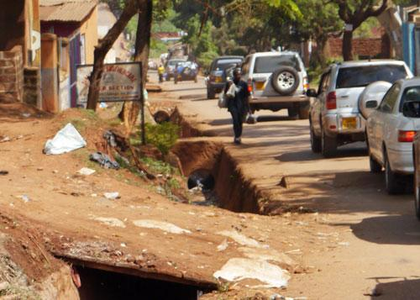
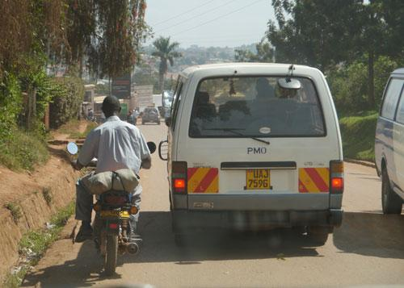
Some roads in Kampala that are risky for NMT as they are narrow with open drains and no footways

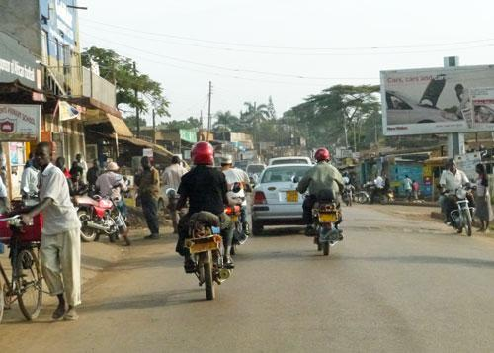
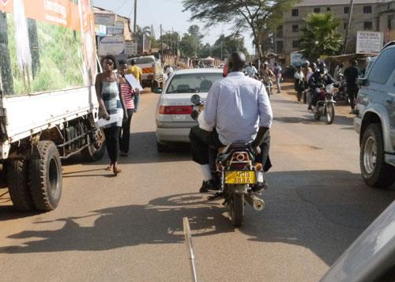
Chaotic roads providing problems for pedestrians in Kampala

Urban roads in Uganda are often chaotic, due to obstructed pedestrian infrastructure, parked vehicles, loading vehicles, taxis and motorcycles plying for trade, street vendors and pedestrians crossing everywhere. Most of these issues could be resolved through improved management and enforcement of existing regulations.

2.7. Rural footpaths and trails
Roads are vital to the people and economy of Uganda, and the Government allocates a significant part of the national budget to road construction and rehabilitation. Less attention is given to footpaths, even though these are also extremely important. Most rural people have to travel along footpaths before they can access roads, public transport, markets, health facilities, education, employment, civic responsibilities and social activities. The paths range in use and significance from small paths running to and from individual houses and fields, to
major paths and trials that link whole communities to the rest of Uganda. Some of these paths and trails are used by non-motorised transport, such as bicycles, wheelbarrows and pack donkeys. Increasing, they are also used by motorcycles, and communities often widen and engineer them to allow occasional access by 4-wheel motor vehicles.

The majority of Ugandans use rural footpaths as pedestrians on a daily basis. The Rural Accessibility Index (RAI) measures the percentage of the rural population that live more than two kilometres from an all-season motorable road. The RAI figure for Uganda has not yet been formally estimated from survey data. A World Bank (2007) model estimated it to be 27% based on data from 2003. This figure appears low compared with more recent calculations from other countries. If it were 50%, it would mean that half of the 26 million rural people in Uganda have to walk at least two kilometres along footpaths to reach a road, a journey of at least twenty minutes each way. Some of these thirteen million people would be walking much more, and some of the remaining thirteen million people would be walking over one kilometre. This illustrates the immense importance to the people of Uganda of rural footpaths.

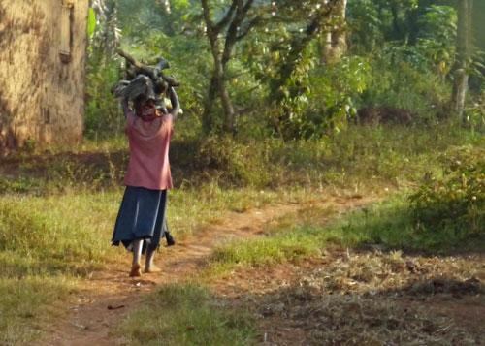
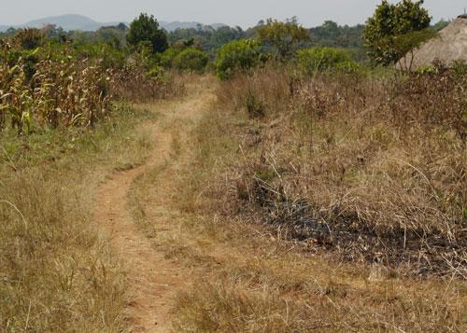
Rural footpaths: most people in Uganda use footpaths on a daily basis

While footpaths are a part of daily life for most people, many vulnerable people are constrained by them. Elderly people who are frail, the sick and physically disabled people can only travel if people are prepared to support or carry them.

The condition of footpaths and trails is highly variable, and may change on a daily basis, particularly in rainy periods. As water sources are low in the local topography, paths descending to them for water collection are often steep and slippery. Very many accidents occur every year, but there are no national statistics on these.

Most rural footpaths in Uganda have developed spontaneously through usage, and are not engineered. The design principles for rural paths are very similar to those for rural roads. The key is water management (drainage systems) and preventative maintenance (just like roads). Issues of alignment, gradient and water crossings (cross drains, stepping stones, culverts, bridges) are particularly important for people carrying loads, bicyclists and vulnerable pedestrians (elderly, disabled, young children). A sensible amount of investment in paths depends on their importance (traffic, strategic prioritisation) and the prevailing environment (like roads). However, the sheer number and total length of paths means that local systems of construction and management need to be developed.

Road schemes should be aware of the pattern of footpaths in the road catchment area. If the paths are inadequate, schemes should be developed whereby local stakeholders can take responsibility for developing accessible footpaths. In many cultural contexts, it is difficult to create the required combination of local enthusiasm, cooperation, good management and
resource allocation. However, the need is often great, and the best offices of local
government, traditional authorities, religious establishments and NGOs need to be sought out to develop appropriate footpath infrastructure.

2.8. Urban footways
In Kampala and all towns in Uganda, there has been some provision of footways, although these are often in poor condition, with irregularities, holes and obstructions. Some urban roads have no footways, and pedestrians are forced to share the road with traffic. However, one of the biggest problems is that many footways are obstructed, forcing pedestrians to squeeze past the obstructions or go onto the road. Footways are frequently occupied by the traders who own shops, by other sellers on the pavement, by parked cars, by motorcyclists and by informal businesses that have established themselves using the pedestrian infrastructure.

The central area of Jinja used to have generous footways, designed to be comfortable for pedestrians (albeit not to Universal Design principles). Now, the combination of inadequate maintenance over the years and encroachment by traders and vehicles means that pedestrians either struggle to make their way between obstructions, or walk in the road. The same problems occur in Kampala and are repeated throughout the country.

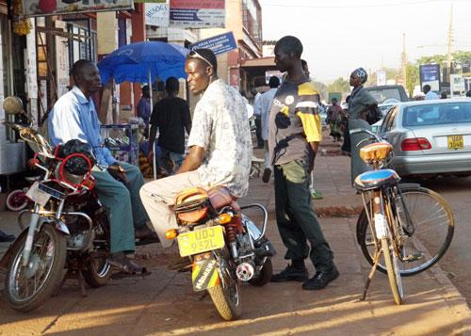
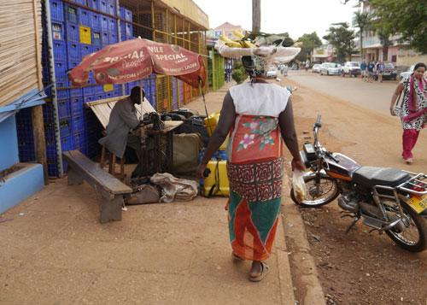
Footways in Jinja congested by boda-bodas, traders and small businesses

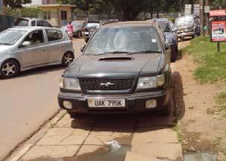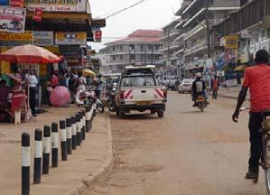

Kampala footway obstructed by parked cars (left) and footways protected by bollards in Masaka (right)

Where there is a significant risk that motor vehicles will mount the footway, in order to park or to undertake a traffic queue, footways should be protected by bollards. It is very difficult to physically prevent motorcycles from entering footways. Any infrastructure that seriously restricts motorcycle access would also be inconvenient for people, particularly those with disabilities. Therefore keeping pedestrian infrastructure free from motorcycle must depend on clear and consistent enforcement, so that motorcyclists will not risk being caught.

In Kampala, several recently-constructed footways have been taken over by informal businesses. These include some vehicle maintenance facilities that now use the whole width of the walkway as their workshop, causing pedestrians to walk in the road. Other NMT facilities have been taken over by parked vehicles and by traders.

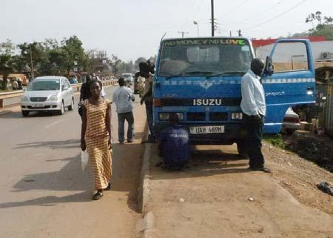
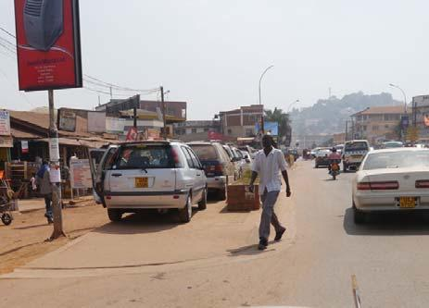
Good quality and relatively new pedestrian infrastructure in Kampala occupied by motor vehicles

Properties with driveways connecting to the road sometimes obstruct the walkway with small walls, bollards or signs, designed to emphasise their driveway, at the expense of the footway.
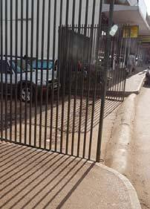
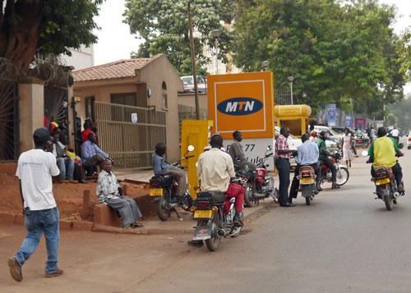

Examples of Kampala footways being obstructed by driveway infrastructure

Authorities not only have the power to clear obstructions, they can also require property owners to construct and maintain urban footways adjacent to their properties. Enforcement is currently low, although there was a campaign to clear traders from some footways in Kampala in 2010 and again in 2012.

2.9 Pedestrian Crossings
There are very few pedestrian crossings in Uganda that have been both well-designed and maintained in good condition. Very few motorists voluntarily stop for pedestrians to allow them to cross. Few pedestrians bother to cross at designated pedestrian crossings. A high proportion of pedestrian crossings on national roads are more or less invisible. This has contributed to a downwards spiral of poor behaviour by drivers and pedestrians that has led most people to ignore pedestrian crossings. This is tragic because pedestrian crossings should be fundamental to the safety of everyone in Uganda.
The standards for pedestrian crossings on national roads are appropriate, with signs, humps, rumble-strips and stop lines. However, few, if any, actually conform to this Uganda design standard. Furthermore, there are no guidelines on how to position the crossings with relation to other infrastructure and pedestrian needs. Many pedestrian crossings seemed to have been placed without thought for the actual needs of pedestrians (where they want to cross). Some are in dangerous or unsafe places, including directly between two bus lay-bys, leading to the carriageway of a joining road and ending in a culvert or drain.

In some towns and trading centres, pedestrian crossings have pedestrian islands, allowing the pedestrians to safely cross one lane of traffic before having to negotiate the second. A small number have ‘Universal Design’ attributes including kerb ramps and islands without kerbs at the pedestrian footway.

In Kampala and other towns, there are few traffic lights designed to allow the safe crossing of roads by pedestrians, with pedestrian lights to inform pedestrians when it is safe to cross. In contrast, there are numerous traffic lights with pedestrian phasing and pedestrian lights in Nairobi. In January 2012, one set of traffic lights in Kampala had very dangerous phasing with the pedestrian green showing at the same time as it was green for the traffic in the lane being crossed.

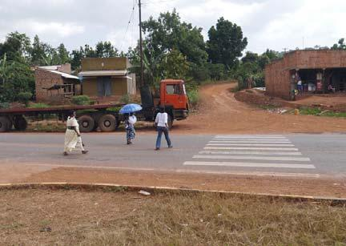
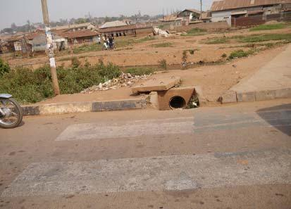

Pedestrian crossings in poor locations relative to the road infrastructure
Left: Pedestrian crossing aligned with an intersection (with poor pedestrian behaviour).
Right: New pedestrian crossing on northern bypass aligned with a culvert.

Pedestrian crossings are irrelevant and even dangerous unless pedestrians and motorists have mutual respect and are prepared to behave reasonably. Pedestrians have right of way on pedestrian crossings, but must be patient should not try to assert priority over fast moving vehicles or create an unbroken stream of pedestrians. Motor vehicles should be prepared to
stop to allow pedestrians a safe crossing. Bicyclists and motorcyclists on the road should not enter the zebra areas while a pedestrian is crossing. Cyclists using the crossing should walk. There is need for education of motorists, pedestrians and cyclists. There is also need for enforcement.

Recent experience in Nairobi has shown that after a laissez-faire period of declining respect for pedestrian crossings, a targeted and consistent programme of publicity, education and enforcement can lead to very noticeable improvements in both driver and pedestrian behaviour within a matter of months. Success was achieved through awareness-raising publicity combined with consistent enforcement by council traffic police (‘ascari’) against offending motorists and jay-walking pedestrians. As a direct result, in the area of Nairobi with the enforcement, drivers looked out for pedestrians and voluntarily stopped for them, while pedestrians crossed more confidently. To date, the campaign has been localised and driver and pedestrian behaviour away from the enforcement area, remains poor.

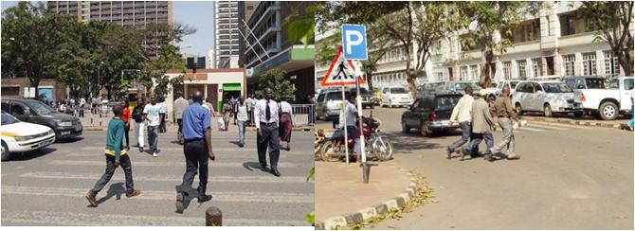

Examples of pedestrian crossings and influence of enforcement
Left: Nairobi, people walking naturally and confidently on the crossing, with cars stopping
Right: Kampala, people walking rapidly and with caution away from a nearby crossing

2.10. | Cycleways
The provision of dedicated lanes for bicyclists is a fundamental aspect of NMT policy. Very many countries provide some dedicated bicycle infrastructure. These include all European and North American countries, as well as most countries in Asia and Latin America. Many countries in Africa, including Burkina Faso, Kenya, Mali and South Africa have some dedicated bicycle ways. In Ouagadougou in Burkina Faso, there are dedicated lanes that are used by bicycles and light motorcycles. These have specially phased traffic signals at junctions. There are no dedicated cycleways or cycle lanes in Uganda.

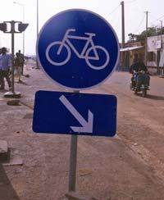
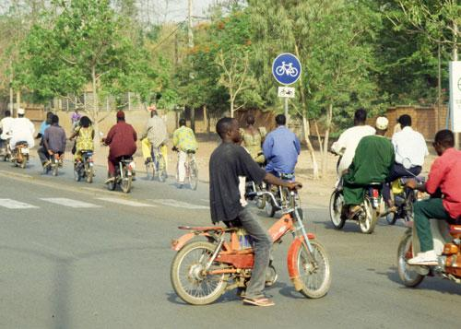
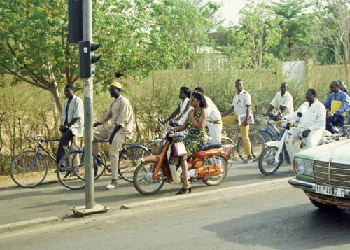
Cycle lane provision in some West African countries
Left: Bicycle lane sign in Mali.
Centre and right: Bicycle and moped lane with dedicated traffic signals in Ouagadougou, Burkina Faso The

The Kenya Urban Roads Authority (KURA) has been established to be responsible for the planning, construction and maintenances of all urban roads, including those of Nairobi and other large towns. KURA has adopted the policy that all new roads it constructs should have cycleways and footways. It is currently implementing this policy and has many on-going projects in Nairobi and elsewhere.

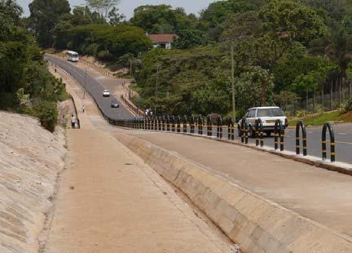
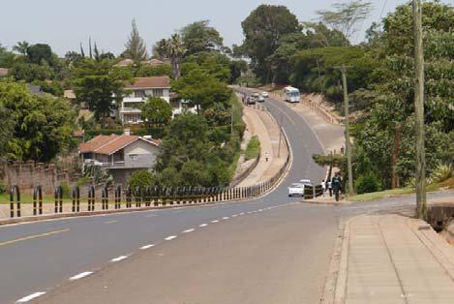
A new cycleway in Nairobi, Kenya, built by Kenya Urban Roads Authority (KURA). It is KURA policy that all new roads it constructs should have cycleways and footways.

In addition to cycle lanes along existing roads, many countries also plan for cycle routes. Some of these are ‘green routes’ that generally avoid the road network and comprise dedicated cycleways, free from other traffic. These may be for recreational use, and may make use of small tracks, bypassed roads, old railway lines, canal tow paths or covered waterways. Many towns and cities have designated cycle routes, often running between residential locations and places of work. For example, many European and Latin American cities have clearly marked routes designed to encourage safe bicycling. In the first instance, these may simply be designated roads, with clear cycle lanes. However, they may be gradually upgraded to increase bicycle flow and safety, with priority given to bicyclists at junctions, and the addition of improved infrastructure at intersections (dedicated bicycle traffic lights, cycle subways or cycle flyover bridges).

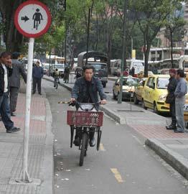
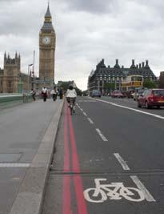
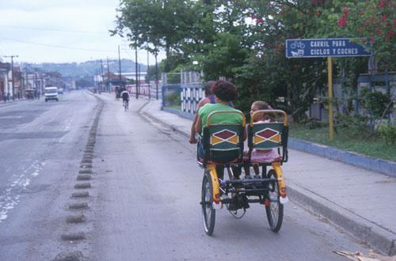
Designated cycle lanes
Left: Protected cycle lane in Bogota, Colombia
Centre: Protected IMT lane for carts, tricycles and bicycles in Cuba
Right: Clearly designated but unprotected cycle lane, London

2.11. | Footbridges
A small number of footbridges have been built in recent years to cross busy roads, mainly in urban areas. However, a much larger number have been constructed from historical times to the present day to allow people to cross streams, gullies and small rivers, often in remote areas.

The urban footbridges have been primarily designed to reduce accidents by providing a safe means to crossing main roads. They have not been constructed to Universal Design principles and therefore most do not have ramps for use by bicyclists or users of push-chairs, wheelchairs or disabled tricycles. As in many countries in Africa and the world, very many pedestrians (often the majority) do not use the footbridges, which require time and energy to climb and descend. Instead, they risk the traffic by crossing the road.

Where it is practical to stop the traffic regularly, level pedestrian crossings with islands and traffic signals are more convenient for pedestrians and offer greater protection for more people, than partly used footbridges. Under-road subways require less change in altitude for pedestrians and cyclists, but may provide problems of cleanliness, security and drainage. In busy urban areas, raised footways that not only cross roads but also have various consumer facilities can increase interest in using footbridges.

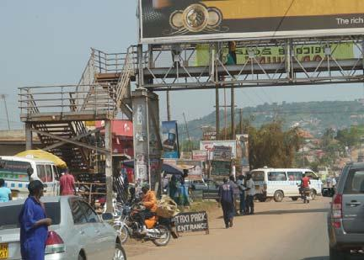
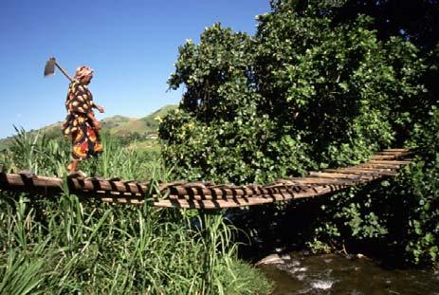
Footbridges
Left: Metal urban footbridge with steps. Right: Example of rural footbridge

On the Northern bypass of Kampala, greater pedestrian use could be made of the various road bridges that cross the carriageway(s). Providing easy access between the bypass and the bridges, through stairs and ramps up and down the embankments, could have created safe crossing places, at very low cost. It would have also reduced the erosion caused by people ascending and descending the embankments by informal pedestrian scrambles.
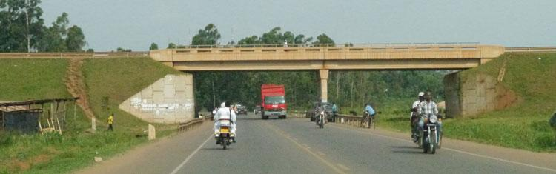
Road bridge over Kampala northern bypass
Note: there is no linking NMT infrastructure but eroded embankments form informal scrambling routes
The number and status of footbridges that cross over streams, rivers and ravines in rural areas does not appear to be well documented. These reduce accidents by stopping people falling into rivers, streams and valleys. They also provide crucial access to markets and services through trails and footpaths. Often they are the only means by which villagers can access roads, public transport and towns. While some mountainous countries, including Lesotho and Nepal have special footbridge departments within the transport ministries, Uganda does not have such specialisation.

2.12. | Bicycle parking
There is very little provision for the safe parking of bicycles in Uganda. A small number of public buildings (such as the Post Office in Tororo) have been constructed with bicycle parking facilities. Similarly, some private sector buildings, such as BAT in Kampala and Bank of Baroda in Jinja have bicycle racks. Experience from other countries suggests that more people will use bicycles for journeys if they know there is safe bicycle parking at their destination. In some countries, including Burkina Faso, there are designated and supervised bicycle parking areas near markets and public buildings, with small, affordable fees collected by the attendant.

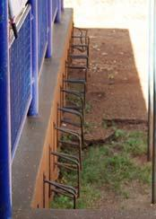
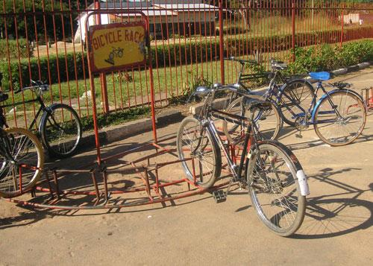
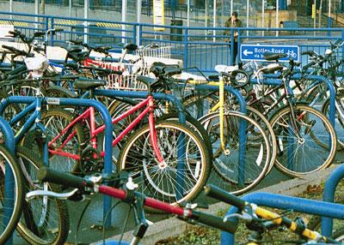
Bicycle racks. Bicycle stands offer better parking and security than front wheel racks
Left: front wheel racks in Tororo. Centre: front wheel racks in Zambia. Right Sheffield stands in UK

The old-fashioned front-wheel bicycle racks (as installed at Tororo Post Office, BAT in Kampala and Bank of Baroda in Jinja) are no longer considered appropriate due to poor security and the potential for wheel damage. Simple stands to which two bicycles can be locked are easy to install and use and are very effective. Although a variety of shapes is possible, an n-shape anchored in concrete (sometimes known as Sheffield stands) are relatively strong, cheap to provide and require little supervision or maintenance. The provision of a horizontal bar across the n (giving an A-shape) provides additional support for small bicycles, but increases the cost.

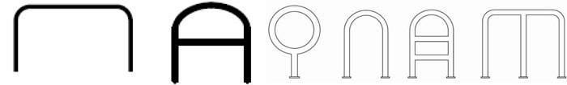
Some shapes of fixed bicycle stands
The simple but effective Sheffield stand is on the far left

2.13. Pedestrianisation, one-way traffic and NMT schemes
At the Pan Africa Bicycle Conference held in Jinja in 2001, the ‘Jinja declaration’ advocated the promotion of non-motorised transport and the development of national master plans to ensure there was appropriate and safe infrastructure for bicyclists and pedestrians. Following this, discussions were started for a NMT Master Plan for Jinja. International funding and support was available from the German agency GTZ, the Dutch Interface for Cycling (I-ce), SUSTRAN (Sustainable Transport Network hosted by UN Habitat) and the Institute for Transportation and Development Policy, Europe (ITDP Europe). FABIO was instrumental in promoting this at a national level. From 2002 to 2004 there were a large number of planning meetings, discussions and workshops, culminating in a three-day strategic planning workshop attended by local MPs, local and national government representatives, international NMT specialists and other stakeholders. A master plan was developed, involving bicycle lanes, bicycle parking, cleared footways, pedestrian crossings, one-way streets and appropriate signage (Heyen-Perschon, 2004). However, the proposed master plan was not accepted by the Jinja council. This was partly because the proposed bicycle lanes would have removed car parking places which were a source of income.

The proponents of the rejected Jinja scheme contacted the Iganga Town Council who agreed to work on an NMT master plan for Iganga in 2005. The existing situation was studied in detail. NMT plans were drawn up and the Town Council seemed pleased to approve them. They included a roundabout, traffic islands, pedestrian crossings, bicycle parking, one-way streets for motor vehicles (to allow more room for pedestrians and bicycles) and appropriate signage. There were participative processes to ensure wide endorsement and compliance with the new regulations and initial reactions seemed positive. However there were some vocal disagreements, with a petrol station fearing reduced sales and some stores being unhappy with the one-way system. The national roads department argued that the street that linked the council offices to the main Kampala road was a national road. Because of this, Iganga Town Council did not have the right to make it into a one-way street. These disagreements were compounded by various administrative problems and delayed payments from the donors, so that the pedestrian crossings and shaded bicycle parking facility were never constructed. The mounting problems caused people to abandon the master plan (Heyen-Perschon, 2007). Now little remains apart from some traffic islands and a few vestigial signs to what used to be the one-way street.

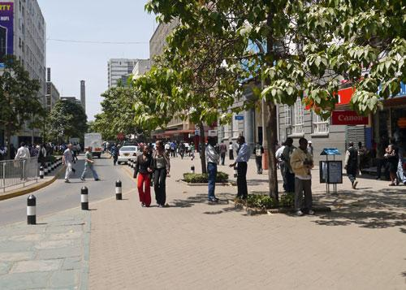
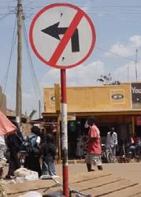
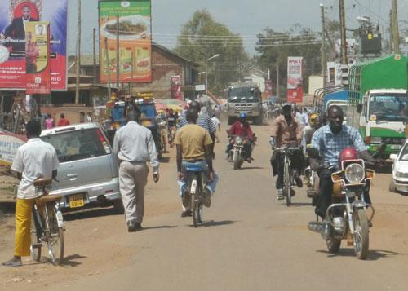
Pedestrianisation and one-way schemes in Nairobi and Iganga
Left: Part pedestrianised one-way scheme in Nairobi. Centre and right: vestiges of the NMT scheme in Iganga

In Kenya, the Nairobi City Council has been promoting pedestrian facilities, but not bicycle lanes. In addition to improved enforcement of pedestrian crossings, the council has made some streets one way, and others have been fully or partly closed to traffic to increase the space available to pedestrians. Making streets one-way, allows greater space for pedestrian footways and this should increase safety. However, altering traffic flow in one street can influence the traffic flows in other streets, and the consequences of this need to be planned for. On the whole, reaction has been good. Shopkeepers, notably those relating to leisure (restaurants, travel agencies, high-value consumer items), have found that sales have increased as pedestrians are more relaxed. However, pedestrianisation does reduce the availability of street parking spaces (and income from parking fees).

In recent decades, the majority of towns in Europe have introduced some forms of pedestrianisation in their town centres. Through traffic is banned, but bicycles are often permitted to ‘share the road’ with pedestrians. Some towns have combined pedestrianisation with ‘park and ride’ facilities, with efficient and regular public transport between car parks and the pedestrianised shopping roads. The pedestrianised areas provide traffic-free environments, and are generally popular with both shoppers and traders, provided there are appropriate facilities for parking bicycles and cars and/or good public transport access.
In suburban areas world-wide, including Kampala and most African capitals, an alternative pedestrian environment is provided by the shopping mall. These are purpose-built pedestrian shopping areas that are often surrounded by car parks (which should also have adequate bicycle parking facilities). Modern business parks often offer similar combinations of pedestrian facilities, parking and public transport connections.

The lessons for Uganda from Jinja, Iganga, Nairobi, European cities and shopping malls may be that well-planned pedestrianisation should improve safety and create a positive pedestrian environment that benefits both traders and pedestrians. However, such schemes do require very careful planning to ensure that all key stakeholders are consulted, that any disadvantages are known in advance and that adequate arrangements are made for parking, altered traffic flows and accessible public transport.

2.14. | Bus rapid transit (BRT)
While there are no bus rapid transit (BRT) systems in use in Uganda, these are being planned for Kampala. The central concept of BRT is the integration of transport modes. The emphasis is on high-capacity buses running on a small number of key routes (or lines) that are ‘fed by’ and ‘deliver to’ appropriate NMT infrastructure and facilities. The aim is for as many people as possible to reach the bus stops (stations) by walking or bicycling, and to also use walking or bicycling to reach their final destinations. Some of the BRT passengers living away from the BRT lines will be brought to the bus stops (stations) by feeder transport (minibuses, taxis).

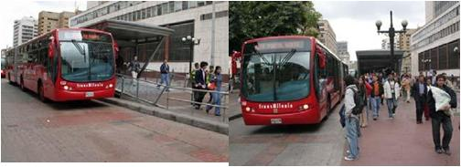
‘TransMilenio’ bus rapid transit system (BRT) in Bogota, Colombia

For the BRT to meet its environmental and de-congestion aspirations, the planning of the pedestrian and bicycling facilities should be as important as developing the BRT lines. In BRT systems worldwide, Universal Design principles are the norm for the buses, the bus stops (stations) and the surrounding pedestrian infrastructure. Similarly, adequate cycle parking is provided at all bus stops (stations) and in many countries there are systems for electronically controlled bicycle hire at all BRT stages and terminals.
Planning for the needs of pedestrians and bicyclists will be an integral part of all BRT schemes in Uganda. All BRT stops (stations) must incorporate Universal Design for easy pedestrian access and provide adequate bicycle parking facilities. In addition, integral to BRT planning and implementation will be the development of suitable medium-distance pedestrian and bicycle routes, with appropriate infrastructure to allow easy NMT access to BRT stops and terminals. Government will ensure that design consultants for BRT schemes incorporate these principles.

2.15 Crosscutting issues
Gender
Men, woman, children and the elderly are all pedestrians. However most means of transport in Uganda are owned and operated by men. In eastern Uganda, many women ride bicycles, although issues of cost and gender relations generally make it easier for men to own and use bicycles. In western Uganda, some girls and women ride bicycles or use them to push loads (such as water). However, there are negative cultural traditions that inhibit women’s use of bicycles. These may prevent them from gaining the productive benefits that bicycles can offer (including greater efficiency of water transport).

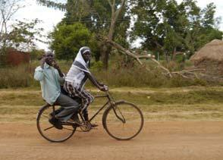
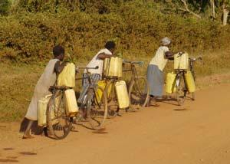
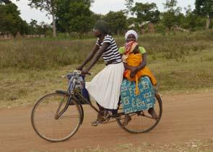
Women using bicycles for leisure, domestic water collection and accessing health care
Safety
Cyclists and pedestrians are the most vulnerable of road users, with no physical protection and being at the bottom of the self-ordained ‘hierarchy of rights’ practised by motor transport. In 2010, about 3000 people were killed in road accidents in Uganda, of which about 40% were pedestrians and about 10% were bicyclists. There were ten times more deaths of pedestrians and bicyclists than there were drivers killed.

The risks to pedestrians and bicyclists are increased by:
• Poor, driver behaviour (selfish, aggressive, risky, fast, intoxicated)
• Poorly maintained roads (drivers changing correct trajectories to find smoother
routes)
• Poorly maintained shoulders (rough, eroded, vegetation encroachment)
• Inadequate infrastructure (footways, cycle lanes, islands, pedestrian crossings)
• Obstructed infrastructure (footways and shoulders blocked by parked cars, materials,
traders, motorcycles, signs, etc)
• Unreasonable behaviour by bicyclists and pedestrians (crossing roads, ignoring lane
conventions).

Most of these safety issues can be improved by better enforcement and resource management, as well as by education, sensitisation, publicity and related well-publicised sanctions against offenders. There is also need for new NMT infrastructure (footways, designated lanes, crossings, islands) in areas of particular danger and concern.

One of the most dangerous times is early evening, with fading light and inadequate street lighting when pedestrians and cyclists are difficult to see, particularly if they are in dark clothes. The problem is often made worse by dust or rain, obstructed NMT infrastructure and badly adjusted headlamps that move erratically vertically and horizontally due to potholes. The use of reflectors, reflective vests and light-coloured clothing greatly increase the visibility of bicyclists and pedestrians.

The use of bicycle helmets provides some protection in case of accident. However, unlike crash helmets for motorcycles, most countries do not make them compulsory. This is partly because they are expensive for poor people and the inconvenience of travelling with a helmet may discourage bicycling when countries wish to encourage it. Also, helmet use can adversely influence the behaviour of both bicyclists and motorists, who may wrongly assume the bicyclists are no longer vulnerable.

The Government has recently developed a new Road Safety Policy. This highlights the particular safety needs of pedestrians and bicyclists. The Government is committed to establishing a National Road Safety Authority (NRSA) and a Multi Sectoral Transport Regulatory Authority (MTRA). The NRSA will be responsible for road safety management, and coordination, whereas MTRA will deal with other regulatory and safety aspects. The NRSA will have a key role in improving the safety of pedestrians and bicyclists.

Environment

Walking and bicycling use renewable energy, and in moderation are good for people’s health. Most Ugandans use walking and bicycling as a necessity. A small but growing minority of affluent Ugandans would benefit from reducing their use of motor transport in order to engage in more walking and/or bicycling as part of a healthier lifestyle. Such a change would have clear environmental benefits, with less congestion and pollution.

Walking and bicycling require relatively little infrastructure, and are highly resilient in the face of crises due to storms, fuel shortages, insecurity and local unrest. Climate change may increase the frequency of natural disasters. In post-disaster recovery, bicycles and walking are often crucial for initial evacuation and distribution of relief.

3. Non motorised transport types
3.1. Bicycle models
Although the bicycle is extremely important in Uganda, there is little authoritative information concerning the national situation. A small but important study of the bicycle sector in Uganda was carried out in collaboration with FABIO in 2003 (Bos, Koster and Mulder, 2003), but this has not been followed up. There are numerous small NGO initiatives to facilitate bicycle use in Uganda. Some of these involve national and international NGOs importing containers of bicycles (often second hand), developing workshops and assisting with credit schemes. Tens of thousands of bicycles have been acquired in this way. There are very many case histories available illustrating the benefits of bicycles to individuals, families and communities. Studies on informal cross border trade have also highlighted the importance of bicycles in transporting Uganda’s small-scale imports and exports. In September 2011, the Ministry of Health reported that 110,000 bicycles would be distributed to village health teams (All-Africa, 2011).

In 2003, it was estimated that about 200,000 bicycles a year were being sold in Uganda, and had been since the 1990s (Bos et al, 2003). Since bicycles are kept going for very many years, it could be estimated that the national fleet is about 3 million, or one for every two households nationally. Naturally, there are big differences, with Busia having more than two bicycles per household, and ownership in Kampala being quite low. In some other countries in Africa, there is an average of at least one bicycle per household (eg, Burkina Faso) while in some Asian and European countries, ownership approaches one bicycle per individual.

Most bicycles are of a roadster design that has changed little since the 1950s. They do not have gears, but have rod brakes and crossbars. These are generally robust and are well adapted to having a rear load-carrier. Tens of millions of similar bicycles have been manufactured and are in daily use in India and China. However, such designs have been largely replaced in Europe and the Americas. The market leader is Roadmaster whose Indian parent company established a local assembly and manufacturing plant in Kampala in 1995. Roadmaster had a 50-60% market share in 2003. Other Indian manufactured brands include Hero and Jupiter. The main Chinese brand of traditional roadster bicycle is Phoenix. Imported Chinese mountain bicycles with gears are still quite rare, but may become increasingly common, particularly with younger people in urban areas.

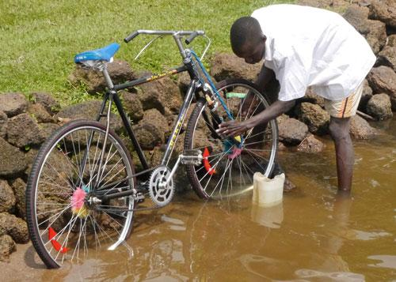
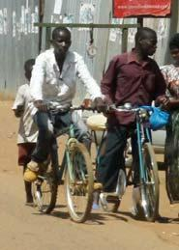
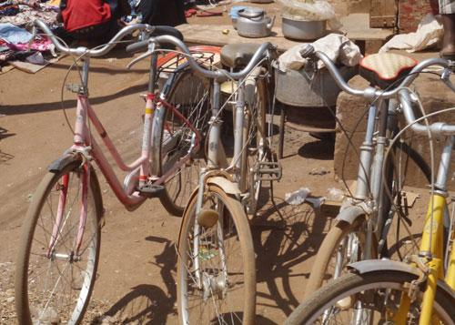
Some bicycle models in Uganda
Left: Common ‘roadster’ bicycle. Centre: Mountain bicycle. Right: Mixed (ladies) design.

Uganda, like many other countries in Africa, faces difficult market conditions for bicycles. There is a very high expressed demand, particularly in rural areas, but because bicycles are expensive relative to incomes, the economic demand is fairly static. Most bicycle components
are manufactured in India and China, and it is difficult or impossible for African countries to achieve the economies of scale and low overall labour costs of China and India. Bicycles are generally distributed in cartons of partially assembled bicycles (generally three to five in one box) and are assembled at the point of sale. Even in Uganda, Roadmaster sells its bicycles in this way, for ease of transportation to the retailers around the country.

When importing bicycles from China, the difference in cost between pre-assembled bicycles in cartons and the same components in a non-assembled state is less than one dollar (USD) per bicycle. There are some savings in transport costs as 1000 bicycles in component form take up less space than a similar number of part-assembled bicycles in cartons. Since Uganda faces high freight charges from Mombasa, the lower transport costs of the components helps to explain the survival of the Roadmaster factory. Many other bicycle ‘manufacturing’ facilities in Africa have been forced to close.

Some African countries have tried to protect local bicycle manufacturing/assembly businesses through duties on imported bicycles. This keeps bicycle prices high, and stops people buying them for use in their lives and livelihoods. Increasing bicycle use is important for the national economy. There would be major economic benefits to a country if there were an increase of 10,000 or 100,000 more people using bicycles for economic purposes. Such an increase would create many supporting jobs in the supply chains and maintenance facilities. The economic implications of increased bicycle use are likely to far outweigh the benefits of retaining 100 jobs in a protected local factory that would never be able to complete with the manufactured output of China and India.

3.2 Bicycle design issues
The common roadster bicycles in Uganda were designed for use by men and have crossbars. Women, children and men in robes may have some difficulty in mounting and riding such bicycles. The problems are not absolute, and most women bicyclists in Uganda ride bicycles with crossbars (partly because many women ride bicycles owned by men). In Europe and North America, the conventional ‘ladies’ bicycles do not have crossbars. Some bicycles of this type have been imported into Uganda (including second hand bicycles from northern countries). FABIO found that women did not appreciate these as they wanted strong bicycles they could use for carrying water and other goods. They felt that roadster bicycles with crossbars were more suitable for transport work. In some countries, notably Vietnam, most bicycles are of a ‘mixed’ type, with a reinforced frame that does not have a crossbar. These can be easily cycled by anyone (but they lack the load-carrying potential offered by the crossbar). Many modern bicycle designs also count as ‘mixed’, having no crossbar and being easily mounted by most people. A number of these are used around Iganga, mainly by men. In general, it is best if people can choose the design that suits them. If there is a demand for mixed bicycles (by women or men), there may be a need to encourage the stocking and purchasing of them in order that a critical mass of such bicycles is established to ‘mainstream’ them into people’s choices.

The people of Uganda, as in other African countries, are beginning to face the choice between the traditional roadster bicycles (black, rod-brakes, carriers, no gears, old-fashioned) and mountain bicycles (colourful, fashionable, modern, with cable brakes and gears). There are relatively few mountain bicycles in Uganda at the moment, but exports from China of these two contrasting designs are of similar cost. The present situation in Madagascar illustrates the dilemma well, and with irony due to its mountainous topography. In the towns around the coast, young people (mainly, but not entirely, male) are buying mountain bicycles and using them for personal transport around the relatively flat towns, where gears are of little advantage. In the rural mountainous areas, men continue to use robust roadster bicycles without gears but with rear carriers to enable them to travel and gain livelihoods through transporting goods. This example is complemented by another from Zambia, which has a very similar bicycle situation to Uganda (landlocked country, local Indian facility manufacturing/assembling robust roadster bicycles). A bicycle mechanic in a rural market town reported that fewer than 10% of bicycles in that area had gears, but over 50% of his income came from sorting out bicycle gear problems (Starkey, 2007; Starkey, 2008).

FABIO, like several other organisations in Africa, has had experience in working with Institute for Transportation and Development Policy (ITDP) to promote the California bicycle. This bicycle has gears and has been designed with Africa in mind to be modern, efficient, reliable and appealing. Through appropriate design and durable components, it is intended that the lifetime cost of ownership should be affordable. However, the uptake in Uganda and elsewhere has been disappointing, even at a subsidised price. While there is a small demand for ‘up-market’ bicycles, the main demand in Uganda appears to be for low cost bicycles (highest priority) that are robust and easy to maintain.

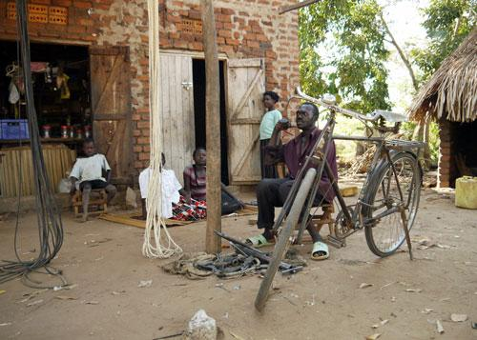
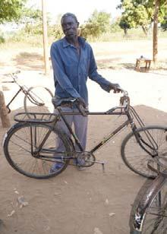
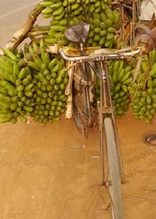
Rural bicycle mechanic and examples of bicycle condition
Left: rural bicycle mechanic located by small store selling parts
Centre and right: bicycles without front brakes or pedals (which is quite a common condition)

3.3 Bicycle safety, maintenance and cost issues
Most bicycles lack the basic safety equipment of adequate reflectors, bells and lights. While lights and their batteries can seem expensive to low-income people, reflectors are extremely cheap. A valuable road-safety initiative could involve the supply and fitting of front and rear reflectors at markets and places frequented by bicyclists. This could be undertaken by the private sector, perhaps in the context of advertising soft drinks.

During the field visits associated with this assignment, the problems of maintenance were all too evident, as were the solutions. A large number of bicycles have no front brake blocks and badly damaged and worn tyres. A surprising number have no pedals (just the axle around which the pedal should rotate). The owners acknowledged that the spare parts were available as were the local mechanics to carry out the work for a reasonable price. The problems were entirely economic. The spares and repairs cost money, but the bicycle could still be used without them. The owners were waiting for sufficient available resources for the repairs. The affordability of bicycles and their maintenance is absolutely crucial to most bicycle users in Uganda.

Bicycles are taxed in various ways, through import tax, withholding tax, import commission and Value Added Tax (VAT). Together these come to about 30%, with the main tax being VAT. Some other countries, including Madagascar and Kenya, have exempted bicycles from import duties and VAT. It is argued that most bicycles are not used as luxury items, but are more like ‘tools of the trade’ that enable people to be more productive in earning their livelihoods. By lowering taxes, these governments anticipate increasing bicycle ownership and use that will lead to greater economic activity and ultimately to greater tax revenue for the governments. Given that the high cost of bicycles is the main barrier to ownership, reducing taxes is likely to increase bicycle ownership in Uganda, with resulting benefits for the economy as a whole.

3.4 Tricycles and bicycle trailers
In many countries of the world, including Asia, Latin America and Europe, human-powered tricycles are used for passenger transport (cycle rickshaws) and freight. They are mainly used in urban and peri-urban areas as they operate best on good infrastructure. Bicycle trailers are also used for passengers and freight transport, but only at a fraction of the level of tricycle use. In many cities, including London, human-powered tricycles provide taxi services that are both more comfortable and safer than boda-boda bicycles.

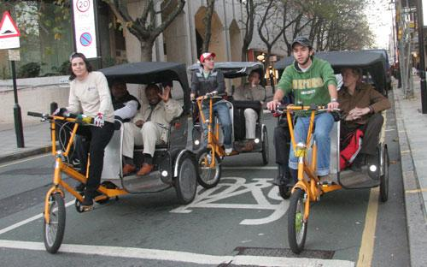
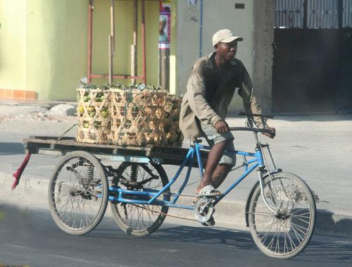
Freight tricycle in Tanzania (left) and passenger rickshaws in London (right)

In Tanzania, a local businessman introduced freight-carrying tricycles in 1990. He imported components from China and established a small manufacturing business. By 2003 there were about 6000 in use and there are probably about 10,000 working tricycles in 2012. They are mainly used for deliveries and small freight distribution in Dar es Salaam and a few other towns.

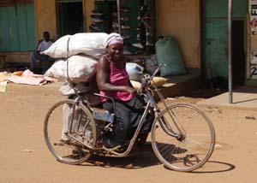
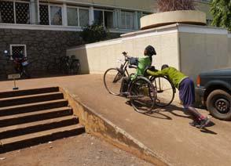
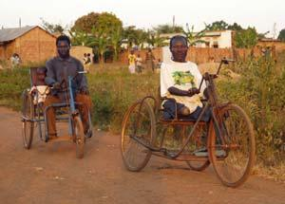
Hand-operated tricycles providing livelihoods and access to services for disabled people
Left: Woman boda-boda operator in Busia; Centre: Woman entrepreneur visiting council offices in Jinja.
Right: Rural men using tricycles to access health care and work options.

In Uganda, the main use of tricycles is for disabled people. The locally-made tricycles have rotating handles rather than pedals for propulsion. People who cannot easily walk can use the tricycles for personal mobility and also for income generation. The tricycles enable disabled men and women to access work places, health facilities, social and administrative services and to develop businesses. Several operate as freight-carrying ‘boda-bodas’ at the border town of Busia. The empowering effect of such tricycles on disabled people is extremely high, and they are used in both urban and rural areas. They are much more robust and stable than wheel-chairs and with a degree of physical protection from all sides, they are more suited to use on footways or roads. In practice, there are few, if any, unobstructed footways in Uganda with consistent provision of kerb ramps, and so most tricycles are used on roads. Some rural people travel to town by taxi with their tricycles carried by the taxi for an additional 50% supplement on the normal passenger fare.

3.5. Other forms of non-motorised transport
This policy is focused on the major forms of non-motorised transport in Uganda, namely walking and bicycling. Other forms of non-motorised transport are also important in particular areas and to certain people. These include canoes and small boats on the many lakes and rivers of Uganda. They also include ox carts, donkey carts and pack donkeys. Handcarts and wheelbarrows are also forms of non-motorised transport as are wheelchairs and human-powered tricycles. All these forms of transport benefit from appropriate infrastructure, safety and welfare considerations, regulation and enforcement.

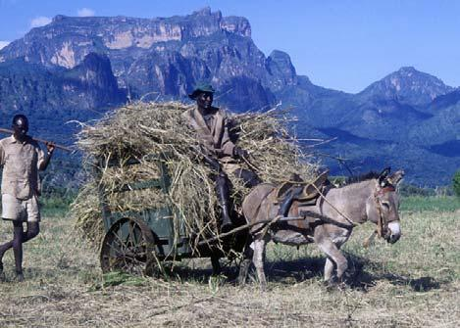
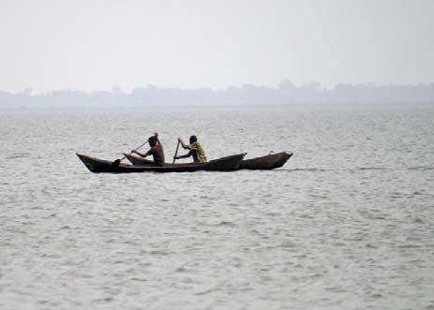

Locally-important forms of non-motorised transport in Uganda: Left: Donkey cart; Right: Canoes

4. Institutional and administrative issues
4.1. Regulation and enforcement
In general, the regulatory framework to facilitate and protect pedestrians and bicyclists is in place. The problem is generally weak enforcement. There are already regulations protecting NMT infrastructure from encroachment. What is lacking is consistent enforcement. Similarly, there is legislation to protect pedestrians and bicyclists from dangerous drivers, but enforcement is insufficiently robust to seriously discourage bad practices.

The Government recognises the contribution that motorcycle boda-bodas make to the overall public transport system in the country. They provide valuable passenger and freight transport services in rural and urban environments (mainly in towns and around trading centres). Many people use them and benefit from their services. However, other road users and some local authorities tend to be negative or ambivalent towards them. This is partly because they sometimes drive aggressively and are commonly overloaded. They can also be both dominating and anarchistic as they congregate around at road corners and fill up traffic lanes. They are taking over some of the transport market previously available to bicycle boda-bodas. With much slower speeds and lower carrying capacity, bicycle boda-bodas can only compete on price. Motorcycle boda-bodas are heavy, compared to bicycles and they travel at high speed. For the safety of pedestrians and bicyclists, motorcycles should not be permitted to use NMT infrastructure, such as footways and narrow cycle lanes. They should also not enter the hard shoulder reserved area when pedestrians and/or bicyclists are using that space.

4.2. Funding and financial issues
Much progress could be achieved if existing NMT infrastructure were adequately maintained and existing regulations to prevent encroachment and improve safety were enforced. Most of the costs associated with this are provided within existing budgets. A campaign to launch and promote a new compliance initiative would require modest funds. The National Road Safety Authority (NRSA) has been proposed to oversee the monitoring of NMT infrastructure and issues will require an appropriate budget for this work.

Most bicycles in Uganda are used for productive activities, including travelling to work and markets, running businesses and transporting water and produce. The bicycles increase human productivity and contribute to the national economy. Many Ugandans find bicycles expensive. The lack of pedals and brakes is often attributed to insufficient funds. In Kenya and Madagascar, the removal of import duty and VAT on bicycles led to increasing numbers being bought and used. It can be argued that increasing the number of productive bicycles would positively benefit the economy, as well as bring major social and economic benefits to individuals. Removal of customs duties and VAT on bicycles could be fiscally neutral and could lead to increased overall government revenues.

Despite important initiatives by FABIO and many NGOs, including ‘car-free days’, there is little coordinated promotion of bicycles at a national level in Uganda. In some African countries, development projects and NGOs have promoted bicycle ownership, often with accessible credit systems. Conventional micro-credit schemes focus on seasonal agricultural loans and trading loans, both of which have repayment periods of a few months. The capital cost of a bicycle may require credit repayments over twelve months. There is need for banks and credit organisations to provide credit products suitable for purchasing bicycles.
In some countries, private sector employees, including garment factories, have provided staff with simple credits to enable them to purchase bicycles. The loans are deducted at source from their salaries, and the bicycles enable the women and men to reduce the time and money they spend travelling to their work,

4.3. Legislation
The primary legislation governing road safety and road use is the 1998 Traffic and road Safety Act. This is generally adequate for enforcing compliance with safely regulation and prosecuting traffic offences and the encroachment of pedestrian facilities. However, it is the intention of the government to review this legislation, and that review should take account of this policy initiative. As noted in many other sections, the problem is not the legal framework but lack of compliance. The problem of inadequate compliance is due partly to insufficient understanding of regulations and the law, which requires improved awareness creation and education. However the biggest problem is lack of enforcement by the responsible authorities, including local authorities and the police. This can require proactive encouragement. The statutory body to be responsible for this should be the National Road Safety Council (NRSC), and any authority created in the future to take over these functions. Legislation, for example to adopt standards relating to Universal Design and appropriate bicycle parking facilities at significant public and private buildings and venues, should also be reviewed.

4.4. Monitoring and evaluation
There is very little monitoring or assessment of existing facilities for bicyclists and pedestrians. Even recently installed NMT infrastructure such as pedestrian crossings on highways have been incorrectly located, but the existing monitoring and evaluation processes have not identified these.

The great majority of existing problems (obstructed and inadequately maintained infrastructure, driver behaviour) could be resolved using existing legislation and resources. There is no department or individual in any of the key organisations that is actively monitoring NMT infrastructure and issues. This includes the Ministry of Works and Transport, UNRA, KCCA, local government, police and the road safety council. Some NGOs have been promoting bicycles and pedestrian facilities (eg, FABIO, TAFMOD and the ‘car-free day’ consortium) but they have not yet managed to hold national and local government to account for the existing deficiencies.

As a result of this policy, and various planned initiatives, additional NMT infrastructure is likely, and there is a need to monitor progress and evaluate its impact. The Government is committed to establishing a National Road Safety Authority (NRSA) and this appears to the appropriate organisation to be responsible for monitoring existing NMT facilities, new infrastructure (planning and implementation) and the enforcement of existing regulations.

Effective monitoring will only be possible if through close collaboration with the large number of organisations that may be associated with implementing the NMT policy. Therefore, all relevant bodies should designate a staff member who will be responsible for promoting and monitoring NMT facilities and activities, and for liaison with the lead agency.

4.5. Education and training
In some countries, knowledge of the Highway Code and cycling proficiency courses are regularly included in educational curricular (from primary school levels) and extra-curricular activities. Some of the main issues to get across concern safety (behaviour, reflective clothing and lights). However, one of the crucial issues to impart is the need for empathy and understanding. Pedestrians, bicyclists and users of motorised transport would all be safer if they understood the needs of other road users and behaved appropriately.

In Uganda, it is generally agreed that there is inadequate understanding of the importance of non-motorised transport. There is also insufficient knowledge of the Highway Code and the rights and responsibilities of pedestrians and bicyclists. It is also agreed that the starting place has to be primary education, with reinforcements through secondary education. There also has to be awareness creating publicity and relevant training for drivers and other road users.
These are not new issues. Road safety was included in the primary curriculum in 2002, following the creation of appropriate training and resource materials. The first cohort to receive the new curriculum will be young adults now.

Civic education topics such as road safety, the importance of NMT and empathy towards other road users have to be included in primary curricula. They also have also to be reinforced by other media (radio, television, printed documents) and observed behaviour of family, peers and other members of the public. To learn in school about the importance of pedestrian crossings is positive. However, to then observe that pedestrian crossings are actually ignored by pedestrians and drivers, and feel little or no family or peer pressure to use such crossings, leads to a dismissal of the seemingly irrelevant education. Radio media, including popular ‘soap-opera’ serial-stories are particularly valuable for imparting issues of empathy to other parties.
The answer may be a coordinated programme of education, multi-media awareness creation, enforcement and peer-pressure. There are various government departments, statutory bodies and NGOs that are in a position to collaborate effectively in such a programme. It is anticipated that the planned National Road Safety Authority (NRSA) will wish to coordinate this.

5. Policy Statements
Mission
Walking and bicycling are healthy, sustainable, economical and non-polluting means of transport: the citizens of Uganda have the right to walk and cycle in safety, while conforming to appropriate regulations, in their pursuit of work and family tasks and in accessing social and economic activities and services.

5.1. Objectives

The objectives of this policy are:

- An increase the recognition of walking and cycling in transport, planning, design, and infrastructure provision;
- The provision of safe infrastructure for pedestrians and cyclists;
- Resources for walking and cycling in being mainstreamed in agencies’ financial planning;
- The development and adoption by all agencies of universal design standards that provide for access to all sectors of the community; and
- An improvement in regulation and enforcement to enhance safety for pedestrians and cyclists.

5.2. ‘Universal design’ principles
Universal Design principles ensure that there is appropriate pedestrian access everyone, including the elderly, men and women in wheelchairs, people with small children and those with various disabilities, including mobility problems and visual impairment. Universal Design infrastructure includes ramp alternatives to steps, hand-rails where falls would be dangerous, lack of obstructions and clear signs. These features benefit pedestrians of all abilities and have a negligible effect on overall costs when included at the design stage.

Policy
Government will require that appropriate ‘Universal Design’ principles will be included in all new and refurbished NMT transport infrastructure. Government will expect existing NMT infrastructure that is non-compliant will gradually be retrofitted to ‘Universal Design’ principles, with emphasis on priority situations where existing obstructions and dangerous places cause problems for vulnerable pedestrians and users of mobility devices.

5.3. Safety
Cyclists and pedestrians are the most vulnerable of road users, with no physical protection. Dangerous driving and inadequate infrastructure contribute to safety risks, but so does the unreasonable behaviour of bicyclists and pedestrians. Many safety issues can be improved by better enforcement and resource management as well as by education and publicity.

Policies
The Government has recently developed a new Road Safety Policy and is committed to establishing a National Road Safety Authority (NRSA) and a Multi Sectoral Transport Regulatory Authority (MTRA). Ultimately, the NRSA will be responsible for road safety management, and coordination, whereas MTRA will deal with other regulatory and safety aspects.

The Government will promote the safety of pedestrians and non-motorised transport through the National Road Safety Council (NRSC), and later the NRSA. They will be expected to work with the Ministry of Education to improve road safety education and awareness in schools and educational establishments. Road safety awareness will be promoted through publicity and the media, in collaboration with the private sector. Campaigns to increase the availability and use of reflective clothes and vests, and bicycle reflectors and lights will be encouraged with the participation of the private sector and NGOs. The Highway Code will be reviewed, republished and widely shared. Cycling proficiency courses and bicycle riding codes will be encouraged and publicised.

The Government will promote the stricter enforcement of safety-related legislation for all road users. This will include dangerous driving practices by motorists and motorcyclists and the obstruction of pedestrian footways by cars, motorcycles and informal sector enterprises.

The Government will promote improved maintenance on all roads in order to remove some of the main causes of accidents.

The Government will promote the construction of new NMT infrastructure, including footways, cycleways and cycle lanes, particularly in areas of high risk to pedestrians and bicyclists.

5.4. Roads and road maintenance
Government is undertaking major investment programmes aimed at improving the physical infrastructure of Uganda’s roads, cities and urban centres. The Government and statutory bodies are also responsible for regulating and enforcing the safe use of existing infrastructure and the design of new infrastructure.

Policies
Government recognises the importance to people and economy of Uganda of walking and the use of non-motorised transport. The Government will ensure that the needs of pedestrians and bicyclists will be adequately addressed in the planning, implementation, regulation and enforcement of roads and other rural and urban infrastructure.

Government recognises the importance of adequate and appropriate design and implementation standards for roads and related infrastructure that meet the needs of all road users, including motorists, bicyclists and pedestrians. The relevant authorities are required to ensure their standards are appropriate for bicyclists and pedestrians, and that engineers, consultants, contractors and supervisors are aware of the relevant standards, and why they are important.

Government recognises that a great contribution to the safety of pedestrians and bicyclists in Uganda would be made if all rural and urban roads were maintained to their designated standards. Government expects the relevant authorities to improve road maintenance.

Government acknowledges that while modern standards for national and urban roads have improved facilities for pedestrians and bicyclists in Uganda, many of the older roads lack suitable provisions. Government will encourage roads authorities to endeavour to improve facilities on older national and urban roads, during maintenance and rehabilitation activities, as far as is practicable.

Government recognises the need to maintain footways and cycleways as well as the roads. This must not only include physical repair and maintenance, but also regular operational maintenance, involving clearing away obstructions, debris and any encroachment.

5.5. Promoting Equality Among Road Users
The hierarchy of presumed rights has no legal or moral basis and cannot be justified. However, the widespread understanding of this presumed hierarchy may reduce accidents by clarifying who is expected to give way (whatever the rights and wrongs of the situation).

Policy
Government considers that all road users in Uganda have equal rights to use the road but they also have clear responsibilities and must not abuse their rights. Dangerous road use is unacceptable and Government will improve enforcement. Drivers, bicyclists and pedestrians must be empathetic to the needs of others, giving way when appropriate and not unreasonably demanding priority on the road. Government will promote this through education and awareness creation, coordinated by the National Road Safety Council, and later the National Road Safety Authority.

5.6. Gender
Men, women, children and the elderly are all pedestrians, but most means of transport in Uganda are owned and operated by men. In some areas many women use bicycles, but in others negative cultural traditions inhibit women from the productive benefits that bicycles can offer.

Policy
Government recognises that men and women have equal rights to own and use bicycles and that gender discrimination should be actively discouraged. Government will consult to gain greater understanding of the practices and attitudes relating to bicycles and gender and the social and economic implications of women using bicycles prior to initiating culturally appropriate promotion of bicycle use by women.

5.7. Environment
Walking and bicycling use renewable energy and cause little environmental pollution. NMT can contribute to healthy lifestyles. In Kampala, and other towns, if fewer people used motor vehicles, there would be clear environmental benefits, with less congestion and pollution. One apparent consequence of climate change seems to be the greater occurrence of severe weather and flooding, which disrupts lives and traffic, making reliable and sustainable transport systems more important.

Policy
The Government recognises the importance of walking and bicycling as non-polluting, sustainable, environmentally friendly and healthy transport options. It will promote and facilitate these modes of transport as part of its environmental policy.

5.8. Non-motorised transport technologies

Policies
Government recognises the importance of bicycles to the people and economy of Uganda. Government intends that the formal and informal private sectors should ensure that bicycles of designs suitable for the various users are readily available and affordable and that the supply, distribution and maintenance markets are sustainable.

Government is aware that may bicycles lack basic safety equipment including reflectors, bells, lights and functioning brakes. Government will encourage the private sector (including bicycle suppliers and commercial enterprises that advertise and sponsor) to develop innovative and imaginative ways of increasing the safety features on bicycles.

5.9. Other forms of non-motorised transport
While this policy is focuses on walking and bicycling, other forms of non-motorised transport are also important in particular areas and to certain people. These include canoes and small boats on the many lakes and rivers of Uganda. They also include ox carts, donkey carts, pack donkeys, handcarts, wheelbarrows, wheelchairs and human-powered tricycles. All these forms of transport benefit from appropriate infrastructure, safety considerations, regulation and enforcement.

Policy
Government places policy emphasis on pedestrians and bicycles as these are the dominant NMT modes. However, Government recognises the great importance of non-motorised boats on the country’s many lakes and rivers. It also acknowledges the great contribution that animal power makes to rural transport in particular areas of the country. The policy of the Government towards such means of transport will be comparable to that towards other means of non-motorised transport. This may involve the provision or facilitation of appropriate infrastructure, regulation and enforcement at national or local levels in line with the legitimate needs and aspirations of the users and the communities in which they operate.

5.10. National roads and urban environments

National Road Policies
Government renews its commitment to the improved maintenance of all roads in Uganda which will increase the safety of all road users, and benefit pedestrians and bicyclists in the process.

Government, through the MoWT and the roads authorities, will review existing standards and prepare relevant codes and manuals that encompass the infrastructure requirements of pedestrians and bicyclists and the best practices to be followed from design to implementation.

Government will require that all national road designs, and related infrastructure such as bridges, should include a non-motorised transport statement explaining how the needs of pedestrians and cyclists have been incorporated into the designs. This should include a statement as to the adequacy of the hard shoulder width close to trading centres.

Government will require that all relevant construction and maintenance contracts should require a non-motorised transport statement explaining how the needs of pedestrians and cyclists should be incorporated into the works. Government will require the relevant bodies to verify that there is compliance with these requirements.

Government will ensure that the interests of pedestrians and cyclists will be considered in any proposals made for ‘motorways’. These would have to include provision for adequate and appropriate crossing places, such as footbridges. If pedestrians and bicyclists are prohibited from national roads with fast traffic, there must be appropriate alternative routes suitable for NMT.

Urban Roads Policies
Government proposes that all new and refurbished urban roads in Uganda should provide appropriate NMT infrastructure, with footways and bicycle lanes.

Government requires that all urban road designs, and related infrastructure such as bridges, should include a non-motorised transport statement explaining how the needs of pedestrians and cyclists have been incorporated into the designs. Similarly, Government requires that all relevant construction and maintenance contracts should require a non-motorised transport statement explaining how the needs of pedestrians and cyclists should be incorporated into the works. Compliance should be verified.

Government will require the authorities responsible for urban roads to identify priority areas for retro-fitting NMT infrastructure, including covered drains, constructed footways and designated shoulders. The use of one-way routes should be considered, to allow greater allocation of space for NMT users.

Government intends that the safe space available to NMT users will be substantially increased through the consistent enforcement of existing regulations to prevent the encroachment of road shoulders and footways by construction materials, stationary vehicles and informal trading enterprises. Government will require the urban authorities and the relevant enforcement personnel to achieve this.

Government requires that the traffic management plans for Kampala should take into account the needs of NMT as a priority. Urban authorities will be asked to prepare plans for networks of bicycle routes as part of their traffic and transport planning.

Urban Footway Policies
Government is committed to the provision of safe, unobstructed footways in busy urban areas on which pedestrians have the right of way. Government will commission a review of the existing situation, including the relevant legislation.

Government intends and requires that urban footways in Uganda should be of appropriate design and standard, consistent, maintained and free from obstructions. Government will require that all new and rehabilitated footways should be incorporate ‘Universal Design’ principles, with kerb ramps and free from unnecessary steps, inconsistencies and obstructions. All cross drains should be covered, and utility covers should not be raised.

Government requires urban authorities to regularly inspect and maintain footways and enforce regulations to keep them unobstructed. Where there is a problem with vehicle encroachment, bollards should be used to protect the pedestrians and the footways.

Pedestrian Crossing Policies
Pedestrian crossings should be clearly marked with standard zebra stripes and stop lines. In general, they should be on platforms to emphasise the pedestrian priority of the crossing and to calm traffic speeds. Zebra stripes must be maintained to ensure the markings remain clearly visible. On national roads, appropriate traffic calming infrastructure and rumble strips should precede the crossings. When traffic is heavy, there should be pedestrian islands between traffic lanes. Crossings should be placed in safe and appropriate locations using information derived from local community participation and/or surveys of local behaviour relating to crossing roads.

Government will develop and issue guidelines on the standards for pedestrian crossings and these will incorporate Universal Design principles. Included in the standards will be criteria for the appropriate, convenient and safe placement of crossings that meet the needs of pedestrians and road users. Government will work with the private sector to promote safe pedestrian crossings, with durable stripes and clear, consistent signage.

Government recognises the need for publicity, education and consistent enforcement to ensure that both pedestrians and motorists respect pedestrian crossings.

Government will coordinate a focussed campaign between appropriate agencies, including the traffic police, to enforce pedestrian rights at properly marked pedestrian crossings, starting in Kampala.

Cycleway Policies
Government will ensure that all new and upgraded urban and national roads include consideration of the needs of bicyclists and include dedicated bicycle lanes when the existing and predicted demand justify this. Government will require the relevant authorities in Kampala and other large urban areas, to plan for through cycle routes between high density residential areas and major places of employment.

Government will commission studies to identify appropriate cycle routes (green ways) and cycle networks in and around Kampala and other towns. Government will work with KCCA and other urban authorities to develop demonstration and pilot projects that prioritise cyclists.

Bicycle Parking Policies
There is very little provision for the safe parking of bicycles in Uganda. Experience from other countries suggests that more people will use bicycles for journeys if they know there is safe bicycle parking at their destination..

Government will promote the provision of adequate facilities for the safe parking of bicycles at all significant public buildings, markets, transport terminals, hospitals, educational establishments, sports grounds, shopping malls and large business premises.

Government will require that suitable stands for easy and secure bicycle parking should be included in the standards for all major buildings noting that cycle parking should be conveniently located for accessing the relevant building or facility. Such stands should normally be closer than the car parking spaces.

Government will require that all new major urban buildings and developments provide appropriate levels of parking for bicycles. This will be incorporated into the appropriate building standards.

Government will engage with the private sector to promote the provision of appropriate bicycle parking facilities at existing factories, offices, shopping malls and leisure facilities.

Government will take the lead by ensuring that Government offices and facilities have appropriate bicycle parking facilities for employees and for visitors.

Footbridge Policies
Urban footbridges are designed to permit traffic flows and reduce accidents by providing a safe means to cross main roads. Most existing footbridges were not constructed to Universal Design principles and they do not have ramps that permit their use by a wide range of people, including those with bicycles, wheelchairs and pushchairs. In Uganda and many countries of world, many pedestrians prefer not to use footbridges (which require time and energy to climb) and they risk accidents by crossing the traffic lanes. On roads where it is appropriate to stop the traffic, level pedestrian crossings with islands and traffic control are more convenient for pedestrians.

Government requires the provision of adequate safe crossing facilities for pedestrians and NMT users on busy or dangerous national and urban roads, noting the benefits to pedestrians of level crossings provided there is adequate safety, compliance and enforcement. Where traffic and pedestrian consideration require provision of footbridges, these will, as far as practicable, incorporate Universal Design principles.

Pedestrianisation and NMT Priority Policies
Government encourages the Kampala Capital City Authority (KCCA) and municipal authorities to develop NMT master plans that provide for cycle networks and appropriate pedestrianisation and one-way systems.

Government will support the pedestrianisation of certain urban roads, provided this is for the overall public good. In all cases, adequate planning and attention must be undertaken to understand and address the consequences of the changes to infrastructure.

Government will provide guidance to the Uganda Road Fund to finance specific projects, in line with its mandate, that are part of approved NMT plans.

Integration with Public Transport Policies
Transport systems should be integrated to allow easy connectivity and exchange between the different transport modes. All transport terminals, including those for buses and taxis should have adequate pedestrian facilities (incorporating Universal Design principles) and parking for bicycles.
Bus rapid transit (BRT) systems are being planned for Kampala. The central concept of BRT is the integration of transport modes, with high-capacity buses running on through routes that are ‘fed by’ and ‘deliver to’ appropriate NMT infrastructure and facilities. Large numbers of people should use walking or bicycling to reach the bus stops, and then their final destinations. For the BRT to meet its environmental and de-congestion aspirations, the planning of the pedestrian and bicycling facilities is as important as developing the BRT lines. Universal Design principles should be the norm for the buses, the bus stops and the surrounding pedestrian infrastructure and adequate cycle parking must be provided.

Government intends that planning for the needs of pedestrians and bicyclists will be an integral part of all land transport schemes in Uganda, including transport terminals and BRT. All BRT stops (stations) must incorporate Universal Design for easy pedestrian access and provide adequate bicycle parking facilities. In addition, integral to BRT planning and implementation will be the development of suitable medium-distance pedestrian and bicycle routes, with appropriate infrastructure to allow easy NMT access to BRT stops and terminals. Government will ensure that design consultants for BRT schemes incorporate these principles.

5.11. District and community roads and rural environments

District and Community Access Road Policies
Government will require that all district and community road construction, rehabilitation, major grading and engineering projects (including the provision of drainage) and related infrastructure such as bridges, should include a non-motorised transport statement explaining how the needs of pedestrians and cyclists have been incorporated into the design and works. Particular attention should be given to the adequate maintenance of road shoulders.

Government will require that all relevant construction and maintenance contracts should require a non-motorised transport statement explaining how the needs of pedestrians and cyclists should be incorporated into the works. Government will require the relevant bodies to verify that there is compliance with these requirements.

Rural Footpath Policies
Government is aware of the great importance of rural footpaths to the people and economy of Uganda. Through its decentralised administrations and rural development projects, it will promote community-based action to consider the importance and condition of rural footpaths and to plan and implement appropriate maintenance and improvement interventions on priority paths and trails.

Government will promote the concept of road catchment areas, in which roads are seen to be part of the local transport infrastructure that also includes paths and trails. The authorities responsible for district and community roads will be encouraged to enter into dialogues with communities to assist them to discuss and plan path improvement and maintenance activities.

Government, through its decentralised administrations, will endeavour to assist with essential materials and technical advice for paths identified as being of crucial importance for communities, and communities will be expected to provide the necessary labour.

Rural Footbridge Policies
Government will commission a review of rural footbridges in Uganda, covering existing provision, additional requirements and recent experiences from other countries. If the conclusions suggest rural access is being constrained by the lack of good footbridges, Government will consider the creation of a specialised footbridge unit within the Ministry of Works and Transport.

5.12. Institutional and administrative issues

Regulation and Enforcement Policies
The regulatory framework to facilitate and protect pedestrians, bicyclists and NMT infrastructure will be strengthened through the creation of the National Road Safety Authority and the Multi Sector Transport Regulatory Authority.

Government will require KCCA and other urban authorities to enforce regulations to prevent the encroachment of NMT infrastructure by traders, parked cars and other obstructions.

The Government recognises the contribution that motorcycle boda-bodas make to the overall public transport system in the country, but requires them to conform to regulations relating to safety and the rights of other people, including pedestrians and bicyclists.

In order to reduce accidents and protect vulnerable pedestrians and bicyclists, Government will require the police and local authorities to more actively enforce existing regulations prohibiting unsafe behaviour by the drivers of motor vehicles, including motorcycles.

Government is commissioning a review the Transport and Road Safety Act and the Highway Code and will ensure that both adequately address the needs of pedestrians and bicyclists.

Government will review, clarify and promote regulations relating to motorcycle use of pedestrian and shared infrastructure. Motor cyclists will not be permitted to drive on pedestrian infrastructure or dedicated bicycle ways. Regulations concerning the use of the hard shoulder on national roads will be reviewed, to reduce motorcycles driving along hard shoulders when pedestrians and bicyclists are using them.

5.13. Funding and financial issues
Government expects that those organisations responsible for transport investment and urban infrastructure will ensure a reasonable percentage of the overall costs are used to provide, maintain and monitor appropriate NMT infrastructure. As all road users, including pedestrians and bicyclists benefit from safe roads, Government expects that those organisations responsible for road maintenance, efficiently invest their resources in improved levels of maintenance.

Government supports the productive use of bicycles and will encourage and, where appropriate, facilitate increased bicycle ownership. Government is aware that lack of capital or credit is constraining some people from owning bicycles. Government, through the institutions responsible for this policy (Ministry of Works and Transport and the National Road Safety Authority), will study the situation and engage in a dialogue with credit-providing organisations and other stakeholders to promote appropriate micro-credit products for the purchase of bicycles. Government will encourage institutions and enterprises to facilitate their staff to acquire and use bicycles, with mechanisms such as payroll loans for bicycle purchase.

In the light of the productive uses and the social and economic benefits of bicycles in Uganda, Government will commission a study review on fiscal profile and economic benefits of bicycle use, to inform the case for the possible reduction or elimination of the duties and taxes currently imposed on bicycles. A study will be commissioned to estimate the fiscal implications of reducing existing taxes on bicycles.

5.14. Legislation
The Government will charge the planned National Road Safety Authority (NRSA) with the tasks or reviewing legislation relating to non-motorised transport and recommending new regulations where required. NRSA will also actively promote greater compliance with, and enforcement of, existing legislation, in close collaboration with the regulatory and enforcement authorities.

5.15. Monitoring and evaluation
At present, there is very little monitoring or assessment of existing facilities for bicyclists and pedestrians and little coordination between the key stakeholder institutions. It is policy that a Monitoring and Evaluation Framework for this policy be prepared. This will be based on the objectives and targets outlined in Section 6.

The Government is committed to establishing a National Road Safety Authority (NRSA) and a Multi Sectoral Transport Regulatory Authority (MTRA). The Government will charge NRSA with coordinating the monitoring of the progress of its NMT strategy and inform Government of inadequate situations. NRSA should publicise longstanding shortcomings where appropriate solutions are easily available. Civil society and the media should be encouraged to engage in the process, identify problems and encourage appropriate solutions.

The Government proposes that every relevant public organisation should have a designated officer responsible for reporting NMT issues relating to that organisation. Their concerns should include the facilities for pedestrians and cyclists in that organisation (for staff and visitors) and the work that the organisation does that relevant to pedestrians and bicyclists. KCCA, UNRA, MoWT and local authorities will be expected to allocate significant time inputs to the designated staff in order to monitor and review NMT infrastructure and issues. The NRSA will be responsible for liaison with the designated NMT officials, encouraging ‘best practices’ in organisations in promoting safe pedestrian and bicycle infrastructure and practices.

5.16. Education and training
Government will promote the importance of walking, bicycling and the safety of all road users through appropriate educational curricula, training, awareness raising and advocacy. The Ministry of Education, the NRSA and other statutory bodies will help children and adults to understand existing regulations and the importance of responsible, empathetic behaviour of pedestrians, bicyclists and drivers of motor vehicles. Government will promote greater understanding of the Highway Code and encourage cycling proficiency courses and tests.

6. Way Forward

6.1 Policy Promotion
The Ministry of Works and Transport will be the custodian of the NMT policy and should be responsible for promoting the funding, infrastructure, regulatory and planning aspects of the policy. The Ministry of Works and Transport will give due diligence to the dissemination of this

The Ministry of Works and Transport will engage with the private sector to mobilise appropriate resources to improve NMT safety, infrastructure and public awareness.

Government will arrange appropriate research studies to gain more information and understanding concerning NMT and its social and economic benefits, to assist with appropriate planning, implementation and outreach programmes.

The Ministry of Works and Transport will commission a review of the impact of the NMT policy after three years, and will ensure that the lessons and good practices identified are fed into the relevant national codes and standards.

6.2 Policy Targets
Objective | Target | Date
Overall Policy Implementation | Implementation Action Plan developed | 2013
Design for Non-Motorised Transport | Statements included in all designs | Early 2013
Universal Design Standards | Standards adopted by all agencies | 2014
Safe Infrastructure | Design for safe infrastructure for walking and cycling mainstreamed in planning and design | 2014
Recognition of Non-Motorised Transport | Awareness Campaigns | To start 2013
Improved footways in Kampala | Identification of priority footways for improvement | End 2013
Better cycling facilities in Kampala | Identification of cycle network | 2014

7. References

All Africa, 2011. Uganda: bicycles to be used in malaria fight. News story at:
http://allafrica.com/stories/201109060064.html
Bos E, Koster F and Mulder F, 2003. The bicycle sector in Uganda: an overview. First African Bicycle
Information Office (FABIO), Jinja, Uganda and Expertise Centre for Sustainable Development,
University of Amsterdam, the Netherlands. 35p. Available from:
www.ibike.org/pabin/bicycles%20Uganda.doc
Heyen-Perschon J, 2004. Making the African cities mobile: non-motorized transport solutions in African cities,
the case of Jinja, Uganda. Institute for Transportation and Development Policy, Europe (ITDP Europe).
Hamburg, Germany. 9p. Available from: http://www.gtkp.com/assets/uploads/20091129-161326-5724-
NMT_Jinja.pdf
Heyen-Perschon J, 2009. Non-motorised transport pilot project: Iganga, Uganda 2005-2007. Final report.
Institute for Transportation and Development Policy, Europe (ITDP Europe), Berlin, Germany. 64p. NZ Transport Agency 2009. Pedestrian planning and design guide. NZ Transport Agency, Wellington, New
Zealand. 188p. ISBN 978-0-478-35228-3. Available from: http://www.nzta.govt.nz/resources/pedestrian-
planning-guide/docs/pedestrian-planning-guide.pdf
Starkey P, 2007. The rapid assessment of rural transport services. SSATP Working Paper No. 87A. Sub-
Saharan Africa Transport Policy Program (SSATP), World Bank, Washington DC, USA. 80p Available
from: http://www4.worldbank.org/afr/ssatp/Resources/SSATP-WorkingPapers/SSATPWP87-A.pdf Starkey P, 2008. Rural transport services in Africa: lessons from studies in Burkina Faso, Cameroon, Tanzania
and Zambia. SSATP Working Paper No. 87B. Sub-Saharan Africa Transport Policy Program (SSATP),
World Bank, Washington DC, USA. 80p
Venter C, Sentinella J, Rickert T, Maunder D and Venkatesh A, 2004. Enhancing the mobility of disabled
people: guidelines for practitioners. Overseas Road Note 21d, Transport Research Laboratory,
Crowthorne, UK. ISSN0951-8797. Available from: http://www.transport-
links.org/transport_links/filearea/publications/1_831_ORN%2021.pdf
VTPI, 2012. Universal design: transportation systems that accommodate all users, including people with
disabilities and other special needs. TDM Encyclopedia, Victoria Transport Policy Institute (VTPI),
Canada. 17p. Updated 22 February 2012. Available from: http://www.vtpi.org/tdm/tdm69.htm World Bank, 2007. Rural Access Indicators: updated model-based scores. World Bank, Washington DC, USA.
7p. Available from: http://www.worldbank.org/transport/transportresults/headline/rural-access/rai-
updated-modelbasedscores5-20070305.pdf

Some suggested research studies
(The following suggestions arose during the field work but are not part of the draft policy)
1) Study of the fiscal implications of bicycles and their economic and social benefits to Ugandans
• Determination of existing prices for bicycles and spare parts and the views of the
manufacturers’, importers, resellers and consumers for lowering the end-prices.
• Determination of existing import duties and taxes on bicycles and spare parts
• Estimation of fiscal, economic and social benefits of current bicycle usage
• Estimation of fiscal, economic and social benefits of increasing bicycle usage
• Estimation of the overall fiscal implications of reducing/removing taxes on bicycles.
• Recommendations for reducing the cost of bicycle ownership in Uganda.

2) Study of the gender implications of bicycle ownership and use
• Survey of practices and attitudes relating to bicycles and gender
• Estimation of bicycle ownership and use disaggregated for gender
• Study on the social and economic implications of women using bicycles.
• Proposals for culturally appropriate promotion of bicycle use by women

3) Study on the relative contribution of walking, carrying and bicycle use in rural marketing and trade
• Survey of selected stratified rural markets to determine market share and costs by different
transport modes for customers, traders and goods.

NMT Steering Committee

Kabanda Peter Assistant Commissioner, Planning, MoWT
Opio Owalu C Assistant Commissioner, Policy Analysis, MoWT
Edward Kizito Senior Safety Officer, MoWT
Adoch Winifred Geda Senior Environmental Officer, MoWT
Richard Sendi Senior Policy Analyst, MoWT
Dr. Sion Haworth Policy Adviser, MoWT
Kibwika Sarah Acting Assistant Commissioner, Traffic Police
Racheal Nganwa Project Engineer, UNRA
Rwenfuna Abel Principal Planner, KCCA
Bonnie Nsambu Project Engineer, KCCA
Amanda Ngabirano Lecturer, Makerere University
Jane Akuma Programme Officer, UNEP
Kayemba Patrick Executive Director, FABIO
Maria Nansasi St John, Uganda
Paul Starkey Consultant, Non-motorised and integrated transport

