

THE REPUBLIC OF UGANDA

MINISTRY OF WORKS AND TRANSPORT

Communication Strategy for the Road Sub-Sector
2007 – 2010

Prepared by:

Permanent Secretary,
Ministry of Works and Transport,
P.O BOX 10,
Entebbe, UGANDA.

December 2006

FOREWORD

Uganda’s national development agenda targets Poverty Eradication and the Government’s strategic framework is elaborated in the Poverty Eradication Action Plan (PEAP). Poor infrastructure was singled out as a major constraint to rapid and sustainable growth. Consequently, the government initiated the Road Sector Development Programme (RSDP) to spearhead efforts aimed at poverty reduction, sustainable development and improved quality of life for the poor and the vulnerable.

The Ministry however, recognizes that there are some pertinent social and environment issues that influence optimal utilization and accessibility of opportunities offered by the road sub-sector. The Ministry has established an Environmental Liaison Unit (ELU) whose mandate is to integrate Gender, HIV/AIDS, Occupational Safety and Health (OSH), Environmental and People with Disabilities/Elderly’ concerns in the planning process, programmes and activities of the Ministry and to monitor the implementation. It is appreciated that while the ministry has developed policy statements on the above cross-cutting issues, compliance still remains a challenge.

We therefore, embarked on developing a Communication strategy for the Road Sub-sector on the cross-cutting issues as one of the effective tools in this integration process. The communication strategy design process was research based and widely consultative involving stakeholders from Ministries of Gender Labor and Social Development, Ministry of Health, Ministry of Finance, Ministry of Environment, District Local Governments, representatives of people with disability/elderly and association of contractors/builders.

This Communication strategy presents innovative approaches to inform, educate and influence behavioral change among all the stakeholders towards increased compliance of the ministry’s policies and to stimulate utilization of the opportunities offered by the road sub-sector. This will help improve livelihood of our people. My ministry recognizes the challenges that implementation will unravel, but is fully dedicated towards implementation of this strategy. I like wise call upon all stakeholders and partners to sustain their commitment and support in this endeavourer.

Hon. Eng. John Nasasira

Minister of Works and Transport

ACKNOWLEDGEMENTS
This Communications strategy is designed as an effective tool to educate, inform and influence knowledge, attitudes and practices of the Road Sub-sector stakeholder towards mainstreaming cross-cutting issues in their programs, plans and activities.

We are indebted to all the staff of Ministry of Works and Transport particularly the Department of Quality Assurance and management for their constructive support and input.

Special thanks are due to a team of Consultants from IMPACT Associates in association with Communication for Development Foundation Uganda (CDFU), who facilitated this strategy design process. We particularly thank Basil Tushabe (Communications Advisor), Allen Nankunda B. (Communications Advisor), Robinah Rubimbwa (Materials Development Specialist/Professional Editor), Andrew Turiho (Social Development Specialist), Robert Mwiine Kaggwa (Cross-cultural/Linguistic Advisor), Chris B. Kyerere (Project Coordinator), Gerald Wall Okwonga (Graphic Designer & Illustrator), Simon Banga (Illustrator), IVAD Productions (Filming crew), Martin Aryagaruka (Environmental Management Specialist). Also, our indebtness go to the District Engineers, local governments, UNABCEC, AAMP, NUDIPU, NEMA, civic organizations and host communities that participated/contributed in the strategy design process. Appreciation also goes to the Ministry of Health, Ministry of Local Government, Ministry of Finance, Ministry of Gender, Labour and Social Development and Uganda AIDS Commission.

ABBREVIATIONS/ACRONYMS
AAMP | Area Based Agricultural Modernization Programme
AIDS | Acquired Immuno-deficiency Syndrome
AIC | Aids Information Centre
ARVs | Anti-retroviral drugs
BCC | Behaviour Change Communication
CDFU | Communication for Development Foundation Uganda
DANIDA | Danish International Development Agency
DEO | District Environment Officer
DFID | Department for International Development
DISH | Delivery of Improved Services for Health
DQM | Department of Quality Assurance and Management
GOU | Government of Uganda
IEC | Information, Education and Communication
HIV | Human Immuno Virus
KAP | Knowledge, attitudes and practices
LG | Local Governments
MDGs | Millennium Development Goals
M&E | Monitoring and Evaluation
MoWT | Ministry of Works and Transport
NEMA | National Environmental Management Authority
NGO | Non-Governmental Organization
NUDIPU | National Union of Disabled Persons of Uganda
OSH | Occupational Safety and Health
PEAP | Poverty Eradication Action Plan
PMTCT | Prevention of Mother to Child Transmission
PRSPs | Poverty Reduction Strategy Papers
PWDs | People with Disabilities
RSDP | Road Sector Development Programme
STD | Sexually Transmitted Disease
UNABCEC | Uganda National Association of Building & Civil Engineering Contractors
TA | Technical Assistance
TASO | The AIDS Support Organization
ToR | Terms of Reference

TABLE OF CONTENTS

FOREWORD ii
ABBREVIATIONS/ACRONYMS iv
TABLE OF CONTENTS v
EXECUTIVE SUMMARY viii
1.0 BACKGROUND 1
1.1 Cross-Cutting Issues in the Road Sub-Sector 2
1.1.1 Gender 2
1.1.2 HIV/AIDS 2
1.1.3 Occupational Safety and Health (OSH) 3
1.1.4 Environment 3
1.1.5 People with Disabilities/Elderly 4
2.0 COMMUNICATION STRATEGY 2007 – 2010 5
2.1 Strategy Development Process 5
2.2 COMMUNICATION STRATEGY OUTLINE 8
3.0 Strategy for Thematic Area I: 9
3.1 KEY ISSUE - OCCUPATIONAL SAFETY AND HEALTH (OSH) 9
3.2 Targeted Audiences 9
3.3 Communication Objective 10
3.4 Monitoring and Evaluation (M & E) indicators 11
4.0 Strategy for Thematic Area II: 13
4.1 KEY ISSUE – HIV/AIDS 13
4.2 Targeted Audience 13
4.3 Communication Objective 13
4.4 Media and Channels 15
5.0 Strategy for Thematic Area III: 16
5.1 KEY ISSUE - PEOPLE WITH DISABILITIES (PWDs) 16
5.1.2 Targeted Audience 17
5.1.3 Communication Objective 1 17
5.1.4 Key message concepts/Support Points 17
5.1.5 Desired Action/Response 19
5.1.6 Media and Channels 19
5.2 KEY ISSUE: THE ELDERLY 21
5.2.1 Communication Objective 21
5.2.2 Targeted Audience 21
5.2.3 Key message concepts/Support Points 21
5.2.4 Media and Channels 21
5.2.5 Monitoring and Evaluation (M & E) indicators 22
6.0 Strategy for Thematic Area IV: 23
6.1 KEY ISSUE - ENVIRONMENT 23
6.2 Target Audience 24
6.3 Communication Objective 24
6.4 Key message concepts/Support Points 25
6.5 Desired Action/Response 26
6.6 Media and Channels 26
6.7 Monitoring and Evaluation (M & E) indicators 26
7.0 Strategy for Thematic Area V: 27
7.1 KEY ISSUE - Gender 27
7.2 Targeted Audiences 27
7.3 Communication Objective 1 27
7.4 Key message concepts/Support Points 28
7.5 Media and Channels 29
7.6 M & E indicators 29
8.0 IMPLEMENTATION FRAMEWORK 30
8.1 Project Duration 30
8.2 Policy and Institutional Framework 30
8.3 Role of Department of Quality Assurance and Management in Strategy Implementation 31
8.3.1 Development and Dissemination of IEC Materials 31
8.3.2 Capacity Building Programmes 33
8.4 Monitoring and Evaluation Framework 34
8.4.1 Specific Objectives. 34
8.4.2 M&E Indicators 34
8.4.3 Means of Verification 34
8.4.4 Methodology 35
8.5 Summary Implementation Budget 35
8.6 Summary Recommendations 35
APPENDICES 36
Appendix 1: Workshop Participants 37
Appendix 2: Workshop Expectations 39
Appendix 3: Radio Spots 40
Appendix 4: Sample Posters 42
Appendix 5: Implementation Plan of the Communication Strategy for the Road Sub-sector 43
Appendix 6: Draft Budget for Implementation of the Communication Strategy for the Road Sub-sector 44

EXECUTIVE SUMMARY

The Ministry of Works and Transport (MoWT) oversees the country’s road network/ infrastructure. In Uganda, the most commonly used mode of transport is by road, accounting for more than 92% of the volume of freight and human development. MoWT is mandated to ensure quality delivery of road infrastructure as well as formulation of a nation-wide road policy. To address some of the issues that generally impact on both physical and social environment, MoWT established an Environmental Liaison Unit (ELU) with the overall objective to integrate Gender, HIV/AIDS, Occupational Safety and Health, Environmental and People with Disabilities/Elderly’ concerns in the planning process, programmes and activities of the Ministry and monitor their implementation. One tool to utilize in this integration process is a communication strategy that will address the cross cutting issues.

The communication strategy was developed during a one-week workshop. Participants included officials from Ministry of Works, Gender, District Local Governments, representatives of People with disability/elderly and association of contractors/builders. Prior to the workshop, relevant studies and reports were reviewed. In addition, a formative research was conducted to assess the status of Knowledge, Attitudes and Practices (KAP) of the stakeholders on these cross-cuttings issues and to further understand gaps that existed in literature. Wide consultation with stakeholders was conducted in order to have a strategy that is acceptable, relevant, appropriate and sustainable.

The Goal of the communication strategy is: Utilizing communication, improve knowledge, attitudes and practices in relation to gender equity, occupational safety and health, people with disabilities and the elderly, HIV/AIDS prevention and mitigation within the road sub sector so as to effectively contribute to the socio-economic development of the country.

Under each thematic area (Gender, HIV/AIDS, Occupational Safety and Health, Environmental and People with Disabilities/Elderly), issues to be addressed by the communication strategy were identified based on the research findings. These include:
- Inadequate compliance with the existing laws and regulations (Workers’ compensation, Occupational Safety and Health Act).
- Individual behaviour that leads to casual sex and multiple sexual partners that may lead to HIV infection.
- Negative attitudes of stakeholders towards employment of PWDs and elderly.
- Inadequate compliance to environmental laws and regulations.
- Negative attitudes towards employment of women in road works.

The key communication objectives to address in this strategy include:

- Occupational Safety and Health (OSH) - Increase compliance with OSH laws and regulations by the primary audience from 30% - 60% by Yr 2010.
- HIV/AIDS - Increase the number of target audience who are aware about the dangers of casual sex and take measures to reduce multiple sexual relationships by Yr 2010.
- People with Disabilities (PWDs)/Elderly
- PWDs
  - Increase the number of contractors/road supervisors who have positive attitudes towards employing PWDs in the road sub-sector from 50% to 80% by Yr 2010.
  - Increase the number of road works with special measures in road designs and works to prevent road accidents and injuries for PWDs and the elderly by Yr 2010
- Elderly - Increase the number of physical infrastructure designs that incorporate the special needs of the elderly. (Physical infrastructure includes stop sheds, road signs, markings, locational marks, walk ways, traffic calming facilities) by Yr 2010.

- Environment - Increase the number of primary audience who comply with environmental provisions during planning, design and implementation of road works by Yr 2010
- Gender
  - Increase the number of contractors and host communities with positive attitude towards employment of women from 50% – 80% by Yr 2010.
  - Increase the number of primary audience who involve women in planning and decision-making by Yr 2010

The strategy also highlights an implementation framework giving an overview of the modalities of the Communication Strategy for mainstreaming cross-cutting issues in the road sub-sector. The framework indicates that the Department of Quality Management (DQM) of MoWT through the Environmental Liaison Unit (ELU) shall be responsible for the overall coordination of information, education and communication (IEC) functions identified in the planning process, programmes and activities of this strategy.

The strategy further identifies and recommends the various IEC functions, activities and actions to ensure effective implementation of this strategy.

The implementation framework in addition outlines the budgetary requirements necessary for the successful implementation of this strategy document. Two budget options are highlighted with option 2 going for full “blast” intervention (resources allowing) and option 1 opting for a gradual step by step approach taking into account the availability of resources.

1.0 BACKGROUND

The Ministry of Works and Transport (MoWT) oversees the country’s road network/ infrastructure comprising of 2000 kms of bitumen surfaced highways, 6000 kms of gravel highways and 20,000 kms of feeder roads. In Uganda, the most commonly used mode of transport is by road. MoWT is mandated to ensure quality delivery of road infrastructure as well as formulation of a nation-wide road policy. A good road infrastructure is a pre-requisite for the successful economic and social development and poverty eradication in the country. The national roads are developed and maintained by MoWT while district roads are a responsibility for District Governments; urban governments for urban roads and Sub Counties (LC III) for community access roads.

The vision of MoWT is “to build a reliable, safe and efficient infrastructure in Transport that will always deliver timely, adequate and quality services.” Its mission is “to promote adequate, safe and well maintained transport infrastructure so as to effectively contribute to the socio-economic development of the country”.

Under the Poverty Eradication Action Plan (PEAP), an efficient road network was considered a key priority for improving production, competitiveness and incomes. The policies for the road sub-sector are geared towards providing an optimum and sustainable road network that will effectively and safely satisfy a growing traffic demand while meeting environmental and road safety requirements. Consequently, the government initiated the Road Sector Development Programme (RSDP) to spearhead efforts aimed at poverty reduction, sustainable development and improved quality of life for the poor and the vulnerable. The government of Uganda is committed to expanding and maintaining a good road network.

However, there are some pertinent social and environment concerns that influence the accessibility of opportunities offered by the road sub-sector, which need to be addressed and integrated in the overall road policy framework. The sector activities generally impact on both physical and social environment in a number of aspects including: degradation of biomass, wetlands, and parks that are habitat of bio-diversity; increased runoff causing floods, destroying property and spreading water borne diseases.

To address some of the issues, MoWT established an Environmental Liaison Unit (ELU) with the overall objective to integrate Gender, HIV/AIDS, Occupational Health and Safety, Environmental and People with Disabilities/Elderly’ concerns in the policies, planning process, programmes and activities of the Ministry and monitor their implementation. The purpose of this communication strategy is to address the cross cutting issues in the road sub-sector.

1.1 Cross-Cutting Issues in the Road Sub-Sector

1.1.1 Gender

The overall objective is to strengthen the road sub-sector contribution to poverty reduction through provision of an enabling environment where women and men, girls and boys participate in and benefit from developments in the sub-sector in an equitable manner. The gender policy seeks to promote gender responsive service delivery; strengthen the capacities of the sub-sector institutions, partners and service providers to mainstream gender; and commit adequate resources for gender responsive activities in the road sub-sector. The policy is in line with other gender related policies as spelt out in the PEAP, National Gender Policy (2004), and Local Government Act of 1997.

1.1.2 HIV/AIDS

The roads sub sector is also affected by HIV/AIDS. With the current stagnation at about 6.7%, there is need to strengthen the multi-sectoral approach towards HIV/AIDS prevention and mitigation of its effects. Transport sector workers are twice as likely to acquire HIV as workers in low risk occupation.

The aim of mainstreaming HIV/AIDS in the sector is to reduce the prevalence of HIV infection, provide care and support to the infected and affected and mitigate the effects of the epidemic in the road sub sector.

Broad Objectives
- Reduce vulnerability and risk of HIV transmission in the road sub sector
- Improve the capacity of the road sub sector to respond to the HIV/AIDS epidemic
- Mitigate the effects of HIV/AIDS in the road sub sector

Specific Objectives
For prevention, MoWT supports promotion of safer sexual behaviour, provision of voluntary HIV counseling and testing (VCT), treatment of sexually transmitted diseases (STDs), access to prevention services including condoms.

The MoWT also supports provision of care and treatment to people infected with HIV/AIDS and links with other organizations such as The AIDS Support Organization (TASO), Hospice, for provision of psychosocial support to ministry staff and road sub sector workers infected and affected by HIV/AIDS.

1.1.3 Occupational Safety and Health (OSH)

The roads sub sector under the MoWT includes all aspects having to do with road transport all the way from planning of roads to their construction, maintenance and repairs and to their use for promotion of movement of goods and people in support of poverty eradication and economic development. In the planning of roads, the Health and Safety of people who are involved in the construction, maintenance and repair of roads as well as the users must be taken into consideration in all the aspects.

However the OSH aspects of the roads sub sector mainly hinge around the roads construction, maintenance and repair which components are in most cases directly under Government especially MoWT and District Local Governments. The aspects of road use are mainly related to road safety, a component largely under the National Road Safety Council, which regulates the standards of vehicles on the roads and the quality of drivers of various vehicles as well as public awareness on road safety. When a driver is employed to drive a vehicle of any description, the protection by his or her employer against the road safety hazards is an OSH concern. The Workman’s Compensation Act includes liability for compensation when employees are travelling directly to and from work. The other OSH concern is for the public who may not be travelling but earn their living from the operations of the roads, for example people at road side markets, and those crossing roads in search of water, grazing land along the roads.

In all the above scenarios, the MoWT takes the lead either for direct action in case of the road/works, for legislation in case of road safety of the people who use the roads as their work places, and guidance for all the above categories including the general public.

1.1.4 Environment

Road works may have positive or negative impacts on the environment. The negative ones especially call for sound environmental mitigation plans.

Positive impacts include:
Improved access to goods, services and markets; this contributes to improved socio economic development.

Negative impacts include:
Deterioration in water quality for instance as culverts are fixed to contain the water flow; contamination and sedimentation of water sources; changes in water quantity; effects on wildlife movements and migration; increased runoff and soil erosion; loss of biodiversity, forest and vegetation cover; damage to wetland resources; and changes in population patterns especially as “new comers” get employed by the contractors, people are moved to give space for the road or as they move nearer the road for example for business purposes.

Impacts to the socio-economic environment include: disruption of livelihood; displacement; infrastructure disruption including water supplies, telephones; disruption of social services; loss of social community cohesion; new employment characteristics; change in income distribution and household incomes; limitations in transportation and effects on public health increase in dust emission and introduction of materials that may be harmful to human beings.

Due to these effects and those the environment may have on the road, integration of environment issues into road development activities is critical. This means identifying the environmental issues (usually done through environmental impact surveys), putting in place plans to address the key issues and soliciting support from the community to mitigate the effects. Integration has to be done at all levels – planning, implementation, monitoring and evaluation.

1.1.5 People with Disabilities/Elderly
Disability refers to a condition that denies a person normal economic and social life, which has lasted for or is expected to last 6 months or more. In Uganda, 4% of the population are people with disabilities. An elderly person is described as a person aged 60 years and above. Government of Uganda recognizes the need to involve Persons with Disabilities (PWDs) and Elderly Persons in all sectors of the economy including the road sector. PWDs and the elderly have rights to employment, access to basic resources just like other members of the population as stipulated in the 1995 Constitution of the Republic of Uganda. The National Policy on Disability (2006) promotes equal opportunities for enhanced empowerment, participation and protection of rights of PWDs without discrimination against gender, age and type of disability. Involvement of PWDs and the elderly enhances the government’s efforts towards poverty eradication.

2.0 COMMUNICATION STRATEGY 2007 – 2010

This strategy was developed during a one week workshop with stakeholders including MoWT officials, district engineers, community development officers and environment officers, representatives of people living with disabilities and contractors. Prior to the workshop, relevant research reports were reviewed. In addition, a formative research was conducted to further understand gaps that existed in literature. Wide consultation with stakeholders was conducted in order to have a strategy that is acceptable, relevant and appropriate.

The workshop was opened by the Commissioner for Quality Management MoWT. He emphasized the need to mainstream cross-cutting issues in the communication strategy. He said work to integrate the cross-cutting issues started two years ago. He expressed gratitude to DANIDA for providing funding for the initiative. In his remarks while closing the workshop, he emphasized that:
- Communication is not simply passing information but has to be done professionally. For communication to be effective, one needs to understand underlying issues such as the purpose of the communication and target audiences.
- It is time for Ugandans to acknowledge and embrace the need for technical expertise in communicating our ideas especially when it comes to the different sectors.
- There is need to appreciate importance of communication especially in our families, business and, in public places even in our daily lives.

This communication strategy will guide the development of communication materials and activities/interventions so that the pieces/activities are understandable, influential, consistent and reinforce each other. The integration and commonality of messages will help to strengthen the impact of the communication program.

2.1 Strategy Development Process

A step wise process was utilized in developing this communication strategy. As much as possible, Ministry of Works and Transport officials and representatives of the intended audiences for the strategy were consulted and included in the workshop. The “P” process model which is a worldwide proven approach developed by the John Hopkins University Centre for Communication in the United States of America was adopted. The “P” Process has 5 stages:

- Analysis: Gain a thorough understanding of the existing issues, influencing factors and barriers to change.
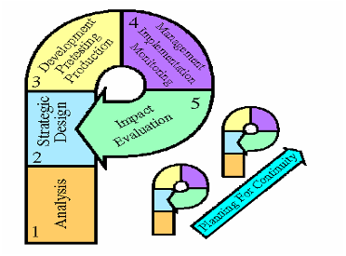
- Strategic Design: Decide on objectives, target audiences, key promises and benefits, develop key messages, select channels of communication, and draw a work plan and design for monitoring and evaluation.
- Development, Pre-testing, Revision and Production: Develop message concepts, pre-test with audiences, revise and produce materials.
- Management, Implementation and Monitoring: Working with organisations and communities to implement plans for local activities and monitor dissemination, transmission and reception of programme outputs
- Impact Evaluation: Measure impact on audiences and determine how to improve future projects.
Planning for Continuity: Adjust to changing conditions and plan for continuity and self-sufficiency.

In conformity with the “P” Process approach, the following development process was undertaken during the design of this strategy:

- Literature Review
A literature review was conducted to establish what has already been done through communication, to address issues related to the cross cutting issues: Gender, HIV/AIDS, Occupational Safety and Health, Environment and People living with disabilities (PWDs) and the elderly. Documents reviewed included the 1995 Constitution of Uganda, Uganda Poverty Status Report, The Amended Traffic and Road Safety Act (1970), Ministry of Works, Housing and Communication Report, 2003 and Ministry of Gender, Labour and Social Development, “National Policy on Disability”. Some information was got from the internet in an effort to learn from experiences of other countries in addressing similar cross-cutting issues.

- Formative Research
The research was conducted in seven districts following the four national roads, each representing a region in the country: The districts comprised; Masindi, Gulu, Kasese, Kampala, Kiboga, Tororo, Kumi and Mbale. Key MoWT officials’ and consultants were interviewed. Methodology used included key informant interviews, focus group discussions, site visits and observations and survey using a questionnaire. The data collected indicates there are issues that could be addressed through communication. Details study findings were presented in a report on the “Knowledge, Attitudes and Practices (KAP) Assessment of Road Sub-sector on Cross-cutting Issues”

- Strategy Design Workshop
Representatives from all cross cutting “sectors” participated in the workshop. The workshop was highly participatory and good input especially from people representing the target audiences was got. This document presents in full the strategy document developed during the workshop.

- Materials Design
Workshop participants were oriented to materials development. They participated in developing some sample poster materials attached in Appendix 4 that will be pre-tested so they can be used in communicating about the cross cutting issues.

This strategy should be updated as new information emerges. For the start, a few problems recommended by the workshop participants as priorities will be addressed in order to maximise available resources. It is hoped that MoWT will solicit funding to implement the suggested interventions.

The Consultants presented workshop participants with a framework for strategy development that has been successfully utilized for similar tasks in other sectors. The framework begins with a problem statement, defines the goal and objective, identifies the audience, lays out the benefits for change in behaviour, then defines the key message concepts and delivery channels. The desired change is also stated. Monitoring and evaluation indicators to assess progress and impact of the communication strategy are also included in the document. These terms are defined as follows:

A: Components of the Strategy:
Priority Issue/Problem
 | What are the problems that the Road Sub-sector Communications strategy hopes to address?
Goal | Expected overall impact of program activities.
Communication objective |  |  | Means to achieve the goal. States what we want to change to attain what the strategy aims to achieve.
Audience |  | The audience to whom messages target; at institutional level and individual level  Goal
- Primary Audience |  | The target audience for the messages/interventions – whose behaviour, attitudes or knowledge we want to influence with our messages.
- Secondary Audience |  | Influence the primary audience.
- Tertiary Audience |  | These are decision/policy makers who control resources.
Key Promise/Benefit |  | States the reason why the audience should believe the messages/adopt the behaviour recommended.
Key message concepts and Support Points |  | Key messages – include facts, testimonies and endorsements. These are concepts that guide materials development as well as interpersonal or group communication activities such as meetings and drama performances.
Channels |  | Means through which the messages will be relayed
Desired Action/Response  Monitoring and evaluation |  | Subjective statement by the audience after receiving the messages; desired action after receiving the messages.
 |  | M&E indicators guide the assessment of progress and impact of the communication strategy.

The strategy outline presented in this document follows the above framework.

2.2 COMMUNICATION STRATEGY OUTLINE

Goal: Utilizing communication, improve knowledge, attitudes and practices in relation to gender equity, environment, occupational safety and health, people with disabilities and the elderly, HIV/AIDS prevention and mitigation within the road sub sector so as to effectively contribute to national socio-economic development.

3.0 Strategy for Thematic Area I:

3.1 KEY ISSUE - OCCUPATIONAL SAFETY AND HEALTH (OSH)
Based on the formative research and literature review, it was determined that levels of awareness of OSH were generally high among all stakeholders. It was also evident that the stakeholders were supportive of the legal/policy provisions of OSH. However the biggest challenge in Road Sub-sector is “Inadequate compliance with the existing laws and regulations i.e. (Workers’ compensation, Occupational Safety and Health Act.”)

This problem is further analyzed below;

Problem Analysis
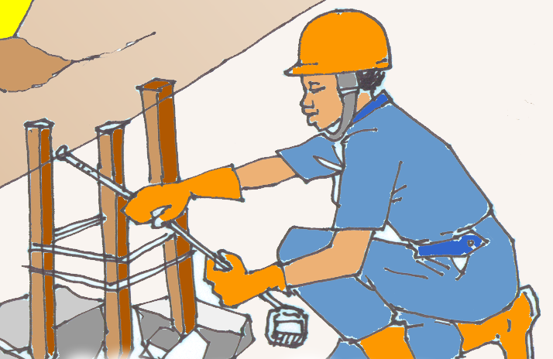
Every employee has a right to safety. Though the MoWT has an OSH policy, and a considerable number of contractors are aware of the laws and regulations, the OSH policy recommendations are sometimes not followed. This is for instance exhibited in the failure to insure workers, unavailability of recreational services and protective gear on part of some of the contractors. The knowledge about the importance of OSH is not translated into practice most of the time.

Non – compliance to the laws and regulations is at times due to:
- Ignorance of the stakeholders including employees on what they are supposed to implement or entitled to.
- Poor publicity – the documents are circulated without deliberate efforts to orient the target audiences on the key issues and the rights and obligations of the workers/contractors. Absence of a proper dissemination strategy may be due to shortage of resources.
- Limited involvement of the clients in the design and dissemination of the laws and regulations.
- Poor reading culture amongst most of the contactors and employees.
- Some laws are thought of as unfriendly and oppressive.

3.2 Targeted Audiences
The audiences targeted by this strategy in addressing OSH issues are categorized as follows;

- Primary Audience:
Road Contractors (includes Association of contractors) and Road Consultant Contractors are a key audience because they are responsible for ensuring the laws are in place.

- Secondary Audience:
Clients (Environment officers, District engineers, Gender, Community development, technical supervisors), Road committees
In most cases, these are charged with a supervisory role to ensure the OSH policy is implemented.

- Tertiary
Workers, host communities, Local leaders, MoWT (Ministers, Permanent Secretary, Directors, Commissioners), Development partners, professional bodies

3.3 Communication Objective
Increase compliance with OSH laws and regulations by the primary audience from 30% - 60% by Yr 2010.

3.3.1 Key Promise
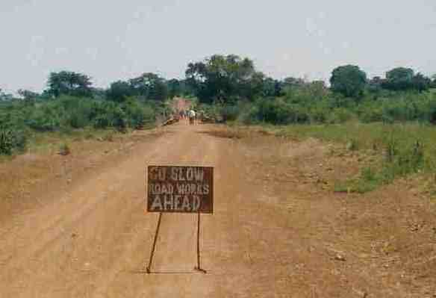

If you comply with OSH contract provisions, you will be more likely to reduce costs and risks on your workers’ health hence be able to make more profits and win more contracts.

3.3.2 Key message concepts/Support Points
The key messages recommended to promote the desired action(s) related to OSH among the targeted audiences include:
- Insuring your work, workers and equipment helps to reduce contract risks. There are insurance companies in many parts of the country to help you get insurance cover.

- You can ensure conducive and safe working environment for your workers, host communities and road users by providing the following as spelt out in the OSH policy:
      - Appropriate protective gear
      - Medical care
      - Site security
      - Feeding
      - Transport
      - Shelter on site
      - Sanitation (take care of gender and PWDs)
      - Necessary diversions to protect road uses

- Good working conditions lead to productive and motivated workforce reduces labour turnover. This also reduces your expenses on recruitment and training.

- OSH is concerned with preserving and protecting human and facility resources in the workplace. Job sites should not be a source of loss of life and resources.

- Provision of recreational facilities at the construction sites helps reduce stress and contributes to increased performance and good working relations among the road construction staff.

- OSH best practices help to save lives of the workers and contractors.

- All accidents should be recorded and reported to the appropriate authorities such as police, MoWT.

3.3.3 Desired Action/Response
Compliance with OSH laws and regulations

3.3.4 Media and Channels
To effectively disseminate the above messages on OSH to the targeted audiences, the MoWT shall apply the following channels:
- Ministry circulars, standing orders, memos, notice boards, handbooks
- Pre-tender meetings:
- Site possession and monitoring meetings
- Print media
- Brochures
- Posters
- Construction magazines
- Local Government (LG) capacity building programmes; The MoWT will liase with LGs to ensure that OSH issues and messages are always incorporated in Road sector related programs.
- TV Documentary on cross-cutting issues including OSH produced by the MoWT
(See developed materials in Appendix: 4)

3.4 Monitoring and Evaluation (M & E) indicators

This shall be a continuous process to be undertaken throughout the duration of this strategy implementation period and two main categories of indicators have been identifies:
Process indicators
- No. of companies that have secured insurance covers against work, workers and equipment
- No. of OSH measures practiced
- No. of contractors with accident reports
- No. of posters with OSH messages produced and disseminated
- No. of meeting on OSH conducted

Impact indicators
- Better compliance with OSH laws and regulations
- Reduced occupational accidents
- Reduced expenditure on accidents that could have been avoided

Means of verification and Methodology: as described in the Implementation framework in Appendix 5.

4.0 Strategy for Thematic Area II:

4.1 KEY ISSUE – HIV/AIDS
Findings from the formative research and literature review indicated that the level of awareness on transmission, prevention and symptoms of HIV/AIDS was generally high among all road sub-sector stakeholders. It was noted however that despite the high level of awareness, road workers were particularly highly venerable to HIV due to the dynamics related to their work. The biggest challenge in Road Sub-sector to be addressed by this strategy is “Negative individual behaviour that leads to casual sex and multiple sexual partners”.

This problem is further analyzed below;

Problem Analysis
The formative research established that most road workers/transporters had low HIV risk perceptions. This may be due to:
- Influence of alcohol.
- Misconceptions about HIV/AIDS and other STDs.
- Inadequate information about HIV/AIDS.
- Misconceptions about condom use among road constructors

People working in the road sub sector have to leave their homes for a long period of time. Since they have some income during such a period, coupled with lack of recreational facilities at most construction sites/truck stop towns, they are at risk of engaging in casual sex and sex with multiple partners.

4.2 Targeted Audience
The audiences targeted by this strategy in addressing HIV/AIDS issues are categorized as follows;
- Primary Audience: Road workers and transporters, host communities (adolescents and adults above 18 yrs)

- Secondary Audience: contractors, works inspectors

- Tertiary Audience: local/opinion leaders, Personnel officer

4.3 Communication Objective
Increase the number of target audience who are aware about the dangers of casual sex and take measures to reduce multiple sexual relationships by Yr 2010.

4.3.1 Key Promise
If you stop having sex with multiple partners and casual sex you will reduce the risk of being infected with HIV/AIDS and other sexually transmitted diseases.

4.3.2 Key message concepts/Support Points
The key messages recommended to promote the desired action(s) related to HIV/AID among the targeted audiences include:
- Spending time away from your home is normal. It is not a reason to engage in acts that may expose you to HIV infection and even disrupt your work and family relationship.
- Being faithful to your partner reduces chances of being infected with HIV/AIDS. The best way to avoid HIV infection is to avoid having sex with someone infected.
- For those not married, abstinence is the best protection against HIV/AIDS.
- Knowing your sero status will help you to make informed decisions about your sex life. Test for HIV with your partner to make joint decisions.
- Alcohol consumption increases the risk of engaging in acts that can expose you to HIV/AIDS. This is because:
  - You lose sense of judgment.
  - You may not use the condom properly.
  - Your risk perception reduces (you are not scared of your acts).
- Always use a condom if you have sex with a non-regular partner or if one or both of you is HIV positive. Condoms are safe and effective. They are available in many places including health facilities, drug stores, shops, clinics, supermarkets, lodges, petrol stations and pharmacies.
- Every sexual encounter that you have without a condom carries a risk of HIV infection.
- Even when you are HIV positive, using condoms helps to prevent further infection with HIV and other STIs.
- Every sexual encounter that you have without a condom carries a risk of HIV infection or infection with other transmitted diseases if your partner is infected.
- Sticking to one, faithful partner who does not have sex with other people helps to reduce your risk of HIV/AIDS infection. It develops your self-esteem, confidence and increases your ability to avoid sexually transmitted diseases.
- If you are HIV positive, using condoms may help you be healthier especially if you are taking anti retroviral drugs.
- Healthy looking individuals may have HIV; the only way to confirm one’s sero status is by taking the HIV test.
- The costs of unprotected sex far outweigh the benefits
- Testimonies from truck drivers who have taken measures to prevent HIV infection.
- Knowledge of HIV sero status helps people to make decisions about marriage, bearing children, and their sexual behavior. It helps people to decide how best to protect themselves and others from HIV infection. The test is not only for sick people.
- The only way to be sure of your HIV sero status is to take the test.
- Accuracy: The tests have been evaluated by the MOH and WHO and are extremely accurate; and each testing site has well trained lab technicians.
- Your test results will remain confidential.
- HIV test is affordable and it is not expensive.
- HIV test is safe and has been approved for use by the MOH and WHO.

- Each HIV testing facility has trained counselors who can help you understand and accept your test results.
- For information about HIV and where you can go for testing, visit a health facility near you i.e. Hospitals, HC IV, AIC, TASO

4.3.3 Desired Action/Response
Road workers/transporters, host communities to stop casual sex and having sex with multiple partners

4.4 Media and Channels
To effectively disseminate the above messages on HIV/AIDS to the targeted audiences, the MoWT shall apply the following channels:
- Radio spots
- Radio Programmes
- Posters
- Drama
- Sensitization Workshops/seminars (on going)
- TV Documentary on cross-cutting issues including HIV/AIDS already produced by the MoWT
(See developed materials in Appendix: 4)

4.5 Monitoring and Evaluation (M & E) indicators
This shall be a continuous process to be undertaken throughout the duration of this strategy implementation period and two main categories of indicators have been identifies:

Process indicators
- No. of road workers, transporters and host communities who are aware of the dangers of casual sex and sex with multiple partners
- No. of radio spots produced and broadcast
- No. of posters produced and disseminated
- No. of drama scripts produced
- No. of drama shows performed
- No. of workshops and seminars held
- No. of participants attending the workshops

Impact indicators
- No. of people using condoms to avoid HIV infection
- No. of people who report they stopped having casual sex and/or sex with multiple partners
- No. reporting faithfulness
- No. reporting abstinence

Means of verification and Methodology: as described in the Implementation framework in Appendix 5.

5.0 Strategy for Thematic Area III:

PEOPLE WITH DISABILITIES (PWDs) AND THE ELDERLY

5.1 KEY ISSUE - PEOPLE WITH DISABILITIES (PWDs)
Data from the formative research and literature review indicated that generally people with disabilities are considered in the national road policy. However it was noted generally PWDs are marginalized in terms of job opportunities and services in the road sub-sector. Two main challenges in Road Sub-sector to be addressed by this strategy are:
- Negative attitudes of stakeholders towards employment of PWDs and elderly
- Road designs mainly focus on motorized traffic and PWDs are least catered for.
These key problems are further analyzed below;

Problem Analysis
People with disabilities have a right to employment in all sectors. They too have different talents and capabilities. Many times, they are denied opportunities by just judging from their physical impairment without giving them chance even when they have the necessary qualifications and experiences. Some contractors, supervisors and road workers think road works is meant for those who are physically okay, yet some people with disabilities could even perform some of the jobs better. In some cases where they have been offered jobs, these are usually sub standard jobs that do not require technical skills.

Formative research further established that PWDs and the elderly are faced with several impediments to their benefits of the road sub-sector. These challenges include: Narrow roads, absence of speed bumps to slow down traffic in busy places. There are no zebra crossings on major roads, and those that are there are put in wrong places; for example places where cars normally move very first , which is a risk to the lives of PWD’s who normally cross slowly. Other roads users especially Bodaboda and taxi drivers are bad mannered and don’t have regard for PWD’s; they are so rude and often knock them down.Drainage Channels are constructed near the road, are not covered, or they have no borders; hence the blind can easily fall in them. Public services vehicles don’t have facilities for the PWD’s and the transporters are usually very rude. Taxis don’t have racks to carry wheel chairs; instead a wheel chair is carried inside the vehicle and charged the fare of a person.

5.1.2 Targeted Audience
The audiences targeted by this strategy in addressing issues on PWDs are categorized as follows;
- Primary Audience: - Contractors, Supervisors on road works, MoWT (district engineers, Environment Liaison Unit staff, departmental heads), Local Governments.

- Secondary Audience – Political leaders, PWD advocates, host communities, Ministry of Gender, Labour and Social Development.

- Tertiary Audience – Development partners, MoWT- (Ministers, Permanent Secretary, Directors, Commissioners), LGs, Civil society, MoH, MoLG

5.1.3 Communication Objective 1
Increase the number of contractors/road supervisors who have positive attitudes towards employing PWDs in the road sub-sector from 50% to 80% by Yr 2010.

Communication Objective 2
Increase the number of road works with special measures in road designs and works to prevent road accidents and injuries for PWDs and the elderly by Yr 2010.

Key Promise 1
If you increase enrolment of PWDs in employment in the road sub-sector you will be recognized for your contribution towards fighting against discrimination of PWDs in the road sub-sector and poverty alleviation.

Key Promise 2
If you incorporate special measures in road designs and works for PWDs and the elderly, you will prevent road accidents, injuries and death.

5.1.4 Key message concepts/Support Points
The key messages recommended to promote the desired action(s) related to PWDs among the targeted audiences include:

- PWDs can perform just like the non-disabled. Disability is not inability. PWDs have all skills needed in the sub sector including driving, mechanics, and supervision of road works, surveying and planning.
- Respect and recognize PWDs just as you do for the non-disabled. Allow them to tell you what they can do best
- People with disabilities also have a voice that should be listened to.
- Offices and departments that have offered jobs to PWDS give good testimony about their performance.
- The MoWT and the Ugandan Constitution condemn all forms of discrimination in regard to people in employment. It is against the law to deny a PWD employment opportunity on the basis of their disability.

Policy measures to address the needs of PWDs and the Elderly that should be incorporated during road designs include

- Improved Design, Construction and Maintenance of Roads and Bridges

The General Series of the Specifications shall be updated to include a section to describe the obligations of the Contractor with regard to addressing the PWD and EP issues and how compliance will be measured and paid for.

- Improvement in Construction of Roads and Bridges

The construction and improvement of roads and bridges will incorporate facilities for the PWD and EP. The facilities will take care of the specific issues resulting from inability to the deprived senses and impairments. The activities will include the following:

- Construction of road humps with gentle gradients for ease of use by wheelchair users;
- Integrate needs of the PWD and EP at crossing points (Zebra Crossing);
- Provision and maintenance of well-labeled road furniture for ease of mobility of PWD and EP;
- Construction of open drains, sub-soil drainage, French drains, banks and dykes that incorporate the needs of the PWD and EP by constructing warning signs that the blind can detect with their White Canes;
- Provide convenient crossing over the open drains for the PWD and EP.
- Construction of parking lots with specific spaces marked for PWD and EP, at least one out of 50 places;
- Demarcation of strategic areas where PWD & EP can cross the roads;
- Construct guide strips to identify the travel routes for a white cane user; and
- Construction and improvement of road infrastructure facilities that make provisions for maximum utilisation of the active senses to make for the lost senses. The blind do not see hence need to utilise their senses of touch, hearing and smelling to access the road infrastructure and make their way through. Similarly utilise the senses of sight, smell and sign for the deaf
- Use of reflective colours to identify humps for low vision will be commenced upon approval of this Policy; and
- Use of tactile on the road humps to inform blind persons of the presence humps and their implications will be commenced immediately.
- Installation of traffic lights at interval points where pedestrians can be guided to cross the roads;
- Programming of traffic lights to provide enough time interval for PWD and EP to cross;
- Integrate a bell system in traffic signals that should ring when it is appropriate for the blind to cross. The Green Period should match with the bang-bang-bang bell sound to indicate crossing and Red Period should match with a tee-tee-tee bell sound to indicate no crossing;
- Provision of low traffic lights control buttons for wheel chair users to access; and
- Provision of signage with contrasting colours for the low vision.
- Ensuring that PSV cater for needs of the PWD and EP by providing special seats for the PWD and EP and space for storage of wheelchairs and clutches.
- Promote use of large-spaced public transport vehicles with ramps for lifting wheelchairs instead of min-buses that have limited space for comfortable use by PWD and EP.
- Provision of shelters at bus stops with facilities for the PWD and EP to wait and board on to public transport vehicles.

5.1.5 Desired Action/Response
  - Positive attitudes towards employing PWDs in road the sub-sector shown by offering them employment opportunities.
  - Road works designs incorporating special needs of PWDS and the Elderly

5.1.6 Media and Channels
To effectively disseminate the above messages on PWDs to the targeted audiences, the MoWT shall apply the following channels:
- Ministry circulars, departmental meetings, standing orders, memos, notice boards, handbooks
- Radio spots and programmes,
- Newspapers and Press releases,
- Sensitization meetings and workshops
- Posters and leaflets,
- Drama shows
- TV Documentary on cross-cutting issues including PWDs produced by the MoWT
(See developed materials in Appendix: 4)

5.1.7 Monitoring and Evaluation (M & E) indicators
This shall be a continuous process to be undertaken throughout the duration of this strategy implementation period and two main categories of indicators have been identifies:
Process indicators
- No. of press releases that promote the employment of PWDs in the road sub-sector.
- No. of workshops/meetings held in relation to employment of PWDs in the road sub-sector.
- No. of Newspaper clippings published to reflect the abilities of PWDs in the road sub-sector work.
- No. of radio spots produced and broadcast.
- No. of Drama shows staged to disseminate information about the benefits of employing PWDs in the road sub-sector work.
- No. of posters designed portraying PWDs potentials and skills in the road sub-sector.
- No. of stakeholders invited to workshops/meetings.
- A policy document drafted and disseminated
- No of bid documents that incorporate Special measures in road designs and works to prevent road accidents and injuries for PWDs and the elderly Road

Impact indicators
- Positive attitudes of stakeholders towards employment and relating with PWDs
- Employers in the road sub-sector offering employment opportunities to PWDs
- Road designs and works with measures to prevent road accidents and injuries for PWDs and the elderly Road

Means of verification and Methodology: as described in the Implementation framework in Appendix 5

5.2 KEY ISSUE: THE ELDERLY
The main challenge in Road Sub-sector to be addressed by this strategy in regard to the elderly is “Lack of provision of physical infrastructure that caters for the needs of the elderly”.
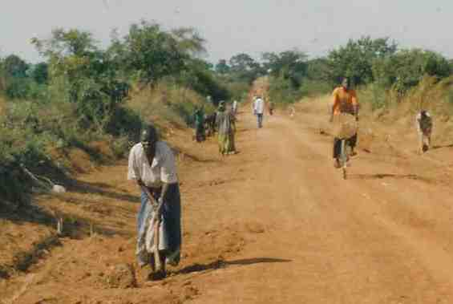
Problem Analysis
The roads do not provide appropriate signs and services for the elderly. This makes it hard for the elderly to use and appreciate the roads in some cases. Many roads do not have pavements where the elderly can walk comfortably.

5.2.1 Communication Objective
Increase the number of physical infrastructure designs that incorporate the special needs of the elderly. (Physical infrastructure includes stop sheds, road signs, markings, locational marks, walk ways, traffic calming facilities) by yr 2010.

Key Promise
If you cater for the needs of the elderly in the roads infrastructure developments, you will contribute towards their safer use of the roads.

5.2.2 Targeted Audience
The audiences targeted by this strategy in addressing issues on elderly are categorized as follows;
- Primary Audience – Technical staff in MoWT and LGs.

- Secondary Audience –Parliament, Cabinet, Development partners to influence policy.

5.2.3 Key message concepts/Support Points
The key messages recommended to promote the desired action(s) related to Elderly among the targeted audiences include:

- Elderly people need special services. Your role is to ensure these services are in place.

- Services required include stop sheds, appropriate road signs, traffic calming facilities and walk ways.

- Special crossing points for the elderly make it easier for them to cross roads and to reduce on accidents.

5.2.4 Media and Channels
To effectively disseminate the above messages on elderly issues to the targeted audiences, the MoWT shall apply the following channels:
- Radio programmes
- Radio spots
- Meetings with contractors and supervisors
- TV Documentary on cross-cutting issues including elderly issues already produced by the MoWT
(See developed materials in Appendix: 4)

5.2.5 Monitoring and Evaluation (M & E) indicators
This shall be a continuous process to be undertaken throughout the duration of this strategy implementation period and two main categories of indicators have been identifies:

Process Monitoring
- No of radio spots and programmes produced
- No of meetings conducted
- A policy document drafted

Impact evaluation
- No of facilities for the elderly constructed/erected/put in place

Means of verification and Methodology: as described in the Implementation framework in Appendix 5.

6.0 Strategy for Thematic Area IV:

6.1 KEY ISSUE - ENVIRONMENT

Findings from the formative research and literature review determined that most contractors had significant knowledge and awareness of Environmental policies and related contractual provisions. However the biggest challenge in Road Sub-sector is to be addressed by this strategy is “Inadequate compliance to environmental laws and regulations”

This problem is further analyzed below;
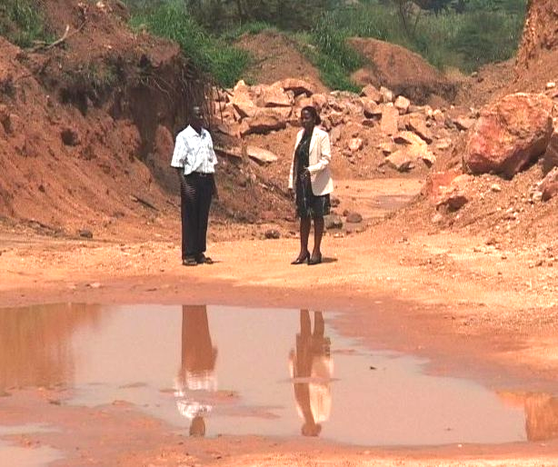

Problem Analysis

Though most contractors are aware of the environmental issues, many do not undertake the mitigation measures. For instance, burrow pits are left uncovered and these are dangerous especially to young children. They also become breeding grounds for mosquitoes that spread malaria when left open.

The study findings confirmed widespread biophysical effects on the environment in the host communities, resulting from road construction and maintenance works. According to some of the district-level key informants, the common biophysical effects of road works include:
- Damage to wetlands through disruption of river flows and direct deposition of materials into wetlands;
- Use of poisonous herbicides by maintenance contractors to destroy grass on the roadsides instead of slashing;
- Destruction of trees where the road passes through forested areas; for instance the Nakwaya Forest Reserve on Hoima Road.
- Burrow pits sometimes end up water-logged, which provide breeding grounds for mosquitoes and is associated with accidents for both drivers and pedestrians.
- Offshoots sometimes direct water into houses, gardens and compounds that get silted.
- Stones, especially the flying stones are left in side drains and by the roadside, which is a common cause of accidents.
- Road works sometimes draw water from the same sources as the host communities
- Extensive bush clearing that leads to loss of natural vegetation and some water catchments, which often results into soil erosion especially where the topsoil piles are not seeded with grass.
- Stockpiles of stone dust are common sight in road works. They usually result in formation of concrete-like structures that are greatly porous; hence making runoff inevitable.

6.2 Target Audience
The audiences targeted by this strategy in addressing issues on environment are categorized as follows;
- Primary Audience – Contractors, MoWT, Ministry of LG.

- Secondary Audience – District/local Environment authorities and activists (NEMA, NFA), host communities.

- Tertiary Audience – Development partners.

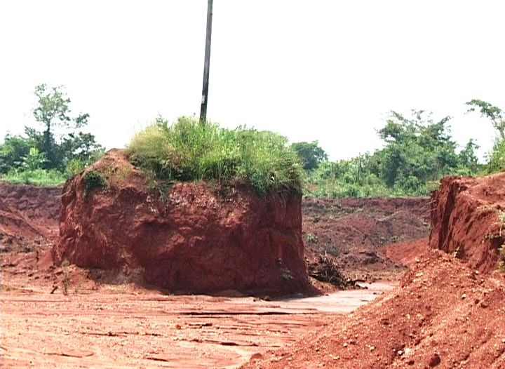

6.3 Communication Objective
Increase the number of primary audience who comply with environmental provisions during planning, design and implementation of road works by Yr 2010

6.3.1 Key Promise

If you comply with the environment provisions during planning, design and implementation of road works, you will be more likely to avoid additional expenses arising out of re-doing poorly planned and done works or litigations costs as a result court cases.

6.4 Key message concepts/Support Points
The key messages recommended to promote the desired action(s) related to environmental issues among the targeted audiences in the road sub-sector include:

- Every Ugandan citizen has a right to a clean and healthy environment. Benefits of protecting the environment include:
  - Conservation of bio-diversity/life.
  - Good climate.
  - Soil productivity.
  - Source of herbal medicine.
  - Control of floods – eat away the road leading to accidents.
  - Reduction in some diseases.

Though some of the benefits are realized in the long run, it is important to conserve the environment now!

- Every road developer has to comply with the following laws and obligations as articulated in the Constitution of the Republic of Uganda, The National Environment Statute, The Land Act; The National Environment, Wetlands, River Banks and Lake shores management (regulations); The Wild Life Act; and the Forest/Tree planting Act.

- Burrow pits may be dangerous especially to young children and animals. They may also become breeding grounds for mosquitoes that spread malaria. It is your obligation to restore all burrow pits after using them.

- All major road works have to be preceded with an Environmental Impact Assessment (EIA). The effects mentioned in the EIA have to be mitigated to comply with environmental standards and needs.
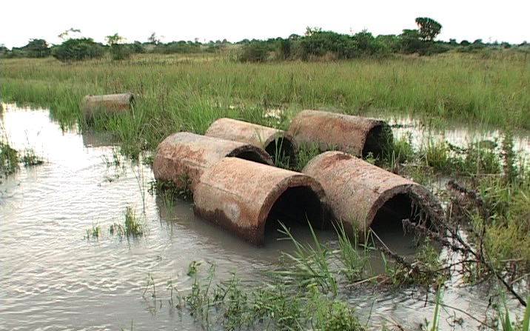
- A safe and clean environment will increase appreciation of the road by the community members. Your workers will also be less likely to suffer from ailments resulting from an environment destroyed by road works.

6.5 Desired Action/Response
The desired action(s) in response to the messages disseminated under this strategy shall include:
- Restoration of burrow pits
- EIAs are carried out before road projects are commissioned
- Implement recommendations from the EIA.

6.6 Media and Channels
To effectively disseminate the above messages on environmental issues to the targeted audiences, the MoWT shall apply the following channels:


- Radio programs
- TV spots
- Posters
- Workshops/Seminars
- TV Documentary on cross-cutting issues including environmental issues already produced by the MoWT
(See developed materials in Appendix: 4)

6.7 Monitoring and Evaluation (M & E) indicators
This shall be a continuous process to be undertaken throughout the duration of this strategy implementation period and two main categories of indicators have been identifies:

Process indicators
- No. of posters developed and distributed.
- No. of TV spots produced and broadcast.
- No. of target audience that have been exposed to the poster.
- No. of radio spots on Environmental laws and regulations developed and broadcast.
- No. of target audience who listen to environmental laws and regulations.

Impact indicators
- No. of target audience who comply with the environmental laws and regulations.

Means of verification and Methodology: as described in the Implementation framework in Appendix 5.

7.0 Strategy for Thematic Area V:

7.1 KEY ISSUE - GENDER
The findings from the formative research and literature review indicated that generally there are gender differences in terms of access to information about available opportunities in road works, and that women compared to men participated least in road-based economic activities. While generally there was support and clear policy framework about employment of women in road works, in practice this was not reflected. After analysis of these issues, it was determined that two key gender challenges in Road Sub-sector is to be addressed by this strategy are:
- Negative attitudes towards employment of women in road works.
- Unequal gender participation in planning and decision-making.

This problem is further analyzed below;

Problem Analysis
There are gender inequities within the road sub-sector. These are shown for example through unequal employment opportunities, negative attitudes towards employment of women in road construction, unequal opportunities in decision-making and segregation in terms of employment opportunities. The government of Uganda strongly supports equal opportunities for both genders.

7.2 Targeted Audiences
The audiences targeted by this strategy in addressing issues on environment are categorized as follows;

Primary Audience: - Road Contractors, Host communities, Workers,

Secondary Audience: - Secondary – Min of Local Governments, Labour and Gender, LCs, Parliamentarians, Civil society. MoWT, LGs.

7.3 Communication Objective 1
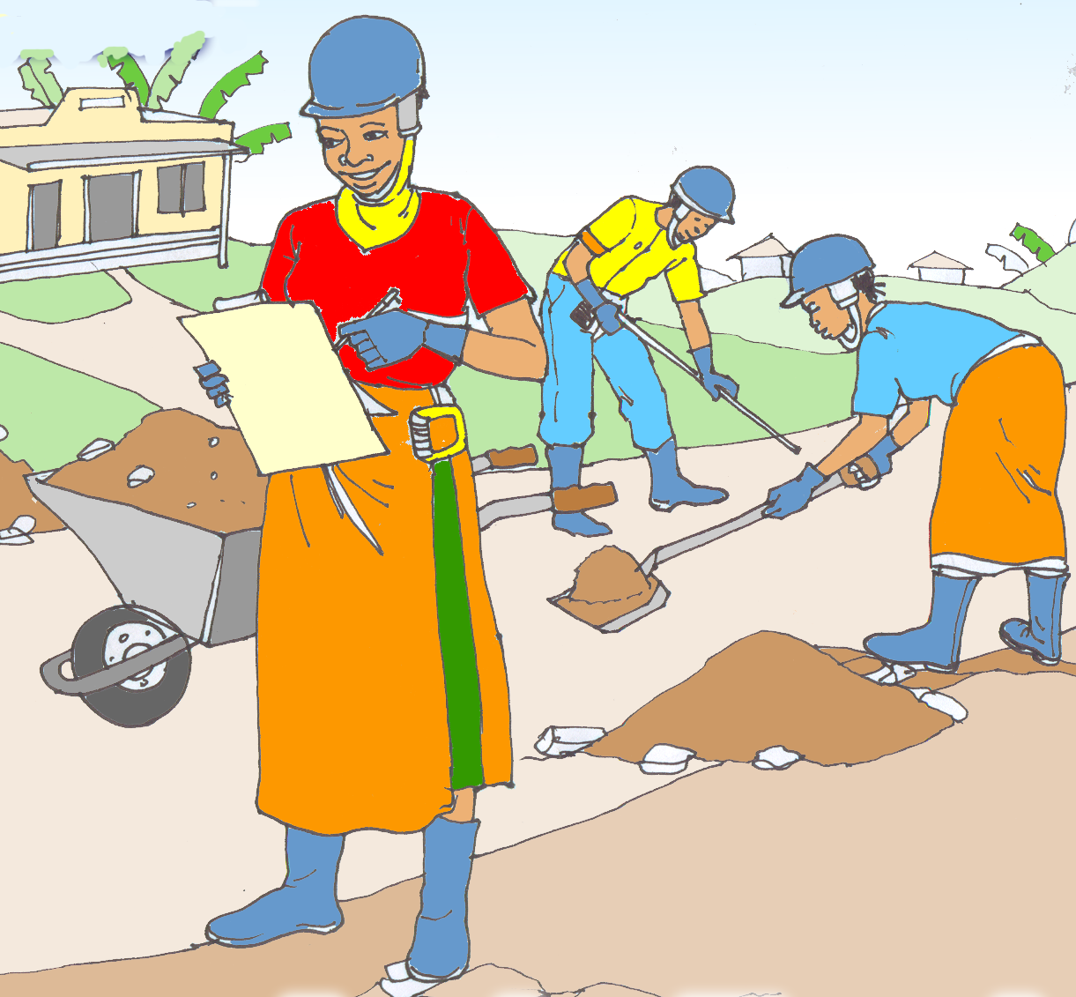
Increase the number of contractors and host communities with positive attitude towards employment of women from 50% – 80% by Yr 2010.

Communication Objective 2

Increase the number of primary audience who involve women in planning and decision-making by Yr 2010.

7.3.1 Key Promise

- Host communities - If you provide employment opportunities to both men and women you will be more likely to contribute towards improved performance, productivity and poverty alleviation.

- Contactors - If you provide employment opportunities to both men and women you will be more likely to increase your productivity, efficiency at work hence more profits.

7.4 Key message concepts/Support Points
The key messages recommended to promote the desired action(s) related to gender issues among the targeted audiences in the road sub-sector include:

- Gender is socially constructed. It refers to the social attributes and opportunities associated with being male or female and the relationships between women and men and girls and boys. These attributes, opportunities and relationships are socially constructed/determined and are learned through socialization processes. They are not static hence are changeable. Therefore the thinking that women cannot do a job as well as men can also change.

- Government policy proposes that at least 30% of the employees in the road sub sector should be females.

- The National Gender Policy stipulates giving equal opportunities in employment to both females and males with special attention to marginalized groups

- When you employ female you help in increasing household incomes and standards of living.

- There is need for the road sub-sector to promote equality in families as well as work places, through policies like maternity leave for married couples encompassing both men and women in order to create a win-win situation.

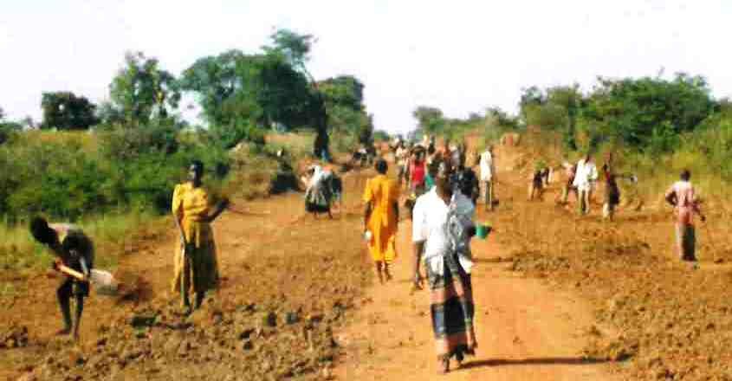
- The Uganda Constitution 1995 recognizes the rights of all Ugandans without discrimination/segregation

- Women are capable of making contribution in the road sector as employees. They have a right of access to information concerning the available jobs and the opportunity to be employed.

- Women can perform the same tasks as men. They can do also do a good job.

- There are many jobs in the sector that women can do effectively if given an opportunity.

7.4.1 Desired Action/Response
Contractors are expected to reconsider their views about employing female road workers with the intention of encouraging more employment of women.

The desired action(s) in response to the messages disseminated under this strategy shall be to generate the following Positive attitudes:
- Not discriminate against women in employment.
- Encourage women to apply for jobs.
- Provision gender sensitive Facilities on road works (eg. separation of bathrooms, latrines).
- Provision for facilities for babies at work places.

7.5 Media and Channels
To effectively disseminate the above messages on gender issues to the targeted audiences, the MoWT shall apply the following channels:

- Sensitization Seminars/Workshops.
- Meetings/community dialogue sessions (Village meetings LCs) involving Community Development Workers.
- Newsletters.
- Radio spots and programmes.
- Posters.
- TV Documentary on cross-cutting issues including OSH produced by the MoWT
(See developed materials in Appendix: 4)

7.6 M & E indicators

Process indicators
- No. of seminars/workshops organized for both women and men on road construction.
- No. jobs advertised in the sub sector encouraging women to apply.
- No. of slots to discuss gender during meetings.
- No. of posters on gender issues in the road sub-sector developed/disseminated.

Impact indicators
- Increased number of women employed in road works.
- Increased number of women participating in decision making (i.e. meetings)

Means of verification and Methodology: as described in the Implementation framework in Appendix 5.

8.0 IMPLEMENTATION FRAMEWORK

This section gives an overview on the implementation modalities of the Communication Strategy for mainstreaming cross-cutting issues in the road sub-sector. The implementation framework briefly covers the following important elements:

- Policy and Institutional Framework
- Program Duration
- Key Activities,
- M & E Framework
- Summary Budget

8.1 Project Duration

The Government of Uganda has committed itself to the integration of the cross-cutting issues in the road sub-sector as a continuous process and this communication strategy serves as a guide to all stakeholders towards attaining this goal. For purposes of this strategy, the implementation is initially planned for a period of three (3) years (2007-2010). During project reviews however, the period may be adjusted accordingly.

8.2 Policy and Institutional Framework

The MoWT is mandated to ensure construction of reliable, safe and efficient transport infrastructure in Uganda with the goal of contributing to national socio-economic development as stipulated in the PEAP. The overall policy design and development in the road sector is premised on the principles of the 1995 Constitution of Uganda. In this context, the Government of Uganda has developed various policies that stipulate a broad regulatory framework and guidelines related to the five cross-cutting issues addressed by this strategy and these include:
- The National Gender Policy (2004)
- Workman’s Compensation Act
- Occupational Safety and Health Act
- Traffic and Road Safely Act (1970)
- The National Environmental Policy
- The Land (Amendment) Act, 2003
- The National Policy on Disability in Uganda 2006
- The Local Government Act (1997)
The implementation of this Communication strategy for mainstreaming cross-cutting issues in the road sub-sector shall therefore be done with regard to the interface of the above national policy frameworks.

8.3 Role of Department of Quality Assurance and Management in Strategy Implementation

The Department of Quality Management (DQM) of the Ministry of Works and Transport through the Environmental Liaison Unit (ELU), is mandated to integrate Gender, HIV/AIDS, Occupational Safety and Health, Environmental and People with Disabilities/Elderly’ concerns in the planning process, programmes and activities of the Ministry, and to monitor the implementation. The department shall therefore, be responsible for the overall coordination of information, education and communication (IEC) functions identified in this strategy.

The strategy identified various IEC functions and activities as summarized in Table below:

Key Activities and Functions
The activities and functions under this strategy are categorized in three (3) broad areas:
- Development and Dissemination of IEC Materials
- Capacity Building Programmes
- Monitoring and Evaluation

8.3.1 Development and Dissemination of IEC Materials

Below is a brief description of the recommended IEC channels to be utilized in the dissemination of the various massages to the different targeted audiences in this communication strategy:

Media/Channels | Activities | Means/Responsible party
Radio spots: | - Indicative radio spots already developed in English are herein attached in Appendix 3.  - Preparation of additional Radio Spots on different messages as may be deemed necessary through Short term Technical Assistance (TA).  - Translation of the Radio spots into the local language dialects as necessary  - Pre-testing of the Radio spots among a sample of targeted audience. (by the TA above)  - Purchase air-time on various Radio stations to disseminate or run the radio-spot messages as per agreed frequency and schedules.  - Radio Monitoring to ensure that the desired performance targets are met. | - MoWT/TA  - Short term TA  - Short term TA  - Short term TA  - Advertising Agent(s)  - Short-term TA
Radio Programmes | - Prepare a radio program (talking–points) to disseminate one or various messages derived from the key messages/support points already described above in the strategy for each of the thematic areas.  - Purchase air-time on Radio stations to run the programmes as per agreed frequency and schedules.  - Identification of key speakers.  - Radio Monitoring to ensure that the desired performance targets are met by the radios. | - IEC Advisor to the MoWT  - Radio Stations  - Short-term TA
Posters | - Indicative Posters of each of the thematic areas already developed and pre-tested (in English)  - Design and pre-test more posters to disseminate other/more messages as necessary  - Translation of the Policy briefs into the local language dialects as necessary.  - Printing of Posters  - Distribution to targeted audiences, MoWT staff, partners and institutions | - MoWT/TA  - Short term TA  - Short term TA  - Private printers  - MoWT/ Courier firm
Policy Popular Briefs | - Preparation of Popular versions of Policies on the five (5) cross-cutting issues (already prepared in English).  - Translation of the Policy briefs into the local language dialects as necessary  - Printing of Policy Briefs  - Distribution to targeted audiences, MoWT staff, partners and institutions | - MoWT/TA  - Short term TA  - Private printers  MoWT/ Courier firm
TV Documentary | - Two (2) TV Documentaries of 15 minute each already developed.  - Reproduce copies of the documentary (DVD, Video tapes)  - Purchase air-time on TV stations to run the programmes as per agreed frequency and schedules.  - Identification of key speakers.  - TV Monitoring to ensure that the desired performance targets are met by the TV Stations.
Construction Magazine | - Develop Content and structure with publishers guided by support points on each cross-cutting issue provided in this strategy.  - Printing and distribution | MoWT/ Publishing & Advertising firm
Billboards | - Design, pre-test and erect Billboards on selected highways | MoWT/Advertising firm
Newsletter | - Design the structure with support of Illustrator/Graphic Designer.  - Printing  - Distribution to targeted audiences, MoWT staff, partners and institutions | - MoWT IEC Advisor
Press Releases & News Articles | - Develop a Regular Schedule for holding press releases.  - Conduct Sensitization and Consultative Meetings with Journalists on Cross-cutting issues.  - Hold Press-releases and generate news articles on topical issues. | - MoWT IEC Advisor
Notices | - Design notices for LGs  - Distribution to LGs | - MoWT IEC Advisor  - Courier firm
Community Sensitization Meetings | - Develop and pre-test Standard guidelines for conducting meetings.  - Print the guidelines.  - Distribute the Guidelines to targeted users (MoWT staff, District Engineers, DEO and other partners)  - Conduct National Level Meetings with support of Facilitator (National TA)  - Conduct Regional Level Meetings (with support of Facilitator (National TA) | - MoWT IEC Advisor with Short-Term TA  - Private Printer  - MoWT  - MoWT/ Short-term TA  - MoWT/ Short-term TA
Drama | - Contract drama groups to prepare play scripts on relevant issues  - Conduct drama shows (translated in local dialects as desired) | - Drama Groups

Detailed Implementation framework in Appendix 5.
    - Capacity Building Programmes
Two major capacity building actions have been identified and recommended to ensure effective implementation of this strategy:
A) IEC Advisor to the MoWT:
A National IEC Advisor shall be hired (national firm or individual) to support the Department of Quality Assurance and Management in implementing this strategy. The IEC advisor shall among other functions be responsible for:
  - Developing of Terms of reference (TORs) for all National and international TA necessary for the implementation of this strategy
  - Develop and coordinate IEC capacity building activities in the Ministry and Local governments for sustainability.
  - Participate in awareness and advocacy activities of the Ministry to enhance implementation of the strategy
  - Liaison with partners and other stakeholders to ensure effective collaboration and sustainability of the strategy efforts.
  - Monitoring of strategy implementation activities and preparation of the reports thereof.

B) Training in Communication and facilitation Skills:
In order to effectively roll-out the activities under this strategy in a sustainable manner, the MoWT shall conduct training and capacity building programmes to impart communication and facilitation skills among her staff and other key partners namely; District Engineers, DEO, LGs. This will be done through short term TA whose tasks shall include:
- Design and prepare a manual and materials for a Training program in Communication and facilitation skills for mainstreaming cross-cutting issues in the Road sub-sector
- Delivery of training programs to targeted participants.

  - Monitoring and Evaluation Framework
Motivation for Research
To generate information and data that will evaluate the communication strategy for mainstreaming cross cutting issues in the roads sub sector. The research activities will determine:
a) Whether the objectives set out in this strategy were achieved and,
b) To find out what elements of the strategy worked well or not.

8.4.1 Specific Objectives.
- To establish the level of knowledge, attitudes and practices of targeted audiences on the cross cutting issues.
- To determine the proportion of audience(s) that were exposed to messages about the cross cutting issues.
- To determine what actions were taken as a result of being exposed to the messages.
- To document and disseminate lessons on capacity building efforts towards sustainable mainstreaming of the cross cutting issues in the roads sub sector.

8.4.2 M&E Indicators
For each of the thematic areas, specific indicators have already been developed and provided in this strategy and they cover the following:
- Process Monitoring
- Impact and Outcome assessment.

8.4.3 Means of Verification
- Surveys: A number of surveys will be conducted as follows:
-Mid Review (after 1.5 years).
-Annual Performance Appraisals.
-Other specific studies.
-End term reviews.
- Quarterly Reports.
- Regular feedback through field supervision reports.
- Minutes of site meetings.
- Workshop/training reports.
- Mid year monitoring reports.

8.4.4 Methodology

The methodology for monitoring M&E activities will use both quantitative and qualitative approaches. Qualitative methods will be used mainly to execute the institution component of the research study. In-depth interviews will be conducted on a one-on-one with stakeholders who have benefited from improved services in the sub-sector. MOWT shall utilize short term TA to undertake these research activities.

8.5 Implementation Budget (Option 1 and 2-refer to Appendix 6)

8.6 Summary Recommendations
Below is a summary of some of the additional IEC activities recommended to enable the effectiveness of the Communication strategy:

Activity | Action
A Construction magazine/newsletter for Roads Sub-sector. | - Short term TA (national) for design  - ELU for Printing & Dissemination
Hire of an IEC Advisor to support the Department of Quality Management in implementing this strategy. | - Short term TA (national/individual)
Revision of the strategy after 1.5 years. | - Short term TA (national)
Media Monitoring | - Longitudinal Service Contract
Broadcasting of Radio Messages | - Short term TA (national)
Broadcasting of TV Messages | - Short term TA (national)/IEC Advisor

The above recommendations were drawn from the field assessment on some of the preferred communication channels.

APPENDICES

Appendix 1: LIST OF PARTICIPANTS

Appendix 2: PARTICIPANTS EXPECTATIONS

Appendix 3: RADIO SPOT

Appendix 4: SAMPLE POSTERS

Appendix 5: THE IMPLEMENTATION PLAN OF THE COMMUNICATION STRATEGY FOR THE ROAD SUB-SECTOR

Appendix 6: BUDGET FOR THE IMPLEMENTATION OF THE COMMUNICATION STRATEGY FOR THE ROAD SUB-SECTOR

Appendix 1: Workshop Participants

Name | Title & Organization /Ministry | Phone Contact | Email address
- Ainebyona Andrew | IMPACT Associates/CDFU | 078 2 822 543 | aineandrew2@yahoo.com
- Assedri Charles | MOWT | 077 2 403 458 | assedri@yahoo.com
- Banga Simon | IMPACT Associates/CDFU | 077 2 669 628 | bangsimo@yahoo.com
- Higenyi John | DE - Kumi | 077 2 468 149 | jmhigenyi@yahoo.com
- Kabagenyi Peluce | Social Service Kasese | 075 2 952 634
- Kabugo Florence | IMPACT Associates/CDFU | 077 2 488 567 | flkab@yahoo.com
- Kaggwa Robert | IMPACT Associates/CDFU | 077 2 414 936 | robertkagwa@yahoo.com
- Kasibante Michael | Ag. D. MoWT - Gulu | 077 2 675 525 | epinex@yahoo.co.ug
- Katusiime Robinah | District Councilor (PWDs) - Masindi | 078 2 698 639
- Kiganda Bennice | Asst. Engineering Officer - PWTC | 077 2 471 519
- Kiiza R. N | P & E training | 077 2 480 459 | uipe@infocom.co.ug
- Kooli Augustine | Environment Officer – Kasese | 078 2 544 911 | mugwaev@yahoo.com
- Kyerere Chris | IMPACT Associates/CDFU | 041 231 583 | chrisk@impactassociates.co.ug
- Lebo Julepa Julius | MLG&SD | 077 2 683 676 | julepad@yahoo.com
- Lukwago Joseph | District Eng. - Mpigi | 078 2 470 848 | Jlsali2003@yahoo.com
- Magezi Denis | DE - Kanungu | 077 2 485 884 | denismagezi@yahoo.com
- Mubuuke F.X | UNABCEC | 077 2 403 265 | fmubuuke@yahoo.co.uk
- Mutemo Charles | SEO (MoWT) | 077 2 315 061 | cmutemo@works.go.ug
- Nankunda Allen | IMPACT Associates /CDFU | 077 2 501 953 | Nankunda@cdfuug.co.ug
- Nankya Dorothy | DEO – Kiboga LG | 077 2 355 681 | Eve.dorah@yahoo.com
- Okalang Emmanuel | Environment Officer - Kumi | 078 2 980 673 | okalemm@yahoo.com
- Olaboro Juliet | ACODE | 041 530 798 | library@acode-u.org
- Omagor Nelson | MoWT | 077 2 458 903 | nelsonomagor@hotmail.com
- Otemo J. S | MoWT | 077 2 859 390 | jsotemo@iwayafrica.com
- Seruma Monica | MoWT | 077 612 673 | monicaseruma@yahoo.com
- Ssebbugga-Kimeze | Commissioner (QM) | 077 2 477 042
- Ssembatya Patrick | Asst. Infrastructure Engineer - AAMP | 077 2 559 153 | psembatya@yahoo.com
- Timu Godfrey | MLG&SD | 071 2 951 035 | timu@mglsd.go.ug
- Tumukunde Melda | Project Officer - NUDIPU | 071 2 851 606 | meldat@mail.com
- Turiho Andrew | IMPACT Associates/CDFU | 077 2 485 715 | Turiho@mail.com
- Tushabe Basil | IMPACT Associates /CDFU | 077 2 409 746 | basil@cdfuug.co.ug
- Wall A. Gerald | IMPACT Associates/CDFU | 077 2 358 392 | gerry@impactassociates.co.ug
- Were-Higenyi (Eng.) | Ag. ACE/QA | 077 2 404 372 | fmwhere@yahoo.co.uk

Appendix 2: Participants Expectations

- To know if there any improvements that the MoWT will put in place to ensure safe road use by PWD
- To learn about the findings of the KAP survey
- To learn about the new environmental issues considered during the survey
- What challenges or gaps there are in the current Communication Strategy
- To come up with a mechanism of information sharing between government ministries in relation to the workshop scope
- To know how the environmental issues can be integrated in the road sub-sector
- To learn how road construction companies can be influenced to ensure that they integrate environmental issues in their operations
- To learn the basics of the Communication Strategy
- What are the comments on the practices in place e.g. Men at work, HIV kills etc.

Appendix 3: Radio Spots

Radio spot 1: PWDs

Topic: Equal Opportunities for PWDS

Target: District Engineers

Duration: 45 seconds

Language: English

SFX: Knock on the door

Eng Muhindo: Yes come in, can I help you?

Mr Masiika: I have brought my bid documents for the construction of

Muhuku road

Eng Muhindo: Oh.. That’s wonderful! we do not see many disabled people applying to do road construction work. I admire your courage Mr Masiika.

Mr Masiika: Perhaps you engineers should give us the disabled - more chances to prove ourselves. Here have a look (SFX-papers being shuffled...). These are certificates of completion for several projects I have undertaken.

VOX: Engineers! Promote increased participation of People with Disabilities in the Road works to contribute to poverty alleviation

Tag Line: This message is brought to you by Ministry of Works and Transport with support from DANIDA

Radio Spot 2: HIV/AIDS

Topic: Protection against HIV/AIDS

Target: Road Workers

Duration: 45 seconds

Language: English

SFX: Bar environment

Kapere: (Burps) …Another round please bar man, and don’t worry, we are road workers at the by-pass so we are loaded, money is not a problem.

Sam: Kapere I think this is enough beer for us this evening, for me I have proggie with this ka girl………..

Kapere: (quickly interrupts) Kwenda Yuko! That’s more reason to drink so you can be powerful……..

Sam: Kapere drinking makes people go live instead of wearing condoms and even when they do they don’t wear them well. I don’t want to contract HIV because of this Alcohol. Make it water for me bar man.

VOX: Protect yourself against HIV. Always use condoms.

Tagline: This message is brought to you by the Ministry of Works and Transport with support from DANIDA.

Appendix 4: Sample Posters

Appendix 5: Implementation Plan of the Communication Strategy for the Road Sub-sector

Appendix 6: Draft Budget for Implementation of the Communication Strategy for the Road Sub-sector

PEAP, 2004/5 – 2007/8
http:/www.miniworks.gov.ug
http://www.miniworks.gov.ug
PEAP, 2004/5 – 2007/8
PEAP, 2004/5 – 2007/8
2002 Population and Housing Census; Main Report
2002 Population and Housing Census; Main Report
The Communication Strategy M&E component should be incorporated into the overall Road Sub-sector M&E framework.

