Part 2: Section 2 Bid Data Sheet

Instructions

to Bidders
Reference
ITB 20.2

ITB 22.1

ITB 25.1

ITB 34.1

ITB 42.1

ITB 43.1
Data relevant to the ITB

The written confirmation of authorization to sign on behalf of the Bidder shall consist of:
For bid submission purposes only, the Employer’s address is: Attention:
Street Address:
Floor/Room number: Town/City:
Postal Code: Country:
The deadline for bid submission is: Date:
Time (Local time):
The bid opening shall take place at: Street Address:
Floor/Room number: Town/City:
Country: Date:
Time (local time):
A margin of preference shall / shall not apply.
If a margin of preference applies, the application methodology shall be: stated in Section 3, Evaluation Methodology and Criteria.
The Advance Payment shall be limited to _______________ percent of the Contract Price.
The Adjudicator proposed by the Employer is:
The hourly fee for this proposed Adjudicator shall be:
The biographical data of the proposed Adjudicator is:

Standard Bidding Document for Works issued by PPDA June 2005 30

Open and Restricted Bidding Section 2 Document: WksSect2

Part 2: Section 3 Evaluation Methodology and Criteria
Section 3. Evaluation Methodology and Criteria
Procurement Reference Number:
A Evaluation Methodology
1 Methodology Used
1.1 The evaluation methodology to be used for the evaluation of bids received shall be
the Technical Compliance Selection (TCS) methodology.
2 Summary of Methodology
2.1 The Technical Compliance Selection methodology recommends the lowest priced
bid, which is eligible, compliant and substantially responsive to the technical and
commercial requirements of the Bidding Document, provided that the Bidder is
determined to be qualified to perform the contract satisfactorily.
2.2 The evaluation shall be conducted in three sequential stages -
(a) a preliminary examination to determine the eligibility of bidders and the
administrative compliance of bids received;
(b) a detailed evaluation to determine the commercial and technical
responsiveness of the eligible and compliant bids; and
(c) a financial comparison to compare costs of the eligible, compliant,
responsive bids received and determine the best evaluated bid.
2.3 Failure of a bid at any stage of the evaluation shall prevent further consideration at
the next stage of evaluation. Substantial responsiveness shall be considered a
pass.
B Preliminary Examination Criteria
3 Eligibility Criteria
3.1 The eligibility requirements shall be determined in accordance with ITB Clause 4.
3.2 The documentation required to provide evidence of eligibility shall be:-
(a) a copy of the Bidder’s Trading licence or equivalent;
(b) a copy of the Bidder’s Certificate of Registration or equivalent;
(c) a copy of the Bidder’s income tax clearance certificate or equivalent;
(d) a copy of the Bidders VAT registration or equivalent;
(e) a statement in the Bid Submission Sheet that the bidder meets the
eligibility criteria stated in ITB 4.1;
(f) a declaration in the Bid Submission Sheet of nationality of the Bidder;
(g) a statement in the Bid Submission Sheet that the Bidder has no conflict of
interest;
(h) a declaration in the Bid Submission Sheet that the Bidder is not under
suspension by the Public Procurement and Disposal of Public Assets
Authority;

Standard Bidding Document for Works issued by PPDA June 2005 31
Open and Restricted Bidding Section 3: Document: WksSect3

Part 2: Section 3 Evaluation Methodology and Criteria

(i)
3.3 For a Joint Venture, the documentation in Section 3.2 shall be required for each
member of the Joint Venture and the following additional documentation shall also be
required:
(a) a certified copy of the Joint Venture Agreement, which is legally binding on
all partners, showing that:
(i) all partners shall be jointly and severally liable for the execution of
the Contract in accordance with the Contract terms;
(ii) one of the partners will be nominated as being in charge, authorised to
incur liabilities, and receive instructions for and on behalf of any and all partners of the joint venture; and
(iii) the execution of the entire Contract, including payment, shall be done
exclusively with the partner in charge.
(b) Power of Attorney of the signatory(ies) of the bid authorising signature of
the bid on behalf of the joint venture;
(c)
4 Administrative Compliance Criteria
4.1 The evaluation of Administrative Compliance criteria shall be conducted in
accordance with ITB Clause 30.3.
C Detailed Evaluation Criteria
5. Commercial and Technical Criteria
5.1 The commercial and technical responsiveness of bids shall be evaluated in
accordance with ITB Clause 31.
5.2 The assessment of responsiveness will consider the following criteria:
(a) acceptance of the conditions of the proposed contract;
(b) acceptable completion schedule;
(c) acceptability of the proposed program (work method and schedule),
including relevant drawings and charts;
(d)
D Financial Comparison Criteria
6. Costs to be included in the Bid Price
6.1 The financial comparison shall be conducted in accordance with ITB Clause 33.
The following costs shall be included in the bid price:
(a) the total price given in the Activity Schedule/Bills of Quantities;
(b) Daywork;
(c)
6.2 The following costs shall be excluded from the bid price:
(a) provisional sums;

Standard Bidding Document for Works issued by PPDA June 2005 32
Open and Restricted Bidding Section 3: Document: WksSect3

Part 2: Section 3 Evaluation Methodology and Criteria

(b) the provision for contingencies in the Activity Schedule/ Bills of Quantities;
(c)
7 Margin of Preference

8 Determination of Best Evaluated Bid or Bids
8.1 The bid with the lowest evaluated price, from among those which are eligible,
compliant and substantially responsive shall be the best evaluated bid.
8.2 If this Bidding Document includes more than one lot, the best evaluated bid shall
be determined separately for each lot.
8.3 Notwithstanding paragraph 8.1, if this Bidding Document allows Bidders to quote
different prices for single lots and for the award to a single Bidder of multiple lots, the Procuring and Disposing Entity shall conduct a further financial comparison to apply any conditional discounts. The bid or bids offering the lowest priced
combination of all the lots shall be the best evaluated bid or bids.
E Post-qualification Criteria
9 Qualification Criteria
9.1 To qualify for award of the Contract, Bidders shall meet the following minimum
qualifying criteria:
(a) average annual volume of construction work over the past _____ years of at
least _________________________;
(b) experience as prime contractor in the construction of at least __________
works of a nature and complexity equivalent to the Works over the last 5
years (to comply with this requirement, works cited should be at least 70
percent complete);
(c) proposals for the timely acquisition (own, lease, hire, etc.) of the following
essential equipment:

(d) a Contract Manager with five years’ experience in works of an equivalent
nature and volume, including no less than three years as Manager;
(e) liquid assets and/or credit facilities, net of other contractual commitments
and exclusive of any advance payments which may be made under the
Contract, of no less than _________________________;
(f)
9.2 A consistent history of litigation or arbitration awards against the Applicant or any
partner of a Joint Venture may result in disqualification.
9.3 The figures for each of the partners of a joint venture shall be added together to
determine the Bidder’s compliance with the minimum qualifying criteria of
paragraph 9.1 (a) and (e); however, for a joint venture to qualify, each of its
partners must meet at least 25 percent of minimum criteria 9.1 (a), (b), and (e) for
an individual Bidder, and the partner in charge at least 40 percent of those

Standard Bidding Document for Works issued by PPDA June 2005 33
Open and Restricted Bidding Section 3: Document: WksSect3

Part 2: Section 3 Evaluation Methodology and Criteria

minimum criteria. Failure to comply with this requirement will result in rejection of the joint venture’s bid.
9.4 Subcontractors’ experience and resources will not be taken into account in
determining the Bidder’s compliance with the qualifying criteria.
9.5 The information and documentation required to provide evidence of qualification
shall be:-
(a) total monetary value of construction work performed for each of the last five
years;
(b) experience in works of a similar nature and size for each of the last five
years, and details of work under way or contractually committed; and clients
who may be contacted for further information on those contracts;
(c) major items of construction equipment proposed to carry out the Contract;
(d) qualifications and experience of key site management and technical
personnel proposed for the Contract;
(e) reports on the financial standing of the Bidder, such as profit and loss
statements and auditor’s reports for the past five years;
(f) evidence of adequacy of working capital for this Contract (access to line(s)
of credit and availability of other financial resources);
(g) authority to seek references from the Bidder’s bankers;
(h) information regarding any litigation, current or during the last five years, in
which the Bidder is involved, the parties concerned, and disputed amount;
and
(i) proposals for subcontracting components of the Works amounting to more
than 10 percent of the Contract Price;
(j) Any other documentation deemed necessary.
9.6 The information and documentation listed in 9.5 shall be provided on the
Qualification Form in Section 4, where appropriate.

Standard Bidding Document for Works issued by PPDA June 2005 34
Open and Restricted Bidding Section 3: Document: WksSect3

Part 2: Section 4. Bidding Forms

[This Bid Submission Sheet should be on the letterhead of the Bidder and should be signed by a person with the proper authority to sign documents that are binding on the Bidder]
Bid Submission Sheet
Date: [insert date (as day, month and year) of Bid Submission]
Procurement Reference No: [insert Procurement Reference number]
To: [insert complete name of Employer]
We, the undersigned, declare that:
(a) We have examined and have no reservations to the Bidding Document, including
Addenda No.: [insert the number and issue date of each Addenda];
(b) We offer to execute in conformity with the Bidding Document and in accordance with
the completion schedule specified in the Statement of Requirements and the terms and
conditions of the Bidding Document, the following Works [insert a brief description of
the Works];
(c) The total price of our Bid, excluding any discounts offered in item (e) below, is: [insert
the total bid price in words and figures, indicating the various amounts and the
respective currencies]; payable in the following currencies:
Currency Percentage Rate of exchange: one Inputs for which foreign
payable in foreign equals [insert local] currency is required
currency

(d) The advance payment (which shall be payable in the same currencies and percentages
as the Contract Price) required is:
Amount Currency

(e) The discounts offered and the methodologies for their application are:
Unconditional discounts. If our bid is accepted, the following discounts shall apply.
[Specify in detail each discount offered (eg amount/percentage) and the specific item of the Statement of Requirements to which it applies.]
Methodology of application of the unconditional discounts. The unconditional discounts shall be applied using the following method: [Specify precisely the method that shall be used to apply the discounts];

Standard Bidding Document for Works issued by PPDA June 2005 36

Open and Restricted Bidding Section 4: Document: WksSect4

Part 2: Section 4. Bidding Forms

Conditional discounts. If our bids for more than one lot are accepted, the following discounts shall apply. [Specify precisely each discount offered (eg amount/percentage) and the conditions for its application.]
Methodology of application of the conditional discounts. The conditional discounts shall be applied using the following method: [Specify in detail the method that shall be used to apply the discounts];
(f) Our bid shall be valid for a period of [specify the number of working days] working
days from the date fixed for the bid submission deadline in accordance with the Bidding Document, and it shall remain binding upon us and may be accepted at any time before the expiration of that period;
(g) If our bid is accepted, we commit to obtain a Performance Security in accordance with
the Bidding Document in the amount of [insert amount and currency in words and figures of the Performance Security] for the due performance of the Contract;
(h) We, including any subcontractors or providers for any part of the contract resulting
from this procurement process, are eligible to participate in public procurement in accordance with ITB Clause 4.1;
(i) We, including any subcontractors or Providers for any part of the contract, have
nationals from eligible countries [insert the nationality of the Bidder, including that of all parties that comprise the Bidder, if the Bidder is a joint venture, consortium or association, and the nationality of each subcontractor];
(j) We undertake to abide by the Code of Ethical Conduct for Bidders and Providers during
the procurement process and the execution of any resulting contract;
(k) We accept the appointment of [name proposed in Bid Data Sheet] as the Adjudicator.
[or]
We do not accept the appointment of [name proposed in Bidding Data] as the Adjudicator, and propose instead that [name] be appointed as Adjudicator, whose daily fees and biographical data are attached.
(l) We are not participating, as Bidders, in more than one bid in this bidding process, other
than alternative bids in accordance with the Bidding Document;
(m) We, including any subcontractors, do not have any conflict of interest and are not
associated, nor have been associated in the past, directly or indirectly, with the
consultant or any other entity that has prepared the design, specifications, and other
documents for the Project or that is being proposed as Project Manager for the
Contract;
(n) We, our affiliates or subsidiaries, including any subcontractors for any part of the
contract, have not been suspended by the Public Procurement and Disposal of Public Assets Authority in Uganda from participating in public procurement;
(o) The following commissions, gratuities, or fees have been paid or are to be paid with
respect to the bidding process or execution of the Contract: [insert complete name of each Recipient, their full address, the reason for which each commission or gratuity was paid and the amount and currency of each such commission or gratuity. If none has been paid or is to be paid, indicate “none”.]

Standard Bidding Document for Works issued by PPDA June 2005 37

Open and Restricted Bidding Section 4: Document: WksSect4

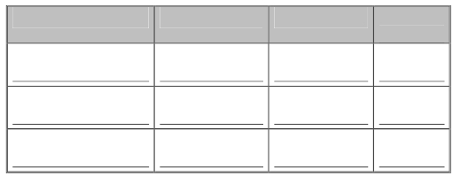

Part 2: Section 4. Bidding Forms

Name of Recipient Address Purpose/Reason Amount &
currency

(p) We understand that this bid, together with your written acceptance thereof included in
your Letter of Bid Acceptance, shall constitute a binding contract between us, until a
formal contract is prepared and executed.
(q) We understand that you are not bound to accept the lowest bid or any other bid that you
may receive.

Signed: [signature of person whose name and capacity are shown below]
Name: [insert complete name of person signing the bid]
In the capacity of [insert legal capacity of person signing the bid]
Duly authorised to sign the bid for and on behalf of: [insert complete name of Bidder/Joint Venture]
Dated on ____________ day of __________________, _______ [insert date of signing]

Standard Bidding Document for Works issued by PPDA June 2005 38

Open and Restricted Bidding Section 4: Document: WksSect4

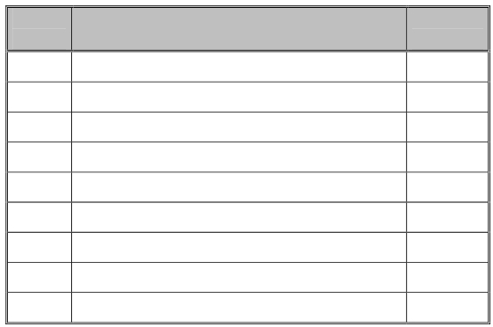

Part 2: Section 4. Bidding Forms

[This blank form is included for guidance purposes only. The Bidder should price the Activity
Schedule included in Section 6, Statement of Requirements. The priced Activity Schedule
should be signed by a person with the proper authority to sign documents for the Bidder and
included by the Bidder in its bid. The Bidder may reproduce this in landscape format but is
responsible for its accurate reproduction. If necessary these may be bound in a separate
volume].
Activity Schedule
Date: [insert date (as day, month and year) of Bid Submission]
Procurement Reference No.:[insert Procurement Reference number]
Name of Bidder: [Insert the name of the Bidder]

Item Activity Description Amount in
number Ug. Sh

Signed: [signature of person whose name and capacity are shown below]
Name: [insert complete name of person signing the bid]
In the capacity of [insert legal capacity of person signing the bid]
Duly authorised to sign the bid for and on behalf of: [insert complete name of Bidder/Joint Venture]
Dated on ____________ day of __________________, _______ [insert date of signing]

Standard Bidding Document for Works issued by PPDA June 2005 39

Open and Restricted Bidding Section 4: Document: WksSect4

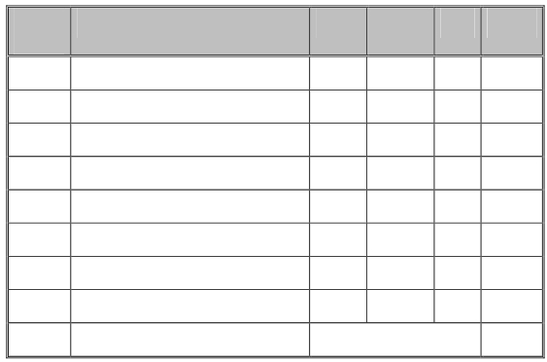

Part 2: Section 4. Bidding Forms

Bill of Quantities
Date: [insert date (as day, month and year) of Bid Submission]
Procurement Reference No.:[insert Procurement Reference number]
Name of Bidder: [Insert the name of the Bidder]

Item Description of Works Unit Quantity Rate Amount
number

Grand Total:

Signed: [signature of person whose name and capacity are shown below]
Name: [insert complete name of person signing the bid]
In the capacity of [insert legal capacity of person signing the bid]
Duly authorised to sign the bid for and on behalf of: [insert complete name of Bidder/Joint Venture]
Dated on ____________ day of __________________, _______ [insert date of signing]

Standard Bidding Document for Works issued by PPDA June 2005 40

Open and Restricted Bidding Section 4: Document: WksSect4

Part 2: Section 4. Bidding Forms

[This Bid Security should be on the letterhead of the issuing Financial Institution and should be signed by a person with the proper authority to sign the Bid Security. It should be included by the Bidder in its bid, if so indicated in the BDS]
Bid Security
Date: [insert date (as day, month and year) of Bid Submission]
Procurement Reference No.: [insert Procurement Reference number]
To: [insert complete name of Employer]
Whereas, [insert complete name of Bidder] (hereinafter called “the Bidder”) has submitted its
bid dated [insert date (as day, month and year) of bid submission] for Procurement
Reference number [insert Procurement Reference number] for the construction of [insert brief description of the Works] (hereinafter called “the bid”).
KNOW ALL PEOPLE by these presents that We [insert complete name of institution issuing the Bid Security] of [insert city of domicile and country of nationality] having our registered office at [insert full address of the issuing institution] (hereinafter called “the Guarantor”) are bound unto [insert complete name of Employer] (hereinafter called “the Employer”) in the sum of [specify in words and figures the amount and currency of the Bid Security] for which payment well and truly to be made to the said Employer, the Guarantor binds itself, its successors or assignees by these presents.
Sealed with the Common Seal of the said Guarantor this [insert day in numbers] day of [insert month], [insert year].
THE CONDITIONS of this obligation are:
(1) If the Bidder withdraws its bid during the period of bid validity specified in the
bid submission sheet; except as provided in ITB Sub-Clause 17.2; or
(2) If the Bidder having been notified of the acceptance of its bid by the Employer
during the period of bid validity fails or refuses to:
(a) sign the Contract in accordance with the ITB Clause 40, if required; or
(b) furnish the Performance Security, in accordance with the ITB Clause 41; or
(c) accept the correction of its bid price pursuant to ITB Clause 29.5,
we undertake to pay to the Employer up to the above amount upon receipt of its first written
demand, without the Employer’s having to substantiate its demand, provided that in its
demand the Employer states that the amount claimed by it is due to it, owing to the
occurrence of one or more of the above conditions, specifying the occurred conditions.
This security shall remain in force up to and including twenty-eight (28) days after the period of bid validity, and any demand in respect thereof should be received by the Guarantor no later than the above date.
This guarantee is subject to the Uniform Rules for Demand Guarantees, ICC Publication No.
458.

Signed: [insert signature of person whose name and capacity are shown below]

Standard Bidding Document for Works issued by PPDA June 2005 41

Open and Restricted Bidding Section 4: Document: WksSect4

Part 2: Section 4. Bidding Forms

Name: [insert complete name of person signing the Bid Security]
In the capacity of [insert legal capacity of person signing the Bid Security]
Duly authorised to sign the Bid Security for and on behalf of: [insert complete name of Financial Institution]
Dated on ________ day of __________________, _______ [insert date of signing]

Standard Bidding Document for Works issued by PPDA June 2005 42

Open and Restricted Bidding Section 4: Document: WksSect4

Part 2: Section 4. Bidding Forms

[This Qualification Form should be submitted for the Bidder, or in the case of bids from Joint
Ventures, for each member of the Joint Venture. The form should be on the letterhead of the
Bidder/member of Joint Venture and should be signed by a person with the proper authority
to sign. It should be included by the Bidder in its bid, unless otherwise indicated in the BDS.
The information will be used for purposes of post-qualification or for verification of pre-
qualification. This information will not be incorporated in the Contract. Attach additional
pages as necessary.
Where a pre-qualification was conducted, the Bidder should complete any information which updates the original pre-qualification application or sign the statement confirming that the pre-qualification information remains current and correct.
Refer to Section 3, Evaluation Methodology and Criteria for details of the criteria to be met].
Qualification Form

Name of Bidder/Member of Joint Venture:
State whether Individual Bidder or Member of Joint Venture:

1. The total annual volume of construction work performed in each of the last five years is:

Year Volume of Construction Work
[Give value in currency used in Section 3]

2. The work performed as prime Contractor on works of a similar nature and volume over the last five years is: [List also details of work under way or committed, including expected completion date.]

No Project Name Name of Client and Type of Work Value of
and Country Contact Person performed and year contract
of completion [in currency used
in 1 above]

3. The major items of equipment proposed for carrying out the Works are:
Standard Bidding Document for Works issued by PPDA June 2005 43

Open and Restricted Bidding Section 4: Document: WksSect4

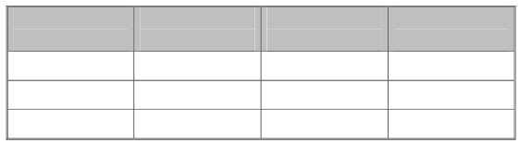
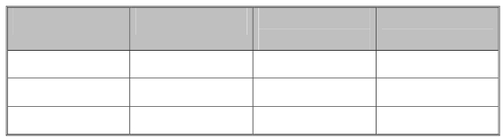
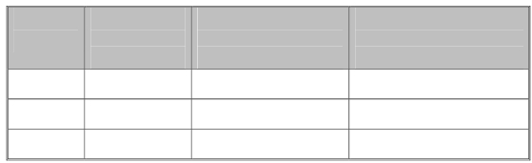

Part 2: Section 4. Bidding Forms

Item of Description, Condition (new, good, Owned, leased (from
Equipment make and age poor) and number whom?), or to be purchased
(years) available (from whom?)

4. The qualifications and experience of key personnel proposed for administration and
execution of the Contract are: [Attach biographical data.]

Position Name Years of Experience Year of Experience
(general) in proposed position

5. The proposed subcontracts and firms involved are:

Sections of the Value of Subcontractor Experience in
Works Subcontract (name and address) Similar Works

6. The following financial reports (e.g. balance sheets, profit and loss statements, auditors’ reports etc) for the last five years are attached: [List and attach]
1.
2.
3.
7. The following evidence of access to financial resources (e.g. cash in hand, lines of credit etc) to meet the qualification requirements is attached: [List and attach]
1.
2.
3.
8. Banks that may provide references if contacted by the Employer are: [State name, address and telephone, telex and facsimile numbers]

Standard Bidding Document for Works issued by PPDA June 2005 44

Open and Restricted Bidding Section 4: Document: WksSect4

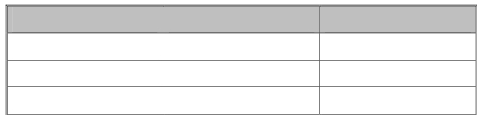

Part 2: Section 4. Bidding Forms

9. We are currently involved in the following litigation:

Other Party(ies) Cause of Dispute Amount Involved

We, the undersigned, declare that
(a) the information contained in and attached to this form is true and accurate as of the date of bid submission:
or [delete statement which does not apply]
(b) the originally submitted pre-qualification information remains essentially correct as of the date of bid submission.

Signed: [signature of person whose name and capacity are shown below]
Name: [insert complete name of person signing the Qualification Form]
In the capacity of [insert legal capacity of person signing the Qualification Form]
Duly authorised to sign the Qualification Form for and on behalf of: [insert complete name of Bidder/Member of Joint Venture]
Dated on ____________ day of __________________, _______ [insert date of signing]

Standard Bidding Document for Works issued by PPDA June 2005 45

Open and Restricted Bidding Section 4: Document: WksSect4

Standard Bidding Document for Works issued by PPDA June 2005 47

Open and Restricted Bidding Section 6: Document: WksSect6

Part 3: Section 6 Statement of Requirements
1. Scope of Works

Standard Bidding Document for Works issued by PPDA June 2005 48

Open and Restricted Bidding Section 6: Document: WksSect6

Part 3: Section 6 Statement of Requirements
2. Technical Specifications

Standard Bidding Document for Works issued by PPDA June 2005 49

Open and Restricted Bidding Section 6: Document: WksSect6

Part 3: Section 6 Statement of Requirements
3. Drawings

Standard Bidding Document for Works issued by PPDA June 2005 50

Open and Restricted Bidding Section 6: Document: WksSect6

Part 3: Section 6 Statement of Requirements
4. Activity Schedule/ Bills of Quantities

Standard Bidding Document for Works issued by PPDA June 2005 51

Open and Restricted Bidding Section 6: Document: WksSect6

Part 3: Section 6 Statement of Requirements
5. Completion Schedule

Standard Bidding Document for Works issued by PPDA June 2005 52

Open and Restricted Bidding Section 6: Document: WksSect6

